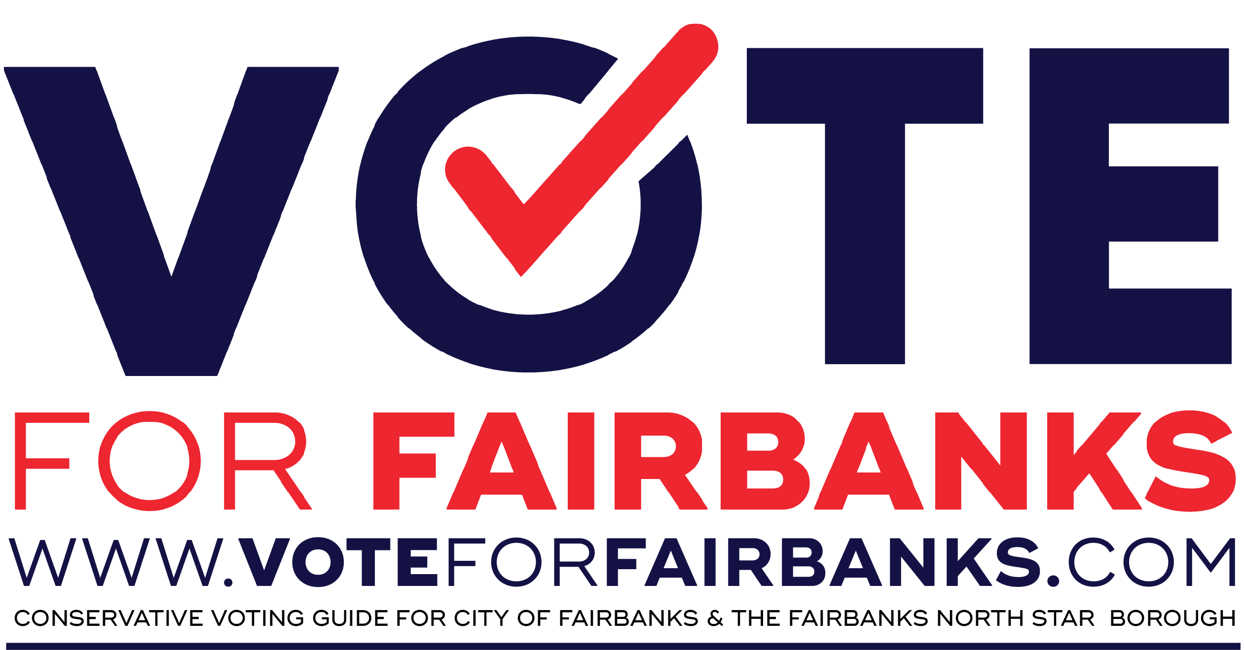

This list is the personal voting list for Pastor (insert your name). This list does not represent the official position of (insert your church's name) and their leadership team or elected board of elders. This list reflects the conservative personal voting preference of Pastor (insert your name).

This list is the personal voting list for Pastor (insert your name). This list does not represent the official position of (insert your church's name) and their leadership team or elected board of elders. This list reflects the conservative personal voting preference of Pastor (insert your name).

***______________________________***

***City of Fairbanks***

City Council Seat A**: Jerry Cleworth**

City Council Seat B**: Jonathan Bagwill**

***Fairbanks North Star Borough Mayor***

Fairbanks Northstar mayor**: Bryce Ward**

***Fairbanks north star borough assembly***

SEAT A: **Kevin McKinley**

SEAT F: **Patricia Silva**

SEAT G:  **Lance Roberts**

***Fairbanks North Star School District***

SCHOOL BOARD (SEAT A): **Andrew Graham**

SCHOOL BOARD (SEAT B): **Jeffrey Rentzel**

***______________________________***

***City of Fairbanks***

City Council Seat A**: Jerry Cleworth**

City Council Seat B**: Jonathan Bagwill**

***Fairbanks North Star Borough Mayor***

Fairbanks Northstar mayor**: Bryce Ward**

***Fairbanks north star borough assembly***

SEAT A: **Kevin McKinley**

SEAT F: **Patricia Silva**

SEAT G:  **Lance Roberts**

***Fairbanks North Star School District***

SCHOOL BOARD (SEAT A): **Andrew Graham**

SCHOOL BOARD (SEAT B): **Jeffrey Rentzel**