**Three Commands in the Culture of Prayer**

1. **________________ - Abandonment; clinging to another**

**Luke 5:5-11 (KJV)** 5And Simon answering said unto him, Master, we have toiled all the night, and have taken nothing: nevertheless at thy word I will let down the net. 6And when they had this done, they inclosed a great multitude of fishes: and their net brake. 7And they beckoned unto their partners, which were in the other ship, that they should come and help them. And they came, and filled both the ships, so that they began to sink. 8When Simon Peter saw it, he fell down at Jesus' knees, saying, Depart from me; for I am a sinful man, O Lord. 9For he was astonished, and all that were with him, at the draught of the fishes which they had taken: 10And so was also James, and John, the sons of Zebedee, which were partners with Simon. And Jesus said unto Simon, Fear not; from henceforth thou shalt catch men. 11And when they had brought their ships to land, they forsook all, and followed him.

**_______________________________________________________________________________________________________________________________________________________________________________________**

2. **________________ - To maintain possession**

**Luke 19:12-13 (KJV)** 12He said therefore, A certain nobleman went into a far country to receive for himself a kingdom, and to return. 13And he called his ten servants, and delivered them ten pounds, and said unto them, Occupy till I come.

**Matthew 25:14 (KJV)** For the kingdom of heaven is as a man travelling into a far country, who called his own servants, and delivered unto them his goods.

**1 Timothy 6:20 (KJV)** O Timothy, keep that which is committed to thy trust, avoiding profane and vain babblings, and oppositions of science falsely so called:

**_______________________________________________________________________________________________________________________________________________________________________________________**

**The Message**

***The Culture of Prayer: “Running with Horses”  
Brother Lee Thompson — August 25, 2021***

***Wednesday Night* 7:30 pm**

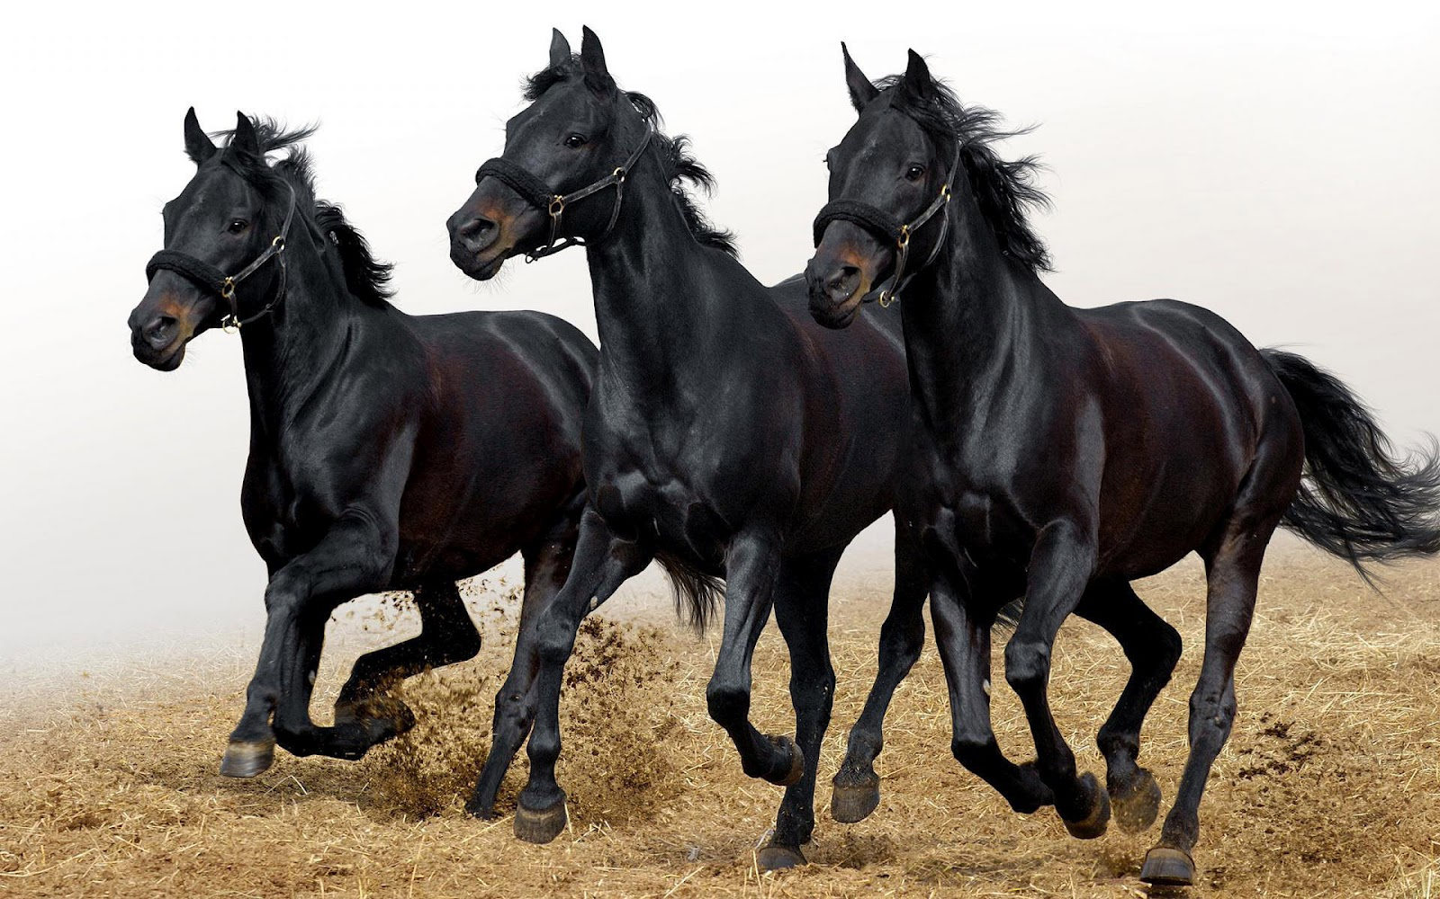

**Jeremiah 12:1-5 (KJV)** Righteous art thou, O Lord, when I plead with thee: yet let me talk with thee of thy judgments: Wherefore doth the way of the wicked prosper? wherefore are all they happy that deal very treacherously? 2Thou hast planted them, yea, they have taken root: they grow, yea, they bring forth fruit: thou art near in their mouth, and far from their reins. 3But thou, O Lord, knowest me: thou hast seen me, and tried mine heart toward thee: pull them out like sheep for the slaughter, and prepare them for the day of slaughter. 4How long shall the land mourn, and the herbs of every field wither, for the wickedness of them that dwell therein? the beasts are consumed, and the birds; because they said, He shall not see our last end. 5If thou hast run with the footmen, and they have wearied thee, then how canst thou contend with horses? and if in the land of peace, wherein thou trustedst, they wearied thee, then how wilt thou do in the swelling of Jordan?

**Jeremiah 12:5 (TLB)** The Lord replied to me: If racing with mere men—these men of Anathoth—has wearied you, how will you race against horses, against the king, his court, and all his evil priests? If you stumble and fall on open ground, what will you do in Jordan’s jungles?

**Additional Notes:**

**_______________________________________________________________________________________________________________________________________________________________________________________**

**_______________________________________________________________________________________________________________________________________________________________________________________**

**_______________________________________________________________________________________________________________________________________________________________________________________**

**_______________________________________________________________________________________________________________________________________________________________________________________**

**_______________________________________________________________________________________________________________________________________________________________________________________**

**_______________________________________________________________________________________________________________________________________________________________________________________**

**_______________________________________________________________________________________________________________________________________________________________________________________**

**_______________________________________________________________________________________________________________________________________________________________________________________**

3. **________________ - Conducts himself gallantly**

**2 Timothy 2:3-4 (KJV)** 3Thou therefore endure hardness, as a good soldier of Jesus Christ. 4No man that warreth entangleth himself with the affairs of this life; that he may please him who hath chosen him to be a soldier.

**2 Timothy 2:3-4 (CEV)** 3As a good soldier of Christ Jesus you must endure your share of suffering. 4Soldiers on duty don’t work at outside jobs. They try only to please their commanding officer.

**_______________________________________________________________________________________________________________________________________________________________________________________**

**Three Areas of Moral Strength Characterized in a Good Solider of Christ:**

1. **A _________________ force that is stronger than any adverse challenge of life that comes against him.**

2. **A _________________ passion that deadens the negative thoughts that attack him.**

3. **A _________________ for righteousness that overrules all the forces of hell.**

***Will you run with the horses in the culture of prayer?***

