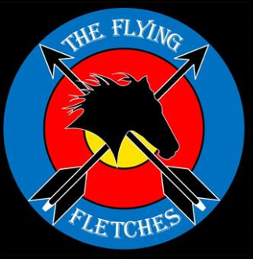 Safety Rules and Procedures for The Flying Fletches Inc.

General Rules

1. Horse archery is our passion, a combination of two dangerous sports. Safety is always the first priority.

2. It is the rider/archer’s responsibility to make sure he/she is fit for this sport.

3. Do not ride/shoot under the influence of drug and alcohol. Members are not allowed to ride or shoot once consume alcohol on club activity day.

4. Every member can tell any other members to stop if have any safety concern about the rider/shooter, horse or equipment.

5. Wear proper protection. Helmet is compulsory. Gloves, armguard and riding boots are important. It is the rider/archer’s responsibility to make sure the costume is safe for horse archery.

6. Proper warm up for both rider/archer and the horse are essential to prevent sports injury/incident.

7. Any club activity day, at least one member who hold Senior First Aid Certificate need to be present, also carry a First Aid Kit. Consider fixed First Aid box once club find permanent play ground.

7. Carry a water bottle, keep well hydrated.

Ground Archery Practice (apply to track practice as well)

- It is member’s responsibility to make sure his/her equipment are functional and safe.

- Never draw the bow and pointing to anyone even if it does not have an arrow nocked.

- Do not “ dry fire” bow without an arrow. This can cause shock which may damage the bow or arm/wrist.

- Be aware of what is in the direction behind the target, including human, live stock, vehicle and property.

- Never step in front of the shooting line. Never nock or shoot if anyone is in front of shooting line. Pay attention to junior members including children.

- If dropped arrow forward of shooting line, do not pick up until calling “cease shooting” and no arrows nocked on any bows.

- How to pull arrows out of target. Stand to one side of the target, one hand hold the target, the other hand hold arrow shaft close to the target with forearm parallel to the shaft, steady pulling out. Make sure no one standing at the direction which the arrow is traveling. Do not use two hands to pull towards yourself. Then check the arrow for missing tip or damaged nock/shaft.

- No arrows remain nocked on string when members go forward to retrieve arrows.

On the Track

- Members should consider their own fitness, experience, suitability of the horse including the condition of the horse on the day, to decide what category/track to practice or compete. We encourage good horsemanship, not horseplay.

- It is encouraged when mounting or dismounting, do not hold bow/arrows in hands, no arrows in quiver. Ground support staff will help pass on the equipment after mounting or before dismounting.

- Everyone should follow the instruction/signal from the steward.

- Arrow and bow need to point down and forward when the rule allow nocking before starting pole.

- Riders should walk back along the non-target side off the track, also warn spectator/ground staff when the horse is approaching. For one-side track, riders should stay next to the end of the track, wait for steward’s signal/call to come back to the start point.

- Do not ride/shoot when any ground support staff present on the track or standing on target side between start/finish poles.

- Advise ground support members ASAP once dropped arrow on the track.

