FREE presenter at your Back to School Faculty Meeting! YES, FREE!!
If 10 faculty members join California Reading Association you faculty wins a free visit/motivating presentation from Dr. Danny Brassell! Register here on our website now for $40. Or take advantage of attending a CRA webinar on August 13 on hi-low books for struggling readers or on September 17th on Vocabulary. The special price of the webinar and membership is only $31.50!
Danny is the perfect start to the year, especially during these uncertain times.
He will have you laughing and learning at the same time!

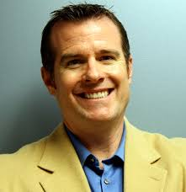
Introducing Danny Brassell

Polished, Dynamic, Positive, Inspirational, Compelling, Energetic, Engaging, Passionate, Funny, Captivating, these are all words that have been used to describe Dr. Danny Brassell and I would have to concur! He’s all that and more.

Danny, the son of a librarian grew up hating to read!? And today he is touted as America’s Leading Reading Ambassador! He chose to teach in the inner-city where he could make the biggest impact. Then as an administrator and a college professor he further inspired students of all ages. He is the author of more than a dozen books and has a mission to bring joy to the classroom while inspiring students to become both readers and leaders.

I guarantee you, this hour will pass quickly and you will leave this webinar laughing and inspired and wishing for more. You will be in a better frame of mind to face the uncertainty of the new school year and whatever that may look like. Danny’s presentation will put a smile on your face, warm your heart, and fuel you with the energy to meet the challenges ahead.

