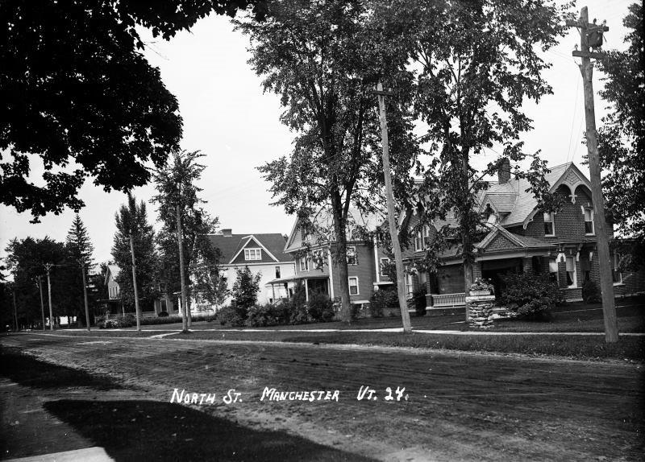
This photo, showing Bonnet Street and the parsonage, was taken in 1925. The road, then called North Street, wasn’t paved until 1929-1930. (Our thanks to Shawn Harrington and the Manchester Historical Society.)

“SpiritSpark”
The First Baptist Church
of Manchester Center, VT
P.O. Box 1049, 4895 Main St. 802-362-1555
www.fbcmanvt.org
fbcmanvt@gmail.com
Pastor: Rev. Rebecca Sommons
_______________________September 2018_________________________

A MESSAGE FROM PASTOR REBECCA
Dear Church Family,
Many of us are facing a season of transition and change. For some, the changes are exciting and full of hope for the future. For others, the changes are stressful and loaded with anxiety. Still others are facing significant transitions involving loss and grief.

We may be tempted to get caught up in a wave of busyness out of enthusiasm or desperation. I suggest that whatever our emotional state, we set aside time to be with God. We are not alone. We’re being held in the hands of our loving, heavenly Father. He is our Rock, the Mighty One. Yet God tenderly sings his love over us, day and night.
Whatever challenges we are facing, we have reason to be hopeful, because our God is with us, and he is good. Slow down. Be still, and know that he is God. Pouring out our hearts to God in prayer, in writing, in song will help our trust in him grow. Reading and praying the Psalms can help us find words for all that we feel. They can lead our hearts to praise God for his unfailing love now and the hope of things to come.
“I trust in you, Lord;
I say, ‘You are my God.’
My times are in your hands…”
Psalm 31:14-15a
With gratitude,
Pastor Rebecca

MARY MARTHA FELLOWSHIP
The Mary Martha Fellowship will resume their regular meeting schedule on Sun., Sept. 9, 2018, meeting at 8:30 a.m. Barb West and Glenna Taxter are in charge of refreshments.
Providing altar flowers for the month of Sept. are Wests, Rosemary Hall, Martha T., Taxters, and Lorraine.
At this meeting we will be drawing the winning lottery tickets for the quilt, the massage, and the picnic bundle. The money raised from this effort will go into the Kitchen Renovation Fund. If we sell all the tickets, we will raise over $1000.
We will also be discussing The Chicken Pie Supper, dates and details.
MMF has another project in the works: selling RADA products, especially knives. This will be on-going and catalogs are in circulation.
All women in the church are invited and urged to attend this social, support and service group.
~submitted by Martha Thompson

MISSIONS COMMITTEE
Blessings and Peace from the Missions Committee!
Summer has been a busy season for the Missions Committee and we are happy to report that our efforts have been successful! We will soon report the results of our One Great Hour of Sharing appeal and our local missions collection. Final numbers are still being calculated.
At our August meeting we voted to pledge support for Jeni Pedzinski (a seminary colleague of Pastor Rebecca) and the New Life Center of Changmai, Thailand at $50.00 per month. The New Life Center supports victims of human trafficking with psychological support and educational opportunities and has been doing so for more than 30 years. We are proud of the work that Jeni does and wanted to offer our support for her mission work. Please consider increasing your local mission giving to help us meet our pledge for this essential work in saving young lives.
We continue to inquire of other churches in our area for participation in the 30-hour Famine for our young people. This has been a successful program in the past, and we hope to revive interest in it for early 2019. It would be a great opportunity for our young people to interact with other young people from our sister churches. Please pray for our efforts as our planning comes together. If anyone is interested in working on this project, please see one of us or Pastor Rebecca to express your interest.
We will begin our World Mission Offering and another local mission appeal beginning in October. Please consider how you can help meet the needs of our missions outreach.
Thank you for your prayers and support for our valuable mission work.
Yours in Christ's service,
Jeff Linebeck, Martha Thompson, Barbara West and Lisa Towslee

CHOIR NEWS!

The choir makes it quarterly visit to the Equinox Terrace on September 13th at 5:45 pm. Both the choir members and the Terrace residents look forward to this time. Come join us!

Thursday night choir rehearsals will resume September 20th at 7:00 pm.
We are always looking for more singers to join us. Talk to Jeff or just show up on Thursday night!

INTERFAITH COUNCIL OF THE NORTHSHIRE
After a summer hiatus of 2 months, the IFC will begin meeting again on Thurs., Sept 5, 2018 at Zion Church. First Baptist will be hosting on Oct. 4, 2018. As many know, the IFC is the umbrella organization for Neighbor to Neighbor, The Emergency Needs Fund, Auto Angels, a storage unit and The Summer Lunch Program as well as planning, the Martin Luther King Service, an Easter Sunrise Service and a Thanksgiving Service for the community. Rev. Dr. Jim Gray is the Council chair. Our own Jeff Linebeck is the go-to person for music leadership at these events.
~submitted by Martha Thompson

NEIGHBOR TO NEIGHBOR
Neighbor to neighbor is responsible for raising their own funds and this year will be sponsoring The Great Neighbor to Neighbor Pie Auction.
One important part of making this event a success is having beautiful pies to auction off. Several members from our congregation have already agreed to bake pies. They can be sweet or savory. Other congregations are being solicited as well. If you have a show stopper pie or pies, we would be grateful for your donation. We are trying to provide glass pie pans. This premier event will be held at the Inn at Manchester Celebration Barn on Nov. 17, 2018. There is a sign- up sheet for pie bakers in the vestry or call N to N at 367-7787 or Martha Thompson at 362-3473.
~submitted by Martha Thompson

PRUDENTIAL COMMITTEE HIGHLIGHTS
Our meeting was held on August 14, 2018.
We welcomed Annie Vickery as our newest member! Thanks Annie!
We are getting more propane price quotes for this coming heating season and are close to signing a contract for one year.
We hope to complete the Bonnet Street door project soon. An outside handicap ramp is in progress.
Bryan Richheimer, chairperson

The following information comes from Kathy Clark of the Federated Church in East Arlington.

Voter Forum Vermont House Race
Hear what the candidates have to say about the issues; follow your heart and vote your values in November.
Tuesday, September 11
6:30 – 8 pm
Federated Church of E. Arlington 102 Ice Pond Road, Arlington
Join members of your community for a non-partisan forum with the candidates for Vermont House seats in the BEN-4 district.
This gathering will feature questions on the issues of economic dignity, affordable housing/homelessness, criminal justice reform, and education, among others. The goal is to help you make up your mind for the General Election on November 6th.
Sponsored by Vermont Interfaith Action
For more information about VIA, see our website (www.viavt.org) or Facebook page, call (802) 651-8889, or email office@viavt.org.

FORGIVENESS CLASS
John Hess is inviting people from both the church and the community to gather for a forgiveness class at the Catamount Bookstore in Arlington.
The interactive class is open to both teens and adults and will meet on Wednesday nights at 7 pm beginning September 12th.
You can contact John at 802-282-9769 for more information.

CHRISTIAN EDUCATION

Happy New Year! The Christian Ed committee is excited to get back into a new Sunday School year!
With the Sunday service time moving back to 10:30am on September 9th, we welcome ALL to continue coming at 9:30am to join in the "Something for Everyone" Sunday School classes.
There will be:
•A children's class for kids up to 5th grade
•A tween/teen's class for 6th thru 12th grades
•And an adult's class
Truly, something for everyone!
If you are interested in serving as a teacher or helper in one of these classes, please speak with Holly O'Brien or Pastor Rebecca.
Also in September, we will be relaunching an invitation to our FBC family to encourage engaging in some RightNow Media opportunities that are available to our congregation. There are programs, videos, materials on faith based topics from closer looks into specific books of the bible, to parenting, relationships, and faith based children's entertainment.
We will also be announcing a date that Jeremy Crumb (Thank you, Jeremy!) will go over any specific technical questions you may have with connecting your device- phone, tablet, laptop, etc.

~submitted by Holly O’Brien, Church School Sup’t

Please continue to hold Matthew and Natalie Sommons in prayer as they hike the Appalachian Trail. They are presently hiking through Pennsylvania. You may follow them on facebook under Matt and Natalie At Thru Hike 2018

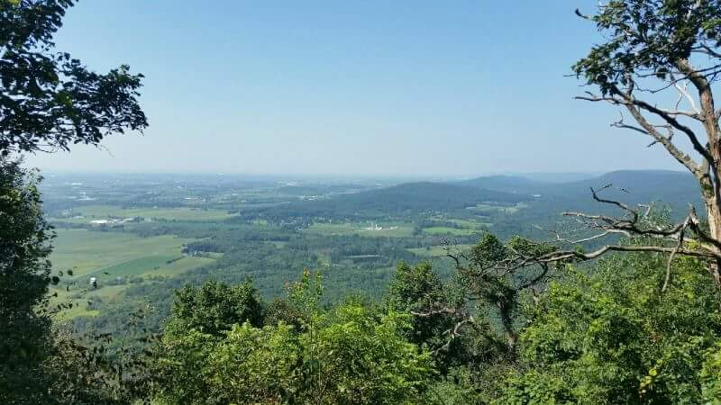
Views of fields and forests from the Appalachian Trail

OUR CHURCH IS PRIVILEGED TO BE ABLE TO OFFER OUR
FACILITY TO THE FOLLOWING AA GROUPS EACH WEEK.
Equinox Group: Mon-Fri from Noon to 1:00 PM
Thursday Morning Men’s Group: Thursday 7:30-8:30 AM
Primary Purpose Group: Sunday 7:30-8:30 PM

IMPORTANT CONTACT INFORMATION
Church Office Hours 9:30-12:30 AM on Tuesdays and Wednesdays
Pastor Rebecca’s e-mail address: rebeccasommons@gmail.com
Pastor Rebecca’s cell phone: (802) 688-3024
Church office Phone: (802) 362-1555
Parsonage Phone: (802) 362-5335
Please call to request a meeting or visit outside of regular church office hours.

FLOWERS CHILD CARE PROVIDERS
September 2: Jim/Barb West September 2: Jenny & Cheryl
September 9: Rosemary Hall September 9: Glenna & Annie
September 16: Martha Thompson September 16: Holly & Ronan
September 23: Russ & Glenna Taxter September 23: Maurie & Kristen
September 30: Lorraine Wilkins September 30: Dottie & Bryan

The First Baptist Church family would like to extend their condolences to the family of Paul A. Ennis, Sr. Paul went to be with the Lord on August 23, 2018.

