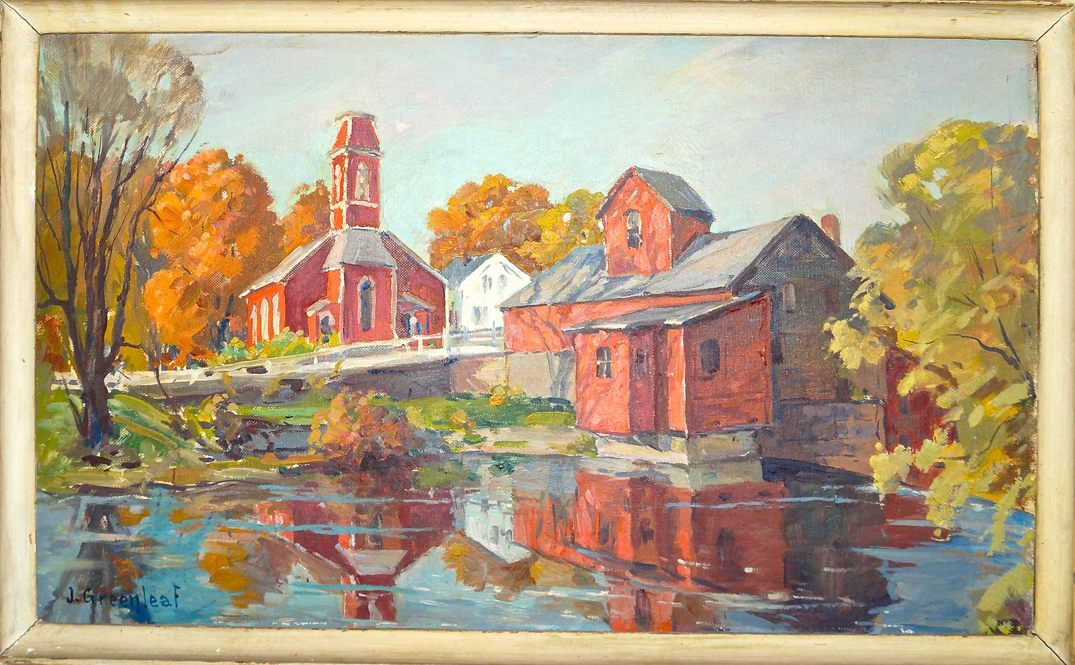
A painting worth seeing again!

“SpiritSpark”
The First Baptist Church of Manchester Center, VT
P.O. Box 1049, 4895 Main St. 802-362-1555 www.fbcmanvt.org
fbcmanvt@gmail.com

Pastor: Rev. Rebecca Sommons
___________________________OCTOBER 2018_________________________

A MESSAGE FROM PASTOR REBECCA

Dear Church Family,
Life this side of heaven isn’t perfect, is it? Matthew and Natalie pictured hiking through beautiful mountains with colorful leaves falling around them this autumn, but so far its been rain falling every day. I pictured having a nice visit with my parents this week, where I would take them on outings to pick apples, go for nature walks, and visit the Vermont Country Store. Our first day together was mostly spent waiting for a series of people to come and examine our broken boiler. Maybe you are dealing with larger issues than rainy weather and cracked boilers this fall, and life isn’t going the way you pictured it might.

We don’t usually get to choose which challenges come our way, but we do get to choose how we respond to them. I find it is helpful to pray for the Holy Spirit to bring an extra measure of peace and calmness to my soul when I feel tension start to grip my heart. Another thing that helps is to take out my gratitude journal and start listing all the things I can notice that are good. Finding the grace in the middle of challenge reminds me that God is here with me, providing what is needed for this hour. I think God especially appreciates being noticed when our natural tendency might be to complain. You and I might be surprised that we can even feel joy in the middle of our mess.
Nehemiah encouraged the people who were rebuilding Jerusalem with these words, and they hold true for us today.
“This is a sacred day before our Lord. Don’t be dejected and sad,
for the joy of the Lord is your strength!”
Nehemiah 8:10

Every day is a chance to choose to look for the good that God is bringing into our lives,
even amidst the struggle. Wherever we do, we open our hearts to the joy of the Lord, that gives us strength.
With eyes open,
Pastor Rebecca

MISSIONS COMMITTEE
Blessings and Peace from the Missions Committee!
Beginning on October 7th, we will be collecting for the American Baptist Churches World Mission Offering, followed by another appeal for our Local Missions activities. Please pray your support for those of us giving Mission Moments during October and how you can pledge some of your ongoing offering to our missions outreach.
We continue to inquire of other churches in our area for participation in the 30-hour Famine for our young people. Martha Thompson has been in contact with representatives of our sister churches in the Northshire, and has received encouragement and pledges of support. This has been a successful program in the past, and we hope to revive interest in it for early 2019. It would be a great opportunity for our young people to interact with other young people and increase their awareness of world hunger. Please pray for our efforts as our planning comes together. If anyone is interested in working on this project, please see one of us or Pastor Rebecca to express your interest.
Thank you for your prayers and support for our valuable mission work.
Yours in Christ's service,
Jeff Linebeck, Martha Thompson, Barbara West and Lisa Towslee

The new web site www.fbcmanvt.org is up and running! As we read the positive feedback from many people, it came to our attention that some parts of the site were going unnoticed. There are several pages. On the top of the home page, you will see tabs titled Home, Calendar, ABOUT US, SpiritSpark, Johnson Organ, History and Contact Us.
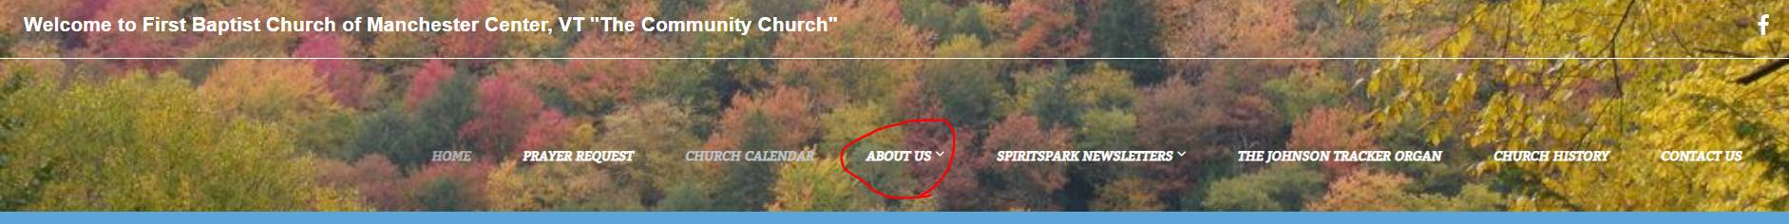
If you look closely at ABOUT US and SpiritSpark, you will see a little down arrow which means there are more pages under those headings.
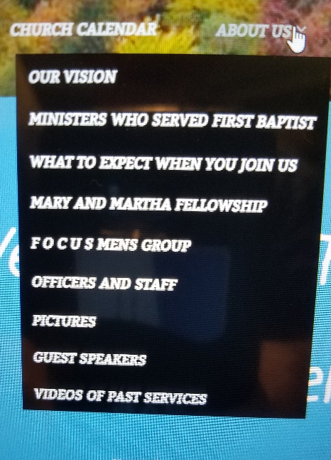

The purpose of the web site is not only to keep the church family up to date with what’s going on, but to be open and inviting to visitors who are looking for a church when they are moving to or visiting the area.
Any thoughts or comments you have about the site are always welcome. We are still looking for pictures of past pastors and the church so dig into the old shoe boxes and see what you have that we can borrow.

MARY MARTHA FELLOWSHIP
The next Mary Martha Fellowship will be on Sun., Oct. 14, 2018. Lorraine Wilkins is our hostess and Judy Koch has a fun fall craft for us to try. At this meeting we will begin to plan for next year as we hope to get the program out by the first of the year. All women of the church are welcome.
One particular project is our baskets of love as an outreach for some members and friends at Christmas time.
MMF also is responsible for keeping the kitchen and bathrooms supplied with soaps and paper goods.
~submitted by Martha Thompson

PRUDENTIAL COMMITTEE_NOTES

On September 11, 2018, the Prudential Committee discussed painting the front of the church and the entry to the vestry. The shrubs were trimmed so we could get to the lower trim in the front and assess the situation.
We are working on getting new vinyl installed in the vestry bathroom and entry. We obtained an estimate from Manchester Carpet Care.
Our next meeting will be at 5pm on October 9.
Bryan Richheimer, Chairman
CHICKEN PIE SUPPER
Save the date, October 20, 2018 at 6:00 pm! MMF will invite the congregation and community to our annual Chicken Pie Supper.
This is truly an all church project with wonderful help from the congregation. We are looking for willing cooks, food providers, people to set up and clean up, waitstaff, dishwashers, etc. etc. If you can help, please call Martha Thompson at 362-3473.
As always, our menu includes, chicken pies with biscuit topping and extra biscuits on the side, mashed potato, mashed squash, green peas, coleslaw, cranberry sauce, and your choice of apple, mince or pumpkin pie with cheese, coffee, tea and apple cider.
Reservations may be made by calling Martha at 362-3473. This year we are raising the price to $13 for adults and $6 for children eight and under. All are welcome.
~submitted by Martha Thompson

SUNDAY SCHOOL
Sunday School meets at 9:30 on Sunday mornings. We have a class for children ages 5-10 in Joy Hall (basement) a class for tweens and teens at the parsonage (98 Bonnet Street) and a class for adults in the conference room (second level). We hope you would like to come to explore and deepen your faith with others.

MEN’S MEETING
Saturday, Oct 6 at 8 AM
Come and
bring a friend! We will be planning the fall and winter get-togethers.
Pass the word!!!

INTERFAITH COUNCIL OF THE NORTHSHIRE
The next meeting of the IFC will be held at our church on Thursday, October 4, 2018 at 11:45 pm.
Harvest Supper
The Interfaith Council invites the congregation to the Annual Harvest Supper to be held at St. Paul’s Catholic Church on October 28, 2018 beginning at 5:00 pm with a brief business meeting followed by a pot luck supper and then an auction whose proceeds benefit the Emergency Needs Fund and the Annual Christmas Project. The IFC is the umbrella organization for Auto Angels, Kids Summer Lunch Program, Neighbor to Neighbor, the storage unit, the Emergency Needs Fund and the Christmas Project. All are welcome.
P.S. Auto Angels has two available cars.
~submitted by Martha Thompson

WALK TO EMMAUS

The Men’s Emmaus Walk #136 is scheduled for October 11-14, 2018.The walk runs from Thursday evening to Sunday evening. Please see John or Cheryl Hess if you are interested in attending the retreat or closing ceremony to learn more.

Book Study/Prayer Group
Prayer Group Members! We are starting our new book "How to Make Jesus Your Best Friend" by Norman Vincent Peale. We will be meeting on Oct 9, Oct 23 and finishing on Nov 6. Then we will take a break until January when we will start "The Divine Hand". See Pastor Rebecca for details on ordering "The Divine Hand". The group meets at 7 pm at Lois Squires. For more information you may see Barb West, Lois Squires or Glenna Taxter.

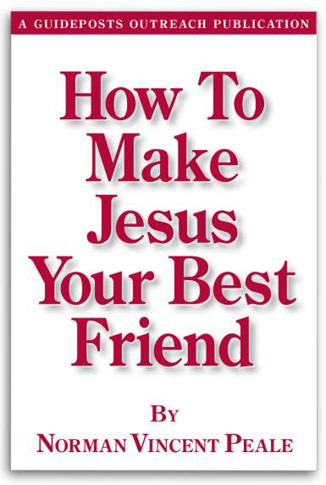

DIACONATE NEWS

On September 9, John Hess spoke about "Walk to Emmaus", that he and Cheryl participate in, and John leads locally. He encourages us to speak to him regarding questions.
In all meetings, members and family members as well as friends needing our prayers are identified and prayed for.
The Fellowship Fund was approved for members and friends in need of help.

On Sept. 30, Pastor Rebecca's father, Paul Juris, will preach on "Joy"
Pastor Rebecca's next sermons will focus on the book of "Ruth".

Sincerely,
Martha Bowen, Co-chair
Linda Hulett, Co-chair

For those of you who are wondering how Matt and Natalie are doing, here is their post from September 27th.
Matt and Natalie AT Thru Hike 2018

We have been back on the trail for 10 days now since being off for the hurricane and have had to deal with some degree of rain every day. That being said, we did get 2 mostly sunny days to hike both last Wednesday and yesterday. Last Saturday we hiked 22 miles, the last 4 hours of which was in pouring rain. Earlier that day a fellow AT southbound thru hiker (named Meltdown) hiked extra fast to catch us as I had accidentally left my tent poles at the shelter where we stayed the night before. After finishing the 22 miles we arrived at the shelter and found it to be full with weekend hikers. We at least ate our meal under the overhang of the shelter before setting up our tents in the rain as darkness began to settle in. Of course, I would not have been able to even set up my tent if not for the kindness of our fellow sojourner. As we climbed into our tents that were still wet from 2 nights earlier and getting wetter by the second, it began to pour once again. We settled into our sleeping bags that were now also dampening as the tent roof sent sprays of water down onto us each time it was pelted by a larger raindrop. But, the sleeping bag did its job! Although wet on the outside, the bag kept our body heat inside providing us with an oasis of dryness and warmth in an otherwise completely wet world. When we emerged from our cocoons the next morning our moods were surprisingly bright despite the ongoing presence of the drizzle and fog we have come to expect. We had made it through the worst 24 hour stretch we have had on the trail and realized that all we needed to be truly content were the kindness of a friend and a functional sleeping bag.

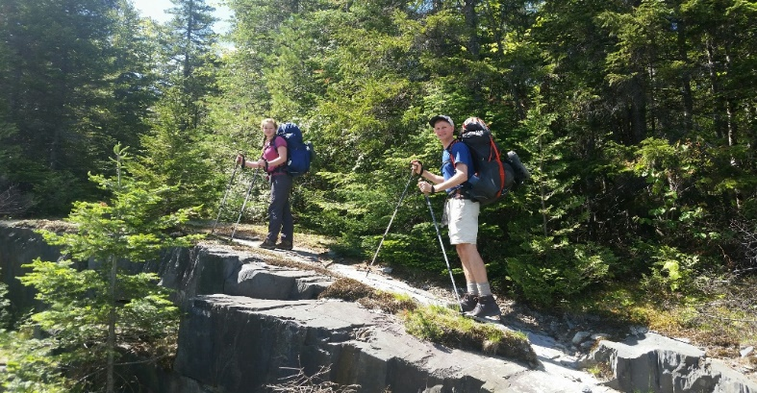

Looking Ahead!
The Interfaith Annual Thanksgiving Service
will be held at the Dorset Church
Tuesday, November 20, 2018 at 7:00 pm.

You Lead Conference
There is an opportunity to attend a Life Way Women’s event on October 26-27th. It will be at the Times Union Center in Albany, NY. Beth Moore will be speaking on equipping every woman’s passion and purpose, and Travis Cottrell will be leading worship. The cost is $79 or $59 for a group of 10 or more. Please see Linell Pike if you are interested in going

OUR CHURCH IS PRIVILEGED TO BE ABLE TO OFFER
OUR FACILITY TO THE FOLLOWING AA GROUPS EACH WEEK.
Equinox Group: Mon-Fri from Noon to 1:00 pm
Thursday Morning Men’s Group: Thursday 7:30-8:30 am
Primary Purpose Group: Sunday 7:30-8:30 pm

IMPORTANT CONTACT INFORMATION
Church Office Hours 9:30-12:30 AM on Tuesdays and Wednesdays
Pastor Rebecca’s e-mail address: rebeccasommons@gmail.com
Pastor Rebecca’s cell phone: (802) 688-3024
Church office Phone: (802) 362-1555
Parsonage Phone: (802) 362-5335
Please call to request a meeting or visit outside of regular church office hours.

FLOWERS CHILD CARE PROVIDERS
Oct. 7: Helen Brimlow Oct. 7: Jenny & Cheryl
Oct. 14: Jeff Linebeck Oct. 14: Maurie & Kristen
Oct. 21 Lindy Mylott Oct. 21: Cathy & Lindy
Oct. 28: Carol Lattuga Oct. 28: Barb & Linell

