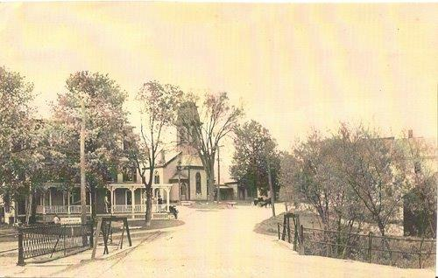
This shows the iron bridge, about 1900. It was replaced with the marble bridge in 1912. (Photo courtesy of the Manchester Historical Society)
“SpiritSpark”
The First Baptist Church
of Manchester Center, VT
P.O. Box 1049, 4895 Main St. 802-362-1555
www.fbcmanvt.org
fbcmanvt@gmail.com
Pastor: Rev. Rebecca Sommons
_______________________July 2018_________________________

A MESSAGE FROM PASTOR REBECCA
Dear Church Family,
Summer is here! The mountains are gorgeous, and there are so many things to do! Everywhere I look, I find things to thank God for in this season of abundant sunshine, color, berries, and bouquets. I just want to take a moment to also thank you for coming alongside me in this season of having my husband and one of my daughters far away, seeing those mountaintops up close.
As my church family, you have reached out to me in meaningful ways. You’ve asked how you can help, listened well, done projects around the parsonage, invited me for dinner, joined me for walks, given me a much needed hose, been flexible about my schedule, and prayed for my whole family.
You are living out what Paul wrote about in Galatians 6:2 ~
“Bear one another’s burdens, and in this way you will fulfill the law of Christ.”
The “law of Christ” is simply about living in loving ways with each other. I have felt your love, not just for me, but also for each other. The kindness, time, and effort that you give toward blessing others is beautiful! I’ve noticed and God notices too.
Love in Christ,
Pastor Rebecca

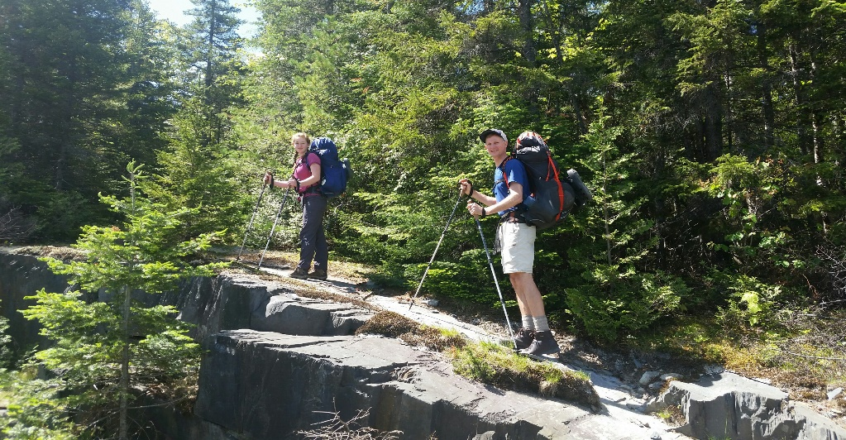
You may follow Matt and Natalie on Facebook at: Matt and Natalie At Thru Hike 2018

REPORT of the MISSIONS COMMITTEE
Happy Summer from the Missions Committee!
On June 15th, members of the Missions Committee and some of our youth participated in the Manchester StreetFest by giving out free bottled water and home-made cookies and collecting free-will donations to be sent to World Vision for clean water and famine relief initiatives in East Africa. All donations will be matched 11 times by World Vision! We will continue collecting donations at the next StreetFest on July 20th as well as accepting spare change and cash in the clay jar at the back of the sanctuary. Thank you to those who donated bottled water and cookies. We have plenty of bottled water left over, but would be happy if anyone could make a batch of cookies to distribute on July 20th. We already have 2 volunteers, but could use 2-3 more. Please let any member of the Missions Committee know if you can help.
In July, we will be collecting offerings for our local mission work and the One Great Hour of Sharing. The members of the committee will be presenting Mission Moments during the Sunday Worship Service beginning July 8th. Please consider giving generously and thank you!
Thank you for your prayers and support for our valuable mission work.
Yours in Christ's service,
Jeff Linebeck, Martha Thompson, Barbara West and Lisa Towslee

MARY MARTHA NEWS – submitted by Martha Thompson
The Mary Martha Fellowship wishes to thank the women of the fellowship who prepared breakfast in honor of Father's Day under the direction of Judy Koch and Lisa Towslee. Some supplies were donated by the Manchester Fire Department. Thank You all.
The Fellowship continues to raise money for the Kitchen Renovation Fund by ongoing sales of RADA products, particularly knives. Several MMF members have catalogs.
A raffle is beginning with three wonderful prizes: a blue and yellow herringbone patterned twin size quilt handcrafted by Bernice Felion, a massage from therapist Jenny Sprague and an insulated bag containing picnic supplies. Tickets are available from MMF members and are $5 apiece or 3 for $10.
The Fellowship will not meet in July, but our Annual Birthday Picnic will be held on August 7th at the home of Judy and Ray Koch. Let us know if you'd like to come and need a ride.

The Ham and Strawberry Supper was a huge success. There were many compliments about the delicious food and the teamwork of the helpers. The Supper cleared $1324. Hooray!
Barb West wants to thank all those who supported this effort in any way. She comments that so many put their best foot forward to find ways to help. She particularly wants to thank Lindy Mylott, her right-hand man.

PRUDENTIAL COMMITTEE
The Prudential will not be meeting in July however we will continue to communicate via email and attempt to keep our projects moving forward.
Current news and info about ongoing projects:
Church Mutual Insurance has approved our claim for wind damage to the steeple. We will receive $2322.00 after paying our $1000.00 deductible.
Chris Fontaine will continue his nice work on The Bonnet St door. Jeremy is working on the new lock set and is having keys made.
We are working on reducing our propane cost through a local buying group called The Dover Group.
We finally got rid of the blackboard and the all of the other stuff that was on the Bonnet Street side of the church basement. The basement storage under the organ is cleaned out and our left over siding is being stored there.
Thanks to all for your efforts. Some work is more visible. It is all appreciated, and truly takes a team effort.
Bryan Richheimer

DIACONATE NEWS
June, 2018
The main event this month was the baptism of Kristen Boudreau, by Pastor Rebecca, on June 24 in the Battenkill River at Benedict Crossing in West Arlington. The baptism occurred after church at First Baptist Church, and was followed by a picnic. Prior to baptism, Kristen gave her testimony of her Christian faith. We were touched by her words.
At the Diaconate’s request, we are asking church members to give food for the refreshments after church. Refreshments provide a time in which members and others can talk with each other and even linger to be able to continue conversations. This socialization has become a valued occurrence, which promotes development of relationships, as well as deepening the faith of many.
June is one of First Baptist’s months to staff the food cupboard. Jim West is to be thanked for his leadership in securing volunteers. Thank you for volunteering.
Reverend Steve Jewett will preach on July 22, in Pastor Rebecca’s absence.
Father’s Day was celebrated on June 17, and the men were given pens with scriptural verses on them.
Lastly, Matt and Natalie Sommons started their hiking of the Appalachian Trail this month. Please remember them as well as Rebecca and Grace in your prayers.
Martha Bowen and Linda Hulett
Co-chairs

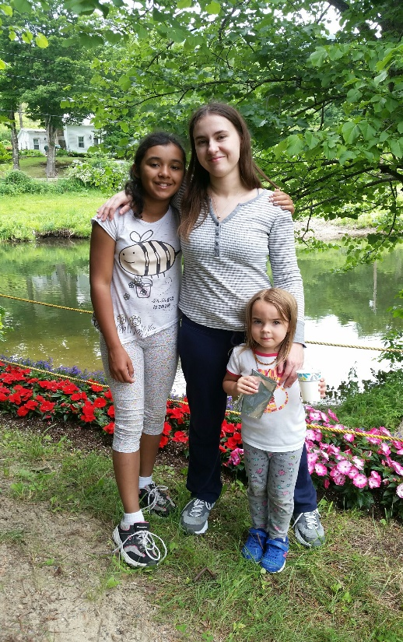
Kristen with Jeweliana & Annabelle Kristen’s Baptism with Pastor Rebecca

INTERFAITH NEWS
Although the Interfaith Council does not meet in the summer one of its projects, the Summer Lunch Program, is in progress. The board with the golden bags is up in the vestry. Each golden bag contains an addressed envelope for a donation to Summer Lunch. Checks can be made out to the Interfaith Council.
Last year about 200 children signed up for this assistance. As you know during the school year children can receive free or reduced lunches, but in the summertime do not and this program fills that gap. Each child receives a bag every week filled with nourishing food such as peanut butter, canned soup or ravioli, fruit, veggies, a coupon for milk and one for bread, etc. at a cost of about $13 for 10 weeks. So, to feed one child for the summer the cost is about $130 per child. The project has grown since its inception. No one likes to think that a child might go hungry in this beautiful valley, so please help as you are able.
~Submitted by Martha Thompson
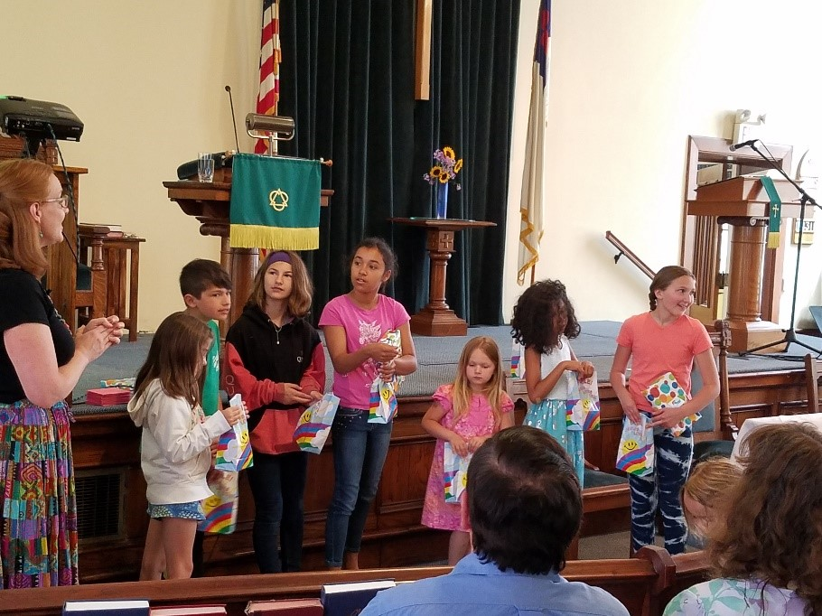

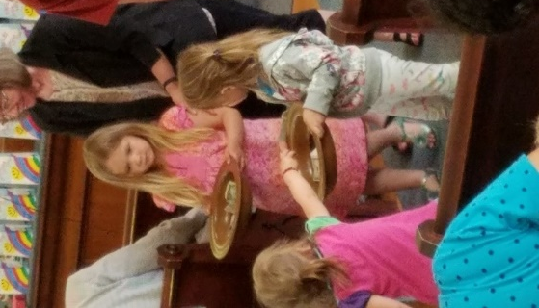

June 3rd was Children’s Day and many of our children participated in the morning worship service! Photo on the left: Emily and Annabelle taking collection!

The following flyer, seeking host families for Chinese students, is submitted by Annabelle Lei Liu.

Dear Brothers and Sisters,
Would you like to open your doors for some Chinese students for one or two weeks and take this opportunity to model God-like life to them?
Arlington Memorial High School is in need of host families for summer camp Chinese students. Host families would receive a stipend to cover food costs for EACH student. Families can host up to THREE students, providing each has his/her own bed. Families need to provide meals, including a bag lunch and mid-morning snack each camp day.
DETAILS
CAMP ONE: JULY 14-28, Two Weeks, 12 students need host families. $200 stipend for each student, up to three students.
CAMP TWO: JULY 29-AUGUST 5, One Week, 10 students need host families. $100 stipend for each student, up to three students.

“We fix our eyes not one what is seen, but on what is unseen. For what is seen is temporary, but what is unseen is eternal.” 2 Corinthians 4:18
Contact: Arlington Memorial School
Dr. Luisa Millington
Email: millingtond@bvsu.org Tel: 802.375.2589, ext. 150
Or Annabelle Liu Tel: 802-753 8189 Email: liul@bvsu.org
------------------------------------------------------------------------------------------------------
Interested in being a host family?
- Host family Name: ___________________________
- Address: _____________________________________________________________
- Tel: _____________________________________________________________

OUR SUNDAY SCHOOL KIDS PARTICIPATE IN THE SPRING FLING!

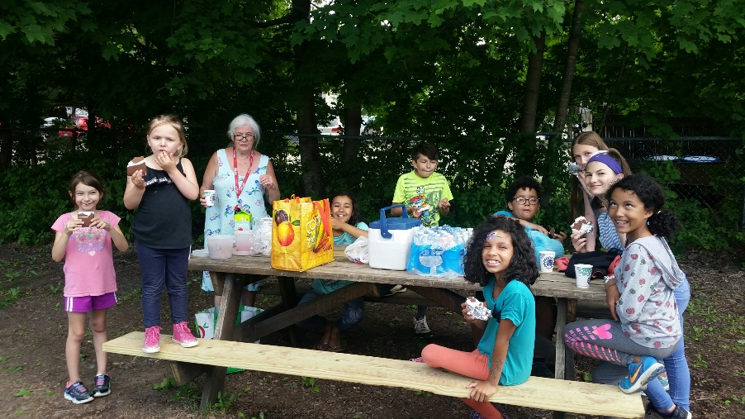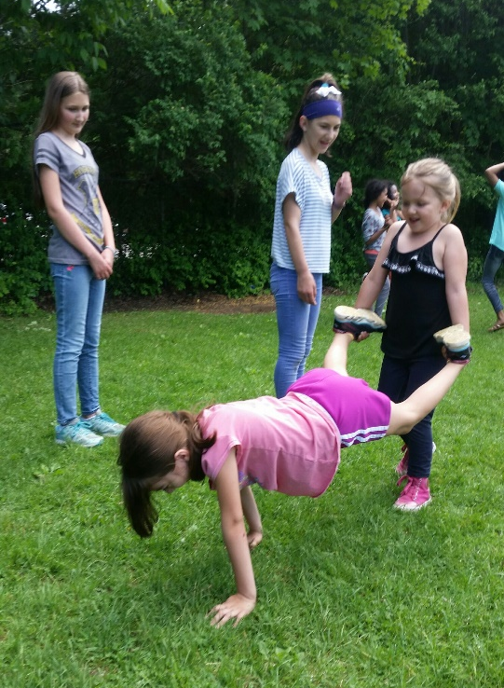

CHURCH WEBSITE

A new web site is coming soon! This website should be easier to navigate, and it can be viewed on a smart phone, tablet, or computer. Our current site will remain up and running until the new one is launched.
One of the things I’m working on is the church history, especially our past pastors, including both full time and interim pastors. I’ll also need their dates of service. If anyone has photos of any past pastors, I would appreciate being able to copy them.
Thank you
Russ Taxter rtaxter@gmail.com

RADA CUTLERY
Knives, spatulas, servers, ladles, cookbooks, and more!
Need a catalog? See Judy Koch.
Judy also has paring knives for $4.75!
This is a fundraiser for the kitchen renovation!

CALENDAR of EVENTS for JULY
Prayer Group/Book Study: Tuesday, July 10 at Lois’s
Celebrate Recovery Step Study: Wednesday, July 11
Church Picnic: Friday, July 13 at the Taxter’s
Rev. Steve Jewett will be preaching: Sunday, July 22
Prayer Group/Book Study: Tuesday, July 24 at Lois’s
Celebrate Recovery Step Study: Wednesday, July 25

OUR CHURCH IS PRIVILEGED TO BE ABLE TO OFFER OUR
FACILITY TO THE FOLLOWING AA GROUPS EACH WEEK.
Equinox Group: Mon-Fri from Noon to 1:00 PM
Thursday Morning Men’s Group: Thursday 7:30-8:30 AM
Primary Purpose Group: Sunday 7:30-8:30 PM

IMPORTANT CONTACT INFORMATION
Church Office Hours 9:30-12:30 AM on Tuesdays and Wednesdays
Pastor Rebecca’s e-mail address: rebeccasommons@gmail.com
Pastor Rebecca’s cell phone: (802) 688-3024
Church office Phone: (802) 362-1555
Parsonage Phone: (802) 362-5335
Please call to request a meeting or visit outside of regular church office hours.

FLOWERS CHILD CARE PROVIDERS
July 1: Lois Squires July 1: Barb & Linell
Bruce Fielding July 8: Lisa & Annabelle
July 8: Martha Bowen July 15: Jenny Cheryl
July 15: Russ & Glenna Taxter July 22: Dottie & Bryan
July 22: Jackie Perry July 29: Maurie & Kristen
July 29: Lois Squires

