Maths Book 2 LEARNING OBJECTIVES
Learning Outcome | Tier | R | Y | G

Topic 1: Fractions ( Core)
LO1: To be able to add and subtract fractions by writing them with a common denominator | F | R | Y | G
LO2: To be able to calculate a fraction of an amount | F | R | Y | G

Topic 2: 2D Shape (Core)
LO1: To be able to identify and state using mathematical notation horizontal, vertical, parallel and perpendicular lines | F | R | Y | G
LO2: To be able to describe quadrilaterals using their properties | F | R | Y | G
LO3: To be able to identify any congruent shapes and prove for simple shapes | F | R | Y | G

Topic 3: Circles (Core)
LO1: To be able to name parts of a circle | F | R | Y | G
LO2: To be able to know and use the formula for the circumference of a circle | F/F+ | R | Y | G
LO3: To know and be able to use the formula for the area of a circle | F | R | Y | G

Topic 4: Scatter Graphs
LO1: To be able to construct and interpret scatter graphs | F | R | Y | G

Topic 5: Graphing ( Core)
LO1: To be able to plot conversion graphs in various contexts | F | R | Y | G
LO2: To be able to plot and interpret graphs of real life situations | F | R | Y | G

Topic 6: Calculations ( Core)
LO1: To be able to use BIDMAS to solve calculations with squares and 3 operations | F | R | Y | G
LO2: To be able to use BIDMAS involving adding and subtracting negatives | F | R | Y | G
LO3: To be able to understand the effect of multiplying or dividing by a number between  0 & 1 | F | R | Y | G

Topic 7: Percentages
LO1: To be able to express a quantity as a percentage of an amount | F | R | Y | G
LO2: To be able to calculate % increase/decrease without a calculator | F | R | Y | G
LO3: To be able to calculate % increase/decrease using a multiplier | F | R | Y | G

Topic 8: Angles (Core)
LO1: To be able to calculate angles in parallel lines | F | R | Y | G
LO2: To be able to calculate internal and external angles of regular polygons | F | R | Y | G

Topic 9: Probability (Core)
LO1: To be able to construct and use sample space diagrams | F | R | Y | G
LO2: To be able to construct and use Venn diagrams | F | R | Y | G
LO3: To be able to construct and use frequency tables | F | R | Y | G

F - Foundation
F+ - Additional foundation
H - Higher

STAGE D WORKSHEETS
Stage D – Topic 1 - Fractions
LO1: To be able to add and subtract fractions by writing them with a common denominator
1 | Leave answers as mixed numbers where appropriate, cancel down where possible
 | 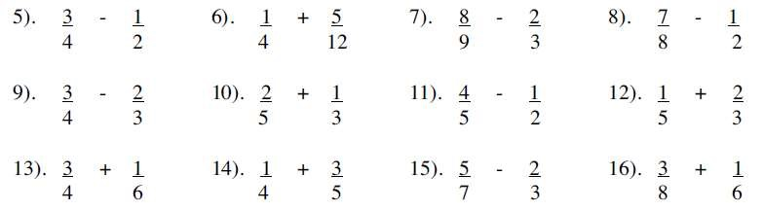
2 | 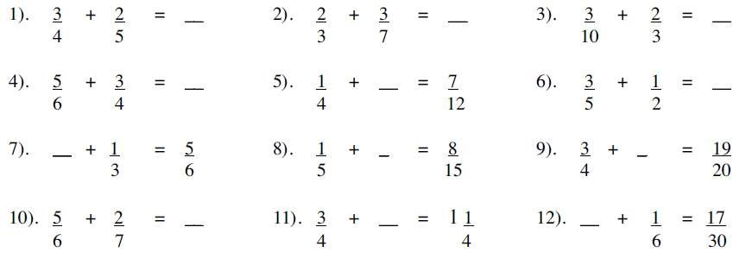
3 | Work out the following giving your answer as a fraction in its simplist form
4
5
6

LO2: To be able to calculate a fraction of an amount
1 | Find
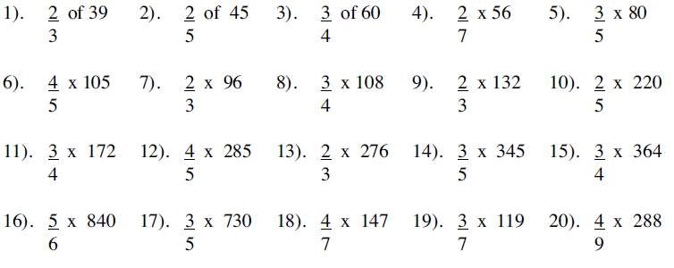
2
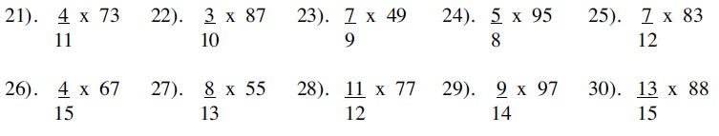

Stage D – Topic 2 – 2D shapes
LO1: To be able to identify and state using mathematical notation horizontal, vertical, parallel and perpendicular lines
1 | On each shape, state using mathematical notation horizontal, vertical, parallel and perpendicular lines
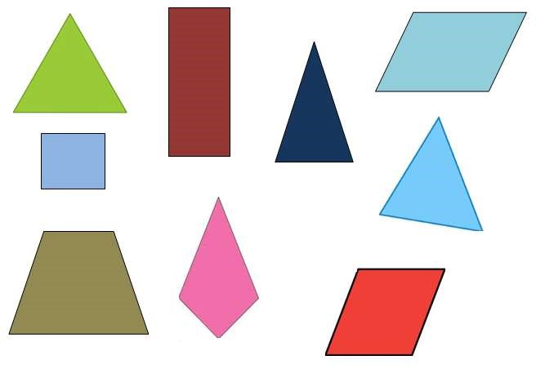

LO2: To be able to describe quadrilaterals using their properties
1 | Complete the table below, identifying the properties of different quadrilaterals  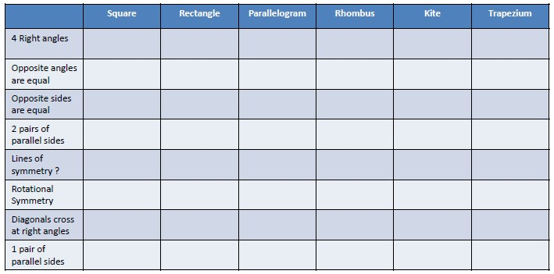  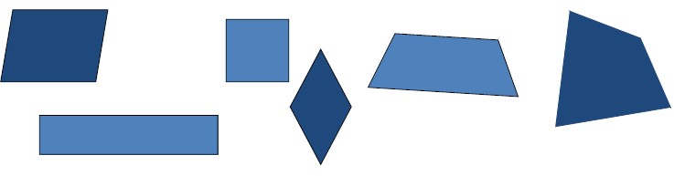
LO3 To be able to identify any congruent shapes and prove for simple shapes
1 | Identify the triangles that are congruent
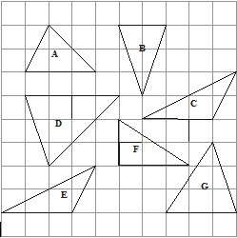

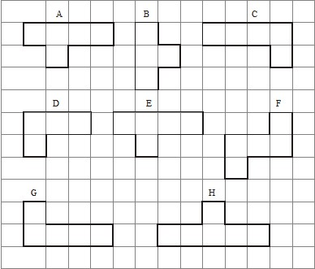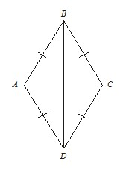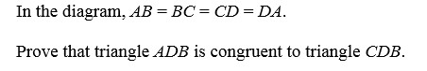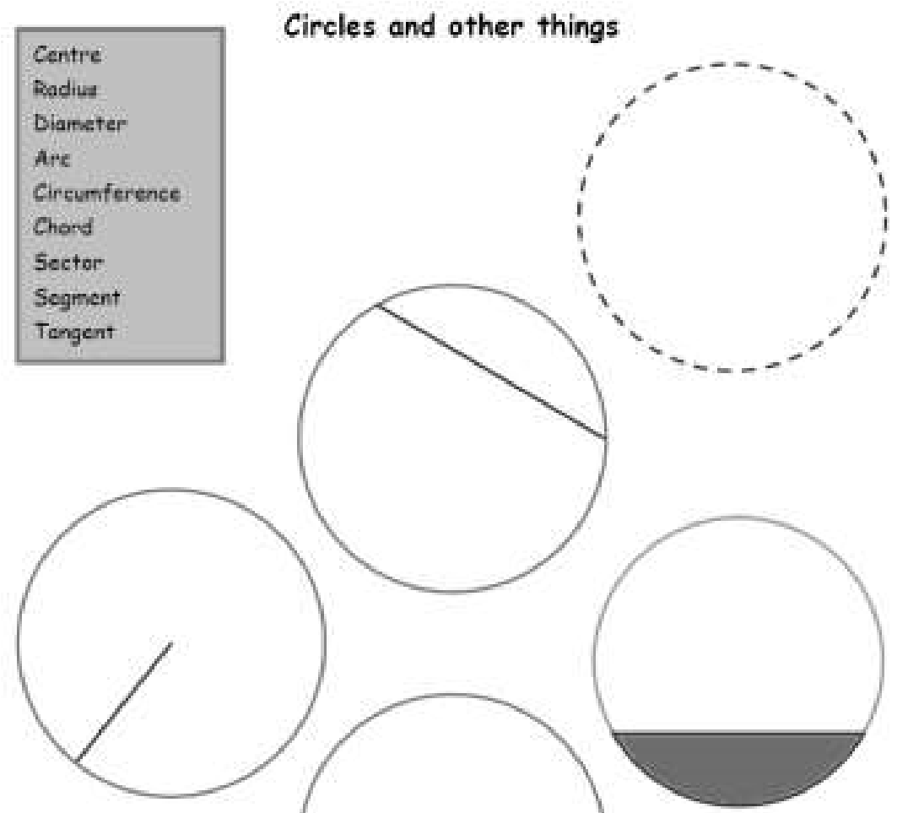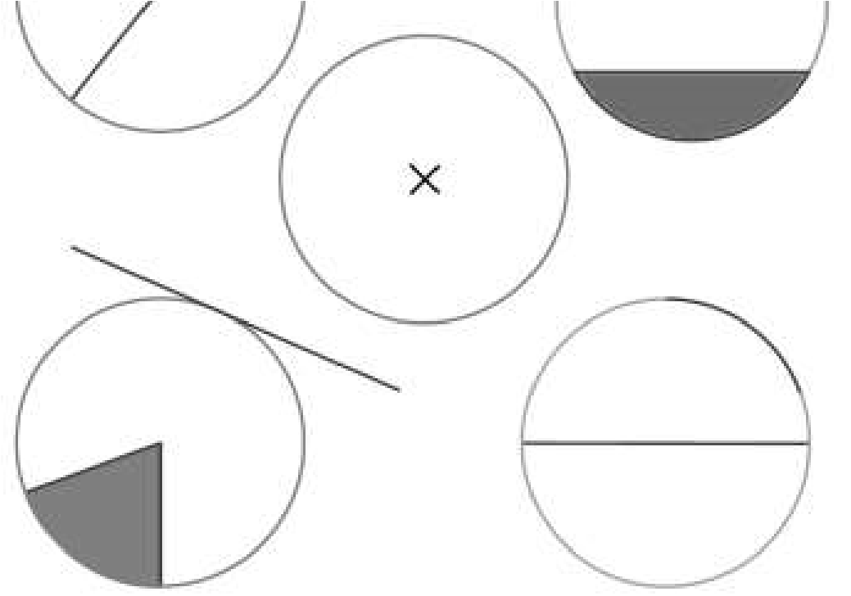
2

Identify the shapes that are congruent

3

age D
St
–

Topic 3
-

Circles

1:
LO
To be able to name parts of a circle

1

From the list in the grey box, label the parts of the circle

LO2: To be able to know and use the formula for the circumference of a circle
1 | 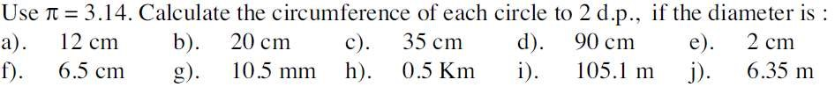
2 | 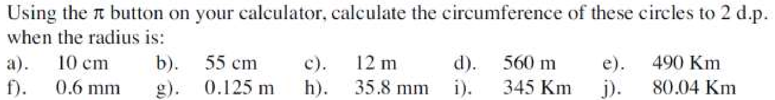
3 | 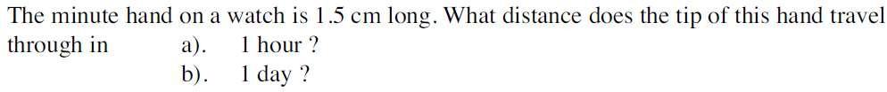
4
5 | 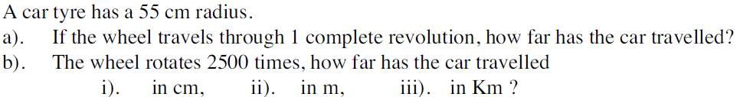
6
 | a | 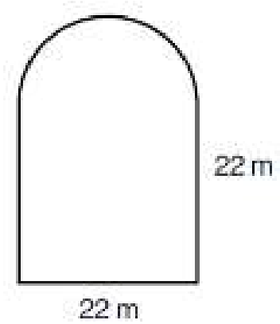 | b | 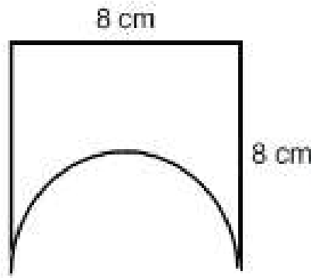 | c | 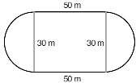 | d | 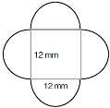
7

LO3: To know and be able to use the formula for the area of a circle
1 | 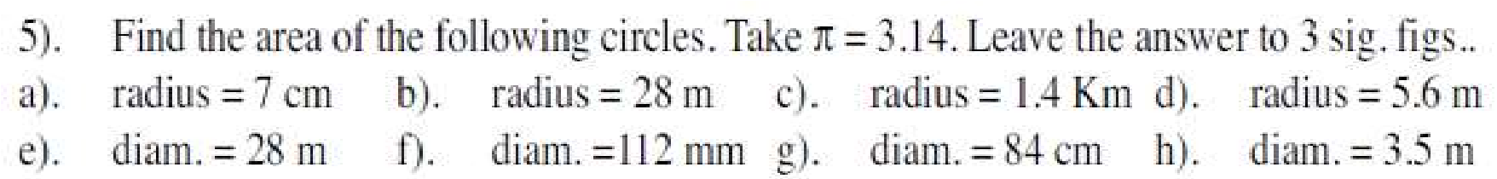
2
3 | 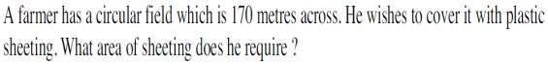
4
5
6 | 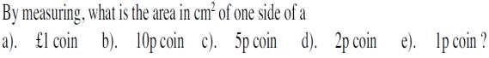
7 | a | 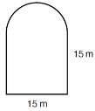 | b | 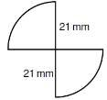 |  |  | c | 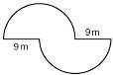 |  | d | 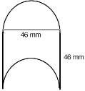
8 | 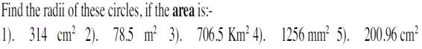
Mixed Problems
1 | 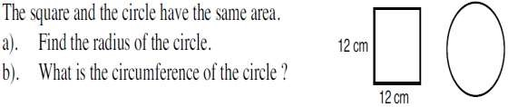
2 | 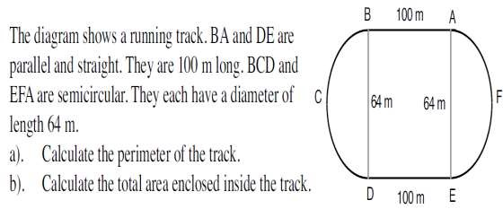
3 | 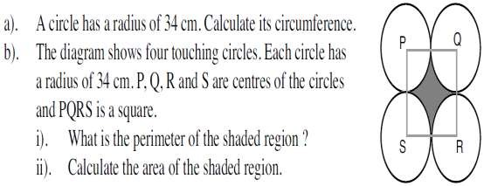
 | a | 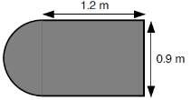 |  |  | b | 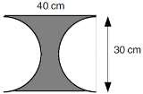 |  |  | c | 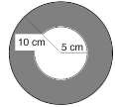

Stage D – Topic 1 - Scatter graphs
LO1: To be able to construct and interpret scatter graphs
1 | 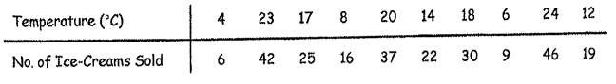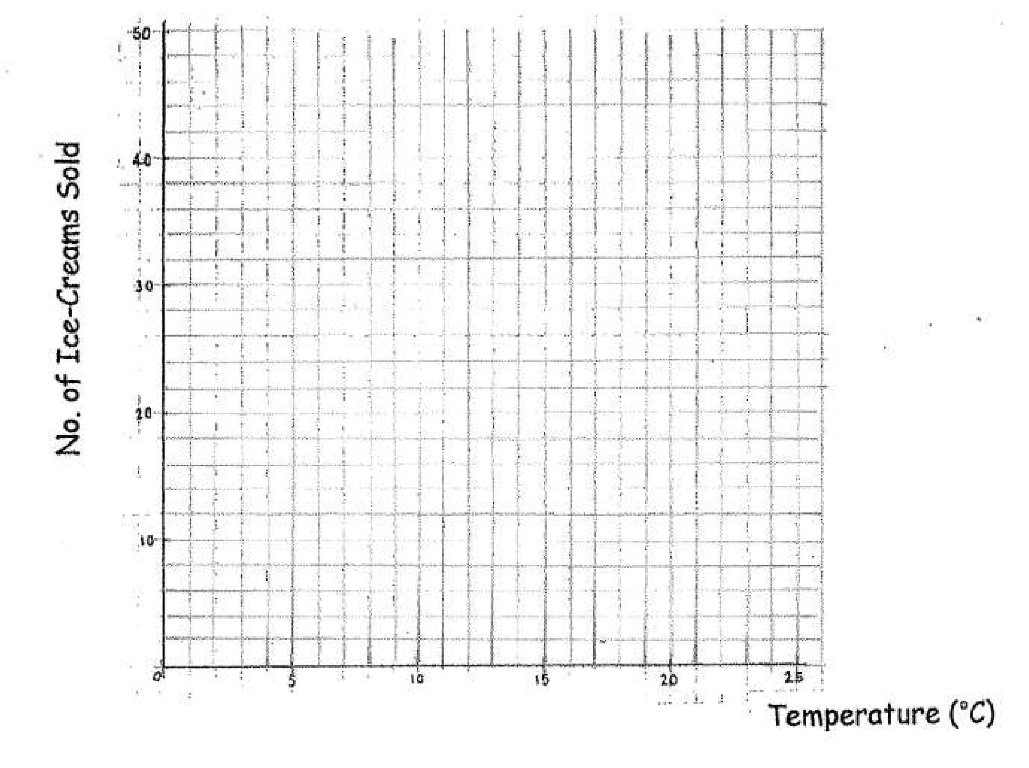

 | 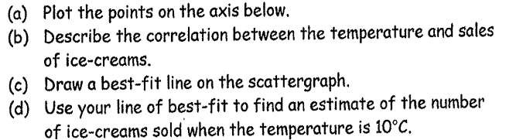
2 | 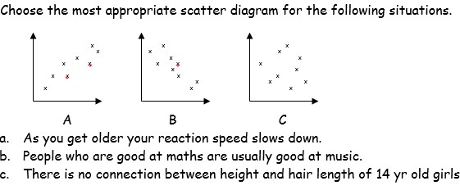
3 | 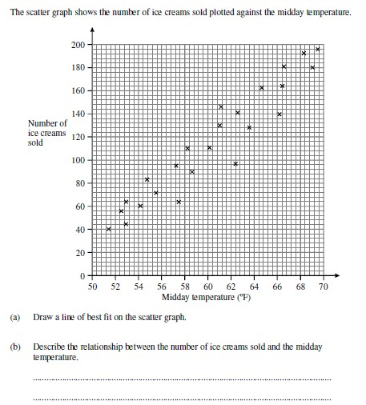
4 | 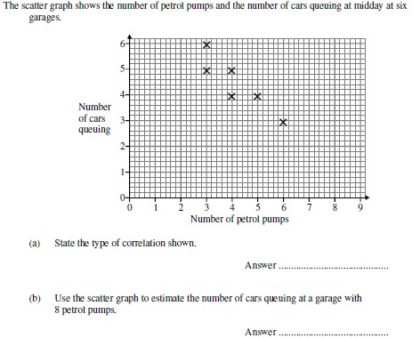

Stage D – Topic 5 - Graphing
LO1: To be able to plot conversion graphs in various contexts
1 | The conversion graph shows conversions between British Pounds and Japanese Yen.  British Pounds to Japanese Yen  0  200  400  600  800  1000  1200  1400  0  1  2  3  4  5  6  7  8  9  10  Pounds  Yen  - Convert £2 into Yen  - Convert 1200 Yen into pounds.  - Mimi buys an MP3 player in the UK for £50 and a memory stick for £10. She notices the same items in Japan for 6500 Yen and 1600 Yen respectively. Mimi believes the total cost in the UK is more than the total cost in Japan. Is she right? You must explain your answer.
2 | The following conversion graph shows conversions between feet and yards. Use it to answer the following questions  Yards to feet conversion graph  0  5  10  15  20  25  30  0  1  2  3  4  5  6  7  8  yards  feet

- How many feet are there in 5 yards?
- 24 feet is the same as how many yards?
- 10 yards is the same as how many feet?
- David measures his living room to be 20 feet long. Esra measures her living room to be 7 yards long. David says his living room is longer. Explain why he is wrong.
LO2: To be able to plot and interpret graphs of real life situations
1 | Here are the side cross sections of five swimming pools
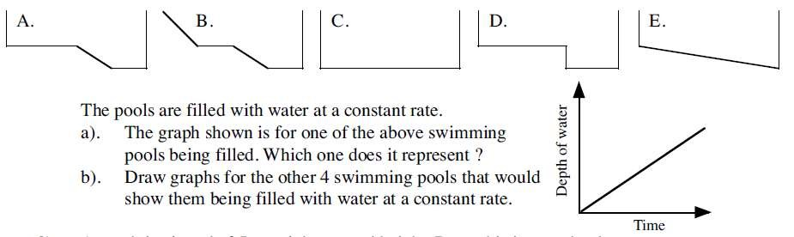
2 | Water is poured at a constant rate into each one of the following beakers
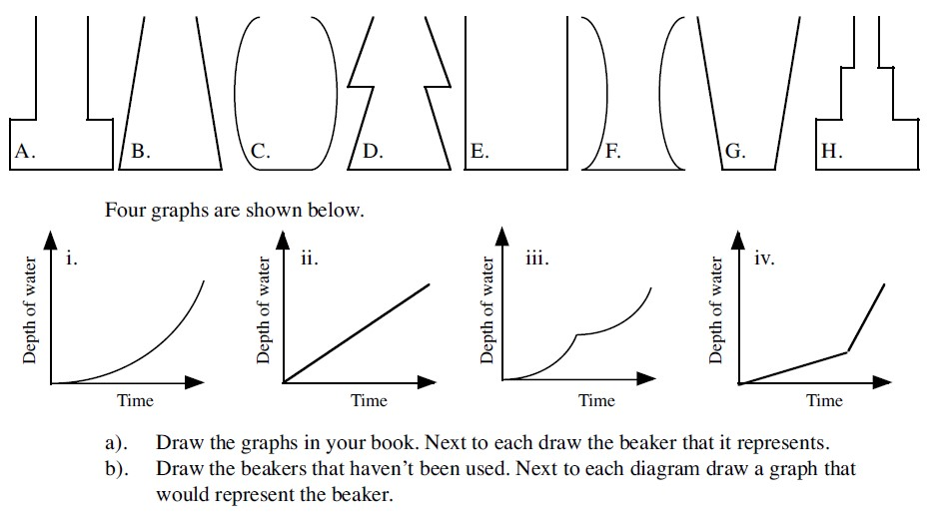
3 | Sarah travelled 20 km from home to her friend’s house. She stayed at her friend’s house for some time before returning home. Here is the travel graph for part of Sarah’s journey.
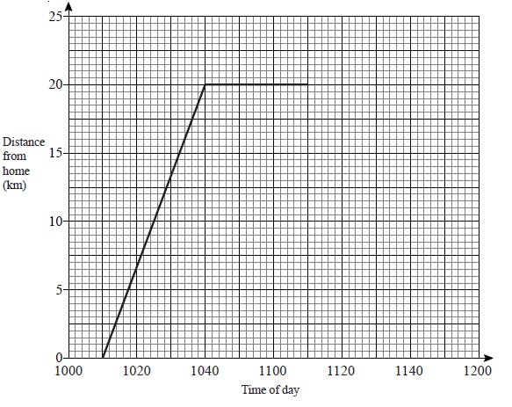

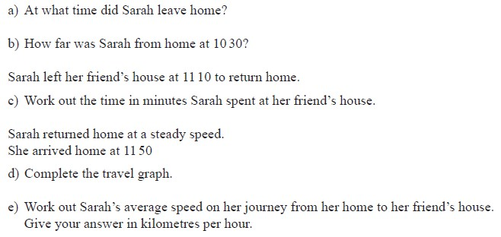

Stage D – Topic 6 - Calculations
LO1: To be able to use BIDMAS to solve calculations with squares and 3 operations
1
 | 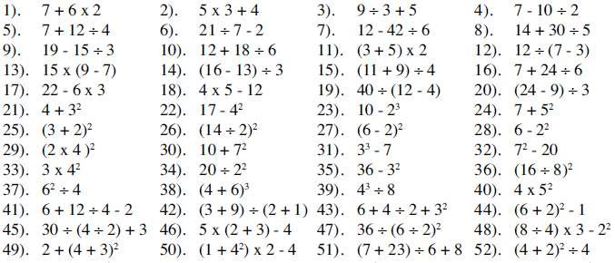
L | O2: To be able to use BIDMAS involving adding and subtracting negatives
1 | a)  b)  c)  d)
L | O3: To be able to understand the effect of multiplying or dividing by a number between 0 & 1
1 | Circle the calculations which will have an answer of less than 50  50 x 0.3 50 ÷ 0.7 50 x 0.9 50 ÷ 28 50 ÷ 1.6  50 x 0.04 50 x 1.5 50 ÷ 2.5 50 x 5.333 50 ÷ 0.0001
2 | Tick the calculation from each row which has an answer less than 1.04 A a) 1.04 ÷ 0.58 b) 1.04 x 2.6 c) 1.04 x 0.99  - a) 1.04 x 0.88 b) 1.04 ÷ 0.5 c) 1.04 x 3.4  - a) 1.04 x 1.22 b) 1.04 ÷ 2.6 c) 1.04 x 2
3 | Which of these will have an answer greater than 1.83? Explain.  a) 1.83 ÷ 2.7 b) 1.83 x 0.27 c) 1.83 x 2.7  d) 1.83 ÷ 0.27 e) 1.83 ÷ f) 1.83 x
4 | Decide which of these statements could be correct (₉) and which are definitely wrong (X).  Justify your decision, but do not calculate the answers  a) 5.02 x 0.3 = 15.06 b) 2.75 ÷ 0.02 = 1.375 c) 6.24 x 1.2 = 7.488  d) 8.127 ÷ 1.4 = 58.05 e) 2.75 x 0.86 = 2.365 f) 2.75 ÷ 0.8 = 3.4375

Stage D – Topic 7 - Percentages
LO1: To be able to express a quantity as a percentage of an amount
1 | Calculate
 | 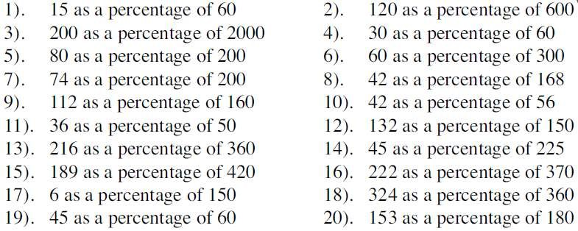
2
3
4
L | O2: To be able to calculate % increase/decrease without a calculator
1  2  3  4 | 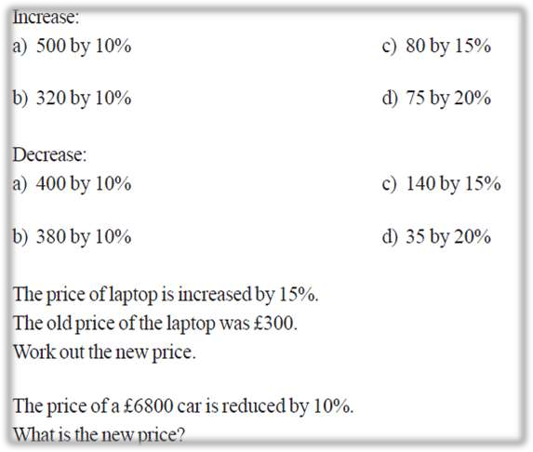
LO3: To be able to calculate % increase/decrease using a multiplier
1 | 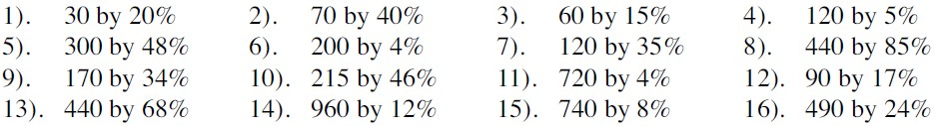
2 | 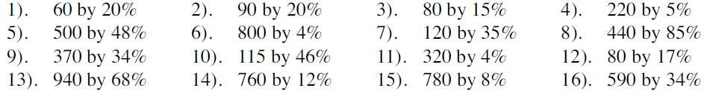
3 | 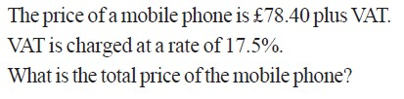
4 | 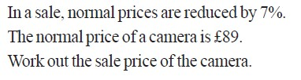
5

Stage D – Topic - Angles
LO1: To be able to calculate angles in parallel lines
1 Calculate the value of the unknown angle, giving a reason for your answer.
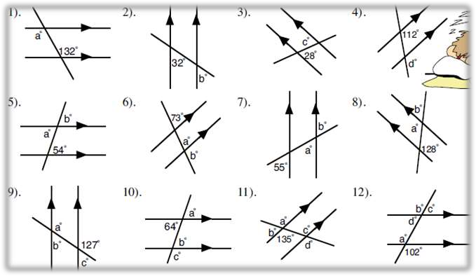
2 | Calculate the value of these supplementary angles
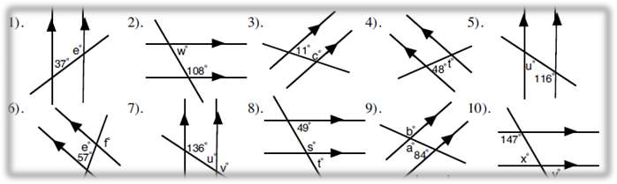
3 | Calcuate the value of the missing angles, giving reasons for answers
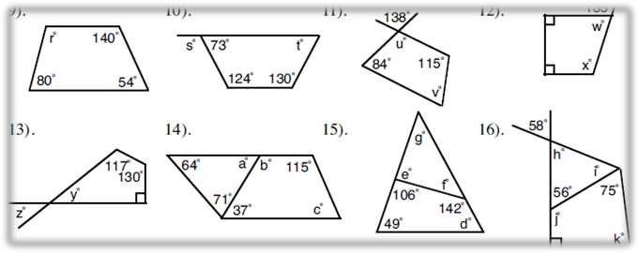
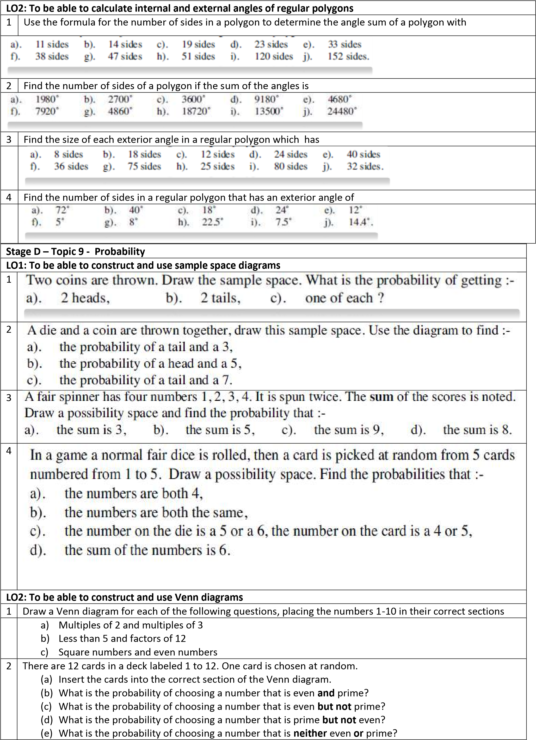
- What is the probability of choosing a number that is even or prime?
- What is the probability of choosing a number that is even or prime but not both?
LO3: To be able to construct and use frequency tables
1 | 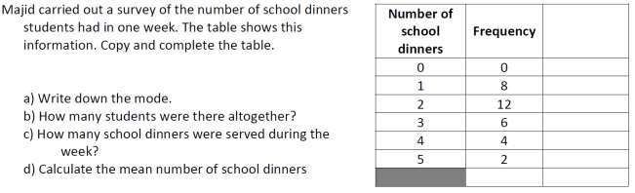
2 | 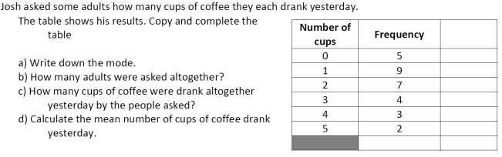
3 | 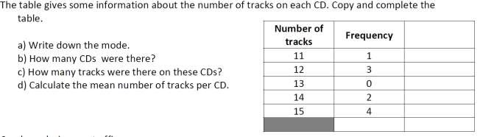

Stage D – Topic 10 - Transformations
LO1: To be able to transform shapes using symmetry and rotations
1 Draw the lines of symmetry on each shape
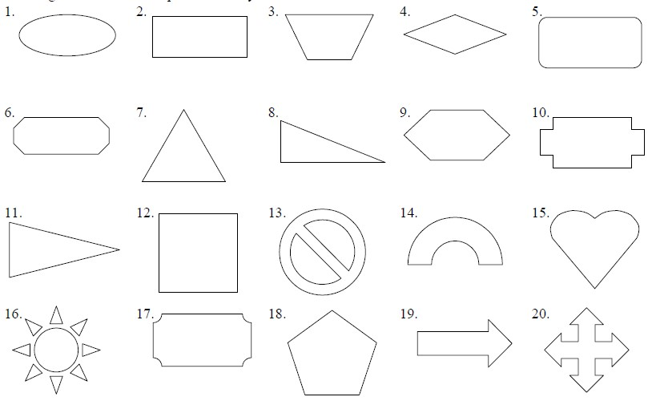
2 | State the order of rotational symmetry for each shape
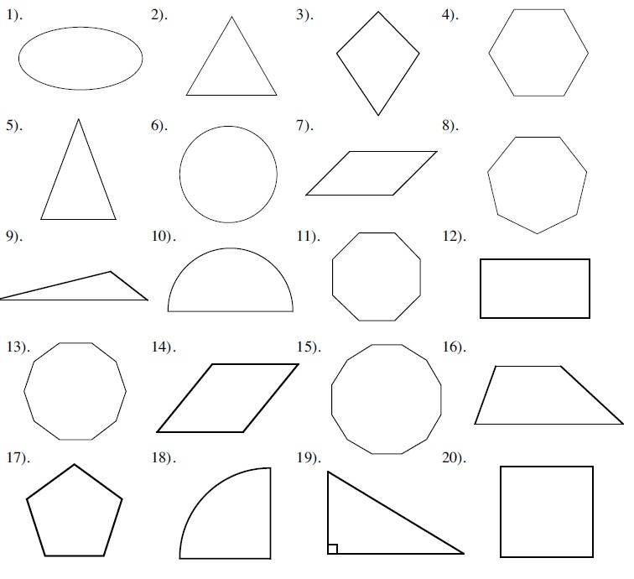
3 | Rotate the shapes about the given centre of rotation
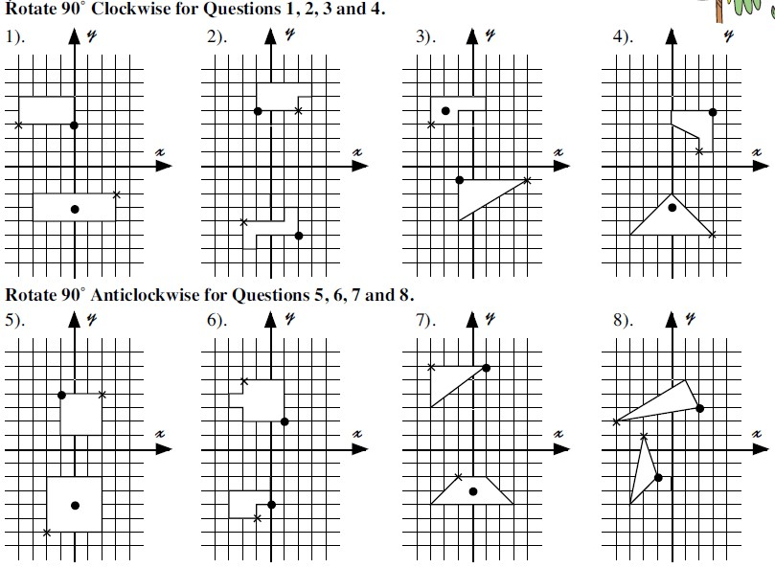

STAGE D ANSWERS
Stage D – Topic 1 - Fractions Answers
LO1: To be able to add and subtract fractions by writing them with a common denominator
1 | 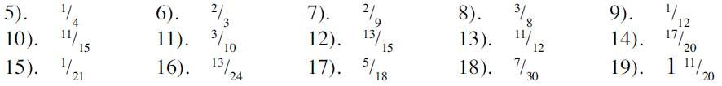
2 | 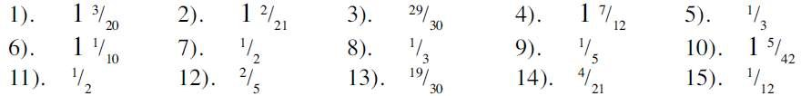
3 | 1) 7 2) 3 3) 4) 4
4 | 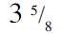
5 | 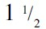
6 | 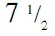
LO2: To be able to calculate a fraction of an amount
1
2

Stage D – Topic 2 – 2D shapes Answers
LO1: To be able to identify and state using mathematical notation horizontal, vertical, parallel and perpendicular lines
1
LO2: To be able to describe quadrilaterals using their properties
1
LO3 To be able to identify any congruent shapes and prove for simple shapes
1 | C and E
2 | A AND E, C AND G
3 | AD = CD equal sides  AB = CB equal sides  BD is common  ADB is congruent to CDB (SSS)

Stage D – Topic 3 - Circles Answers
LO1: To be able to name parts of a circle
1 | From the list in the grey box, label the parts of the circle

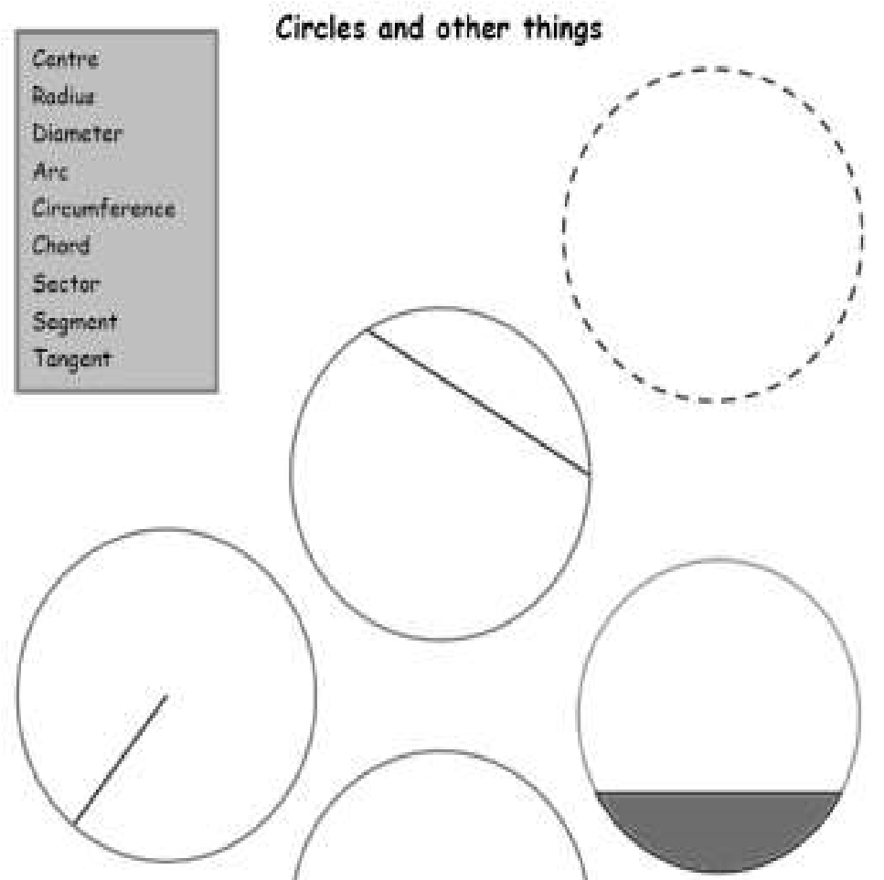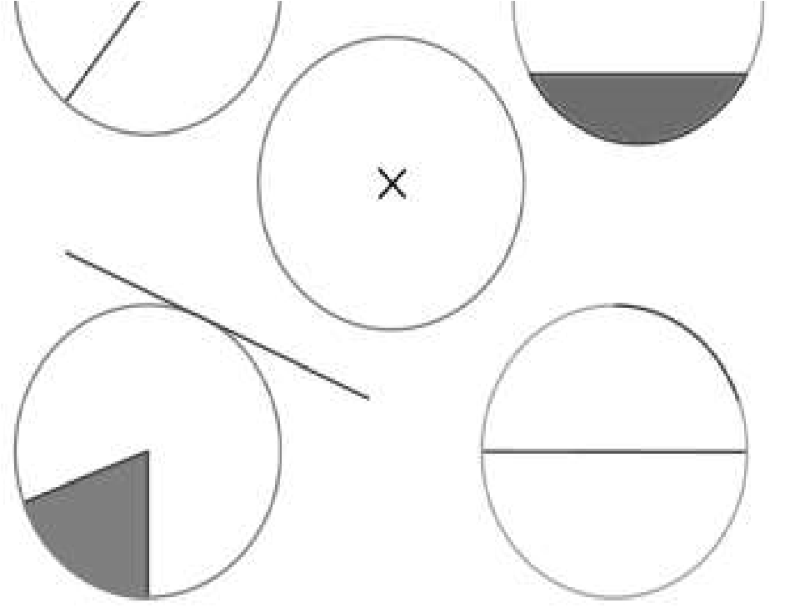

LO2: To be able to know and use the formula for the circumference of a circle
1
Ans

2 | 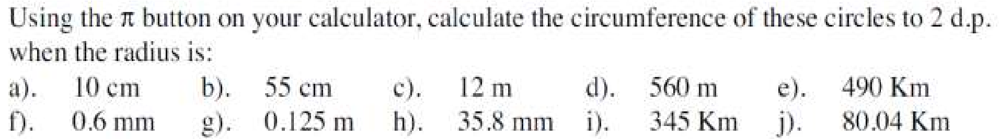
Ans | 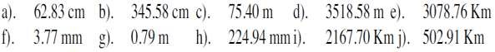
3
Ans

4
Ans | 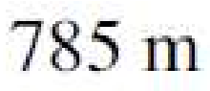
5
Ans

6
7 | a | 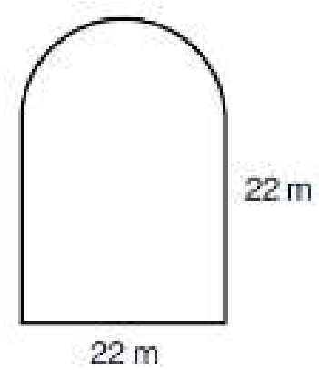 | b | 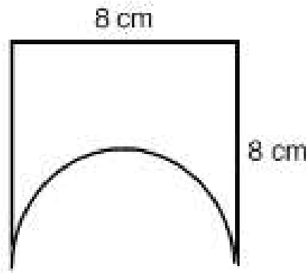 | c |  | d
Ans

8
Ans

Stage D – Topic 4 – Scatter graph Answers
LO1: To be able to construct and interpret scatter graphs
1 | a) | Points plotted correctly
 | b) | Positive correlation
 | c)  d) | Line drawn evenly through points, ignoring outliers
2 | A) | People who are good at maths are usually good at music
 | B) | As you get older your reaction speed slows down
 | C) | There is no connection between height and hair length of 14 yr old girls
3 | a) | Line drawn evenly through points, ignoring outliers
 | b) | As the midday temperature increases so do the number of ice creams sold
4 | a) | Negative correlation
 | b) | 1, note that in order to gain full marks a line of best fit and guidance lines must be present on scatter graph

Stage D – Topic 5 - Graphing Answers
LO1: To be able to plot conversion graphs in various contexts
1 | a) | 280 Yen
 | b) | £9.20
 | c) | £10 = 1300 Yen  Total cost in the UK £60 = 7800 Yen  Total cost in Japan = 8100 Yen  Mimi is not correct. The cost in Japan is greater than the cost in the UK
2 | a) | 15 feet
 | b) | 8 yards
 | c) | 30 feet
 | d) | 20 feet = 6 2/3 yard  David is not correct. Esra’s living room is longer.
LO2: To be able to plot and interpret graphs of real life situations
1 | a) c
2 | a) i = B  - = E  - = D  iiii = A
3 | - 10:10  - 13.5 km  - 30 minutes  - Straight line drawn to 11:50 on x axis  - 40 kph

Stage D – Topic 6 - Calculations Answers
LO1: To be able to use BIDMAS to solve calculations with squares and 3 operations
1 | 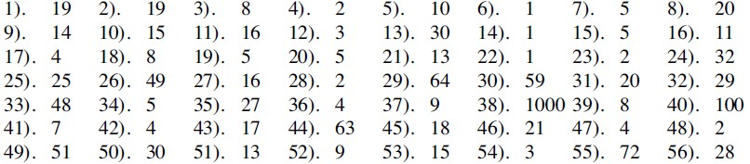
LO1: To be able to use BIDMAS involving adding and subtracting negatives
1 | - -17  - 73  - 33  - -11

Stage D – Topic 7 - Percentages Answers
LO1: To be able to express a quantity as a percentage of an amount
1
2 | 20%
3 | 12.5%
4 | 62.5%
LO2: To be able to calculate % increase/decrease without a calculator
1 | a) 550 b) 352 c) 92 d) 90
2 | a) 360 b) 342 c) 119 d) 28
3 | £345
4 | £6120
LO3: To be able to calculate % increase/decrease using a multiplier
1
2
3 | £92.12
4 | £82.77
5 | £637.2

Stage D – Topic 8 - Angle Answers
LO1: To be able to calculate angles in parallel lines
1 | 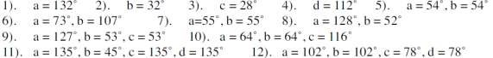
2 | 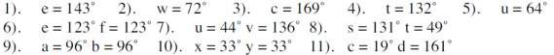
3 | 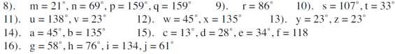
LO2: To be able to calculate internal and external angles of regular polygons
1
2
3
4

Stage D – Topic 9 - Probability Answers
LO1: To be able to construct and use sample space diagrams
1 | a) | ¼ b) ¼ c) ½
2 | a) | 1/12 b) 1/12 c) 0
3 | a) | 1/8 b) ¼ c) 0 d) 1/16
4 | a) | 1/30 b) 1/6 c) 2/15 d) 1/6
LO2: To be |  | able to construct and use Venn diagrams
1 | - 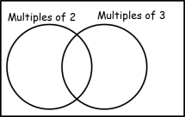  - 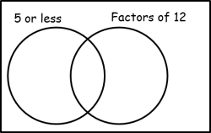  - 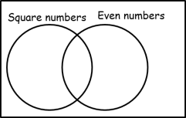
2 | a)  - 1/12  - 5/12  - 1/3  - 1/6  - 5/6  - 3/4
LO3: To be |  | able to construct and use frequency tables
1 | a) | 2 b) 32 c) 2.375
2 | a) | 1 b) 30 c) 1.9
3 | a) | 15 b) 10 c) 135 d) 13.5

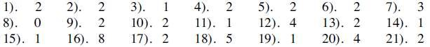
Stage D

–

Topic 10
-

T
ransformations

Answers

LO1: To be able to
transform shapes using symmetry and rotations

