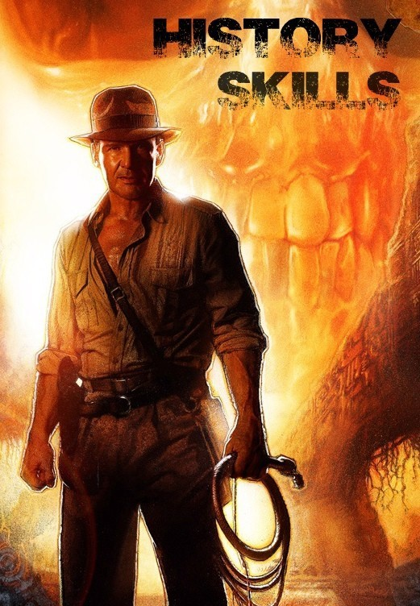
Name:

Key Words
There are many key words in History!! In the word search below are some of the ore common words. Try to find them, then see which words you can define (you can us a dictionary or the internet to help you).
H | A | P | P | E | N | C | W | V | C | S | M | Q
B | I | Y | I | J | Y | R | O | T | S | I | H | W
Y | M | S | Y | K | O | V | Q | D | T | D | N | D
E | N | E | T | I | M | E | L | I | N | E | B | A
A | B | F | U | O | L | W | C | E | G | F | V | T
R | X | Y | N | R | R | E | M | Y | O | R | C | E
T | Z | T | W | E | K | I | N | P | L | A | C | E
Y | H | H | Q | T | U | Y | A | H | L | U | V | Y
U | Y | X | E | Y | J | S | G | N | K | E | G | U
I | T | C | L | K | T | U | O | J | N | I | F | H
O | R | V | P | M | H | I | B | T | Y | O | E | N
C | H | R | O | N | O | L | O | G | Y | P | W | B
Q | E | U | E | V | D | O | E | O | H | O | S | F
W | D | I | P | C | S | P | W | P | B | M | A | W
HISTORIAN ________________________________________________________ PAST______________________________________________________________
TIMELINE__________________________________________________________ EVENT_____________________________________________________________ YEAR______________________________________________________________
DATE______________________________________________________________
MONTH____________________________________________________________
AGO_______________________________________________________________
CHRONOLOGY_______________________________________________________
HISTORY___________________________________________________________
PLACE______________________________________________________________
HAPPEN____________________________________________________________

How is time divided up?
Put the following words in order, from the shortest to the longest.
Century
Hour
Second
Decade
Year
Week
Month
Millennium
Day
Minute

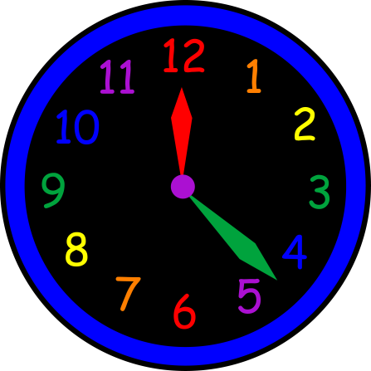
Draw a line to match the words below to their definition:
Decade |  | 100 years
Century |  | 1000 years
Week |  | 10 Years
Millennium |  | 365 days
Year |  | 7 Days
Why do you think that knowing this is important for history?
__________________________________________________________

What are BC, BCE, AD and CE?
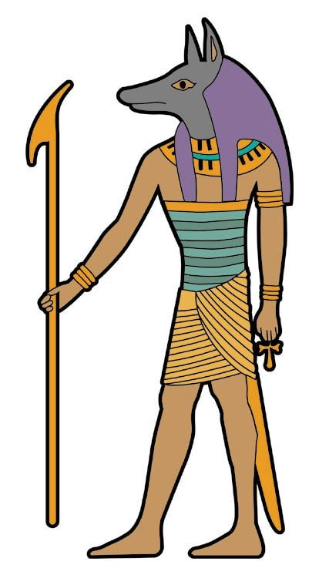
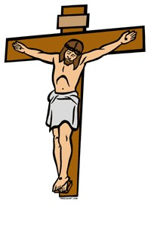
Historians often talk about years as being BC or BCE and AD or CE. This is another way of dividing time. It makes it easier when talking about large areas of time.
BC or BCE

AD and CE

2016

1000

500

100

100

500

1000

1500

BC and BCE
AD years move forward in time, starting at 0 and moving forward until today.
BC years move backwards in time starting from 0.
BC means Before Christ and refers to the time BEFORE
Jesus was alive. Many historians now us BCE that means
Before Common Era as not everyone believe in Jesus. The Common Era is the years 0—2016 so BEFORE common era is earlier than the year 0.

AD and CE
Year 0
AD stands for Ado Domini and refers to the time after Christ. CE means common era which is any time from the year 0.
What are BC, BCE, AD and CE?
Using the information from the previous page, add in the missing words.
BC and BCE
BC means B______ C______ and refers to the time BEFORE J______ was alive. Many historians now us BCE that means B______ C________ E_____ as not everyone believe in Jesus. The Common Era is the y_______ 0—2016 so BEFORE common era is earlier than the year 0.

AD and CE
AD stands for A____ D______ and refers to the time after C______. CE means common era which is any t_____ from the year 0.
2008 AD  54 BC  33 AD  2008 BC  1008 AD  10,000 BC  0  410 BC  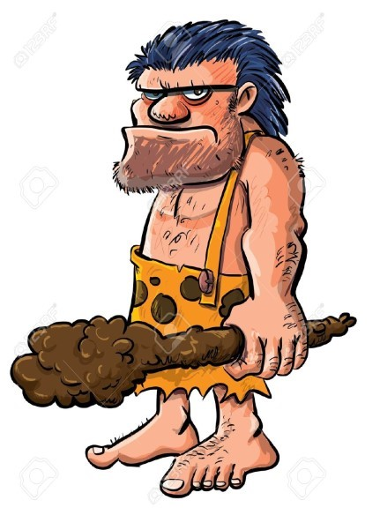  Put this list of year in the correct order—Starting with the EARLIEST and ending with the most recent. |  | 2000 CE  0  123 BCE  2010 BCE  2001 CE  22 BCE  72 CE  1599CE  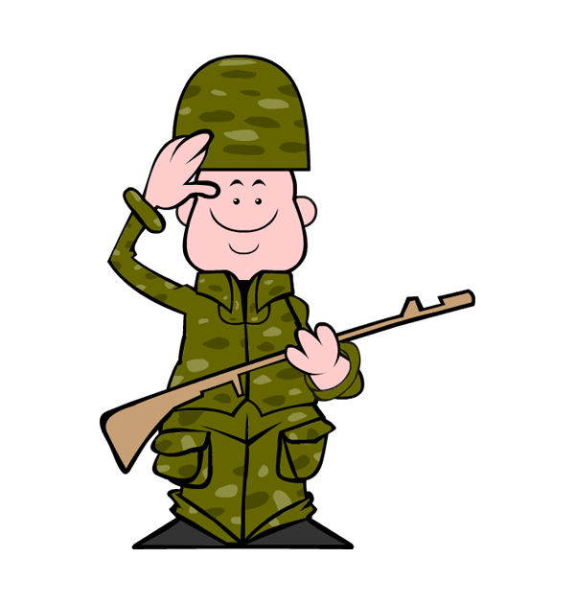  Put this list of year in the correct order—Starting with the MOST RECENT and ending with the earliest.

Using the grid below, rate how well you can use the skills we have covered so far:
 | Agree | Disagree | Not sure | Teacher agree?
I know the definitions of most of the history key words.
I know how time is divided up.
I know the difference between a year, a decade, a century and a millennium.
I know what BC and BCE are and know how to use them.
I know what AD and CE are and how to use them.
Give yourself 1 target based on what you think you need to improve:
Teacher comment:

Chronology
Chronology is a long word, which means putting dates, times and events in order. Look at the images below and put them into Chronological order by writing the letter below the picture into the boxes. (Clue: it spells a word!!)
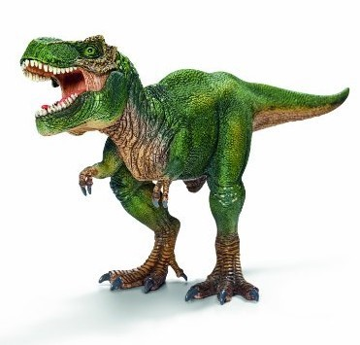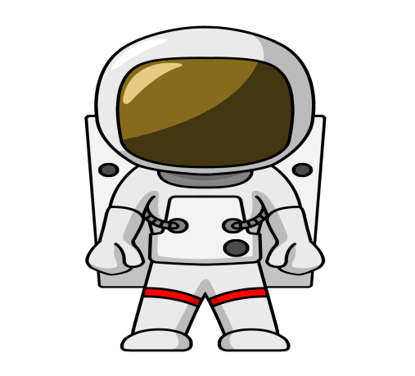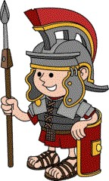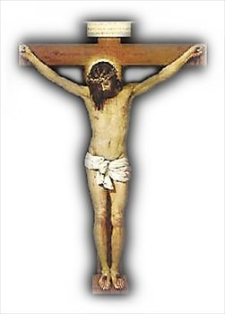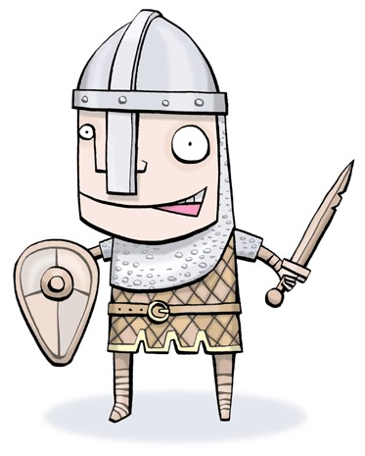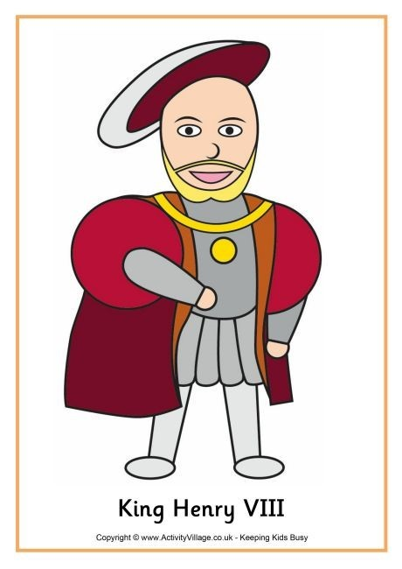
H

S

I

Y

R

T

H

H
How did you work out the correct order?
Why do you think it is important to put historical events in order?

Chronology
Cut out these pictures and glue them into chronological order:
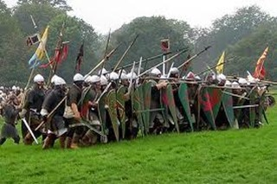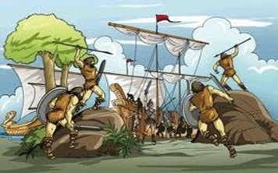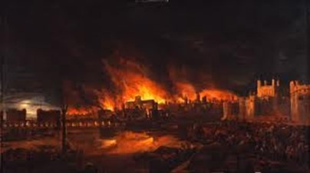
Battle of Hastings 1066 Romans invade Britain 43 AD Great Fire of London 1666
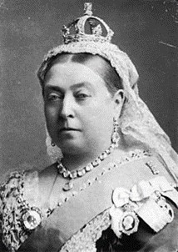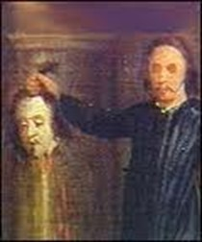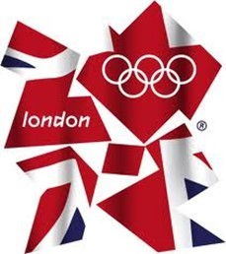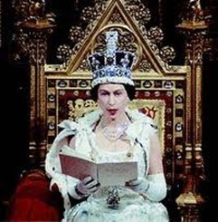
Queen Victoria King Charles was London hosts the Elizabeth II becomes is born 1819 executed 1649 Olympic Games 2012 Queen 1952
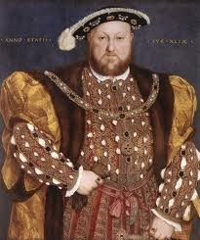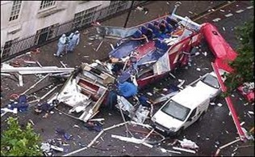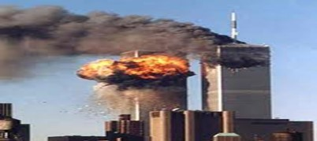
Terrorist Attacks in New York
Henry VIII be- London is bombed 2005 2001
comes king 1509
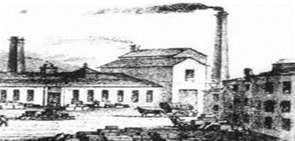
Industrial Revelation begins The English public votes to leave
in the 1750s the European Union 2016
Chronology
Stick you picture in chronological order on this page!!

Timelines
A time line is a way to put information in chronological order. It makes it very clear where event happen in time. Add the information to the following time line about Bob.
Bob was born in 2004 | His Sister, Brenda was born in 2010. | He started secondary school in 2015. | He went on holiday to Florida in 2013
He broke his leg in 2011. | His Nan died on 2009. | He went to his first football match in 2010. | He won his first football championship in 2016.

2004 2010 2016
Draw your own timeline with 8 events:

Colour the traffic light showing how well you think that you have worked so far this module:
Red = I have made some progress but my behaviour or lack of effort has stopped me from completing my best work.

Amber = I have made some good progress. My behaviour and attitude has generally been good but I could do better.

Green = I have worked really well so far this module and made good progress. All the work I have done I have done to the best of my ability and my behaviour has been good and I have learned a lot.

Why did you pick this level?

Evidence
As Historians we have to look at evidence, from this we have to try to deduce, or work out, information. Look at the evidence below and answer the questions about this person:
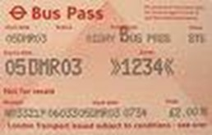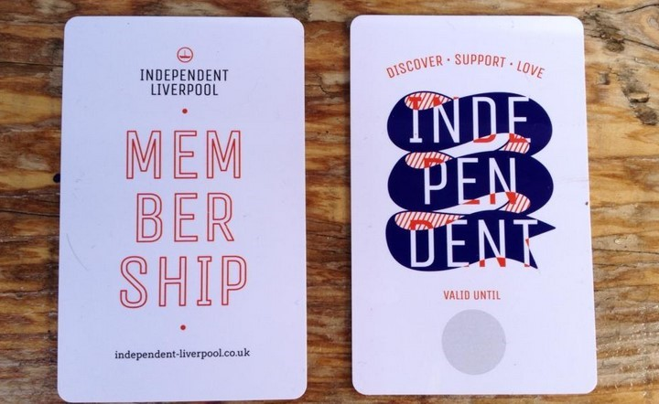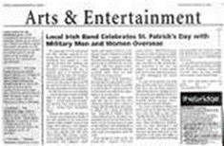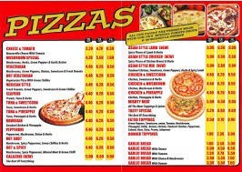

Is the per-
son
male or fe-
male?

___________________________________________________________
What mode of transport do they use?
___________________________________________________________
What is their diet like?
___________________________________________________________
Do they have any pets?
___________________________________________________________ What else can we assume?
___________________________________________________________

Types of Evidence
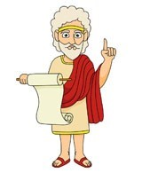
Historians are like detectives because they use
SOURCES and clues left by people of the past. Evi-
dence can be discovered in one of 3 different ways.

Written | Physical | Spoken
Label the following images with which of these three categories it fits in:
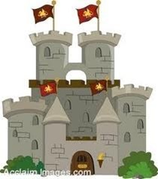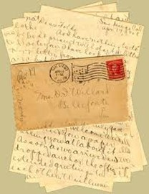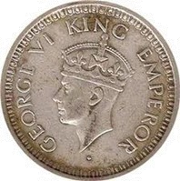
Historians use different terms for different types of evidence.
These are w _ _ _ _ _ _ evidence for things like
______________ , s _ _ _ _ _ evidence for things such as _______________ and p _ _ _ _ _ _ _ evidence for _____________.

Primary and Secondary Sources
In History we get our evidence from two different types of sources:
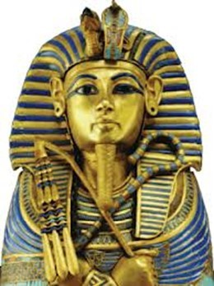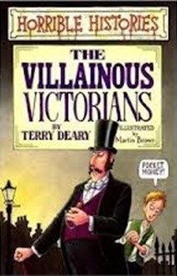

Once we
Primary

sources were made or written at
the time an event happened.

Secondary

sources are made after the
time or by someone who wasn
’
t there.

know the type of historical evidence we have, we need to decide if it was made at the time of the event and therefore is a _ _ _ _ _ _ _ source; or if it has been made later by people who weren’t at the event, making it a _ _ _ _ _ _ _ _ _ source.

Examples of Primary  Sources  - Diaries  - Newspapers  - Letters  - Photographs  - Buildings  - Museum displays  - Recordings | Historians use  Primary sources  to make Sec-  ondary sources! | Examples of Secondary Sources  - School text book  - TV programmes  - Films  - Plays  - Novels and stories  - History books  - The Internet

Primary and Secondary Sources
A diary written by Elizabeth I is _____________ evidence. We know this because____________________________________________________.
Fossilised bones of a saber-toothed cat
WW2 computer Game
An American poster dated from the 1880’s.
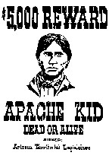
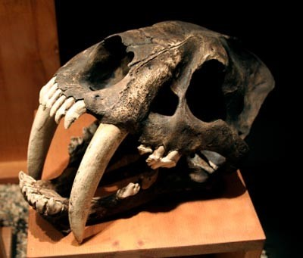
A film made by Elizabeth I is __________ evidence. We know this because____________________________________________________.
Anne Frank
’
s Diary

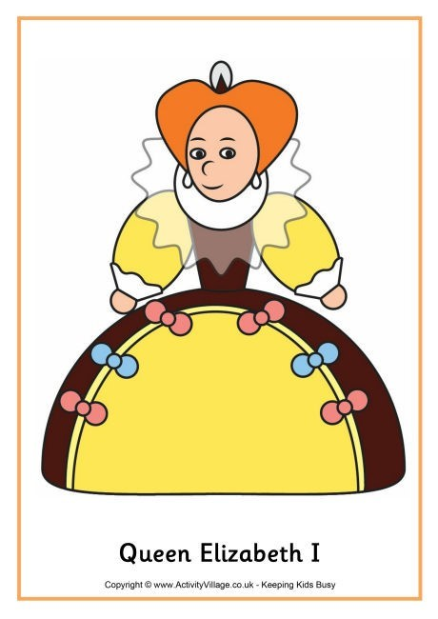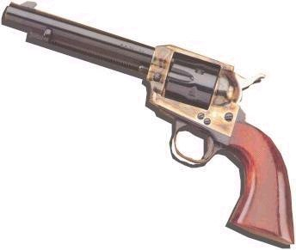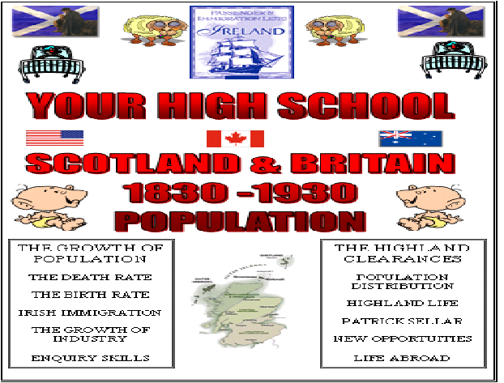
Sort the evidence below into Primary and
Secondary:

A Gun dated
from 1879

A History textbook

A ration book from WW2 | 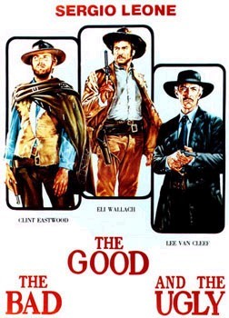 | A film about the  Wild  West | World War 2 veteran talking about his experiences in the war.

Categorising Historical Events
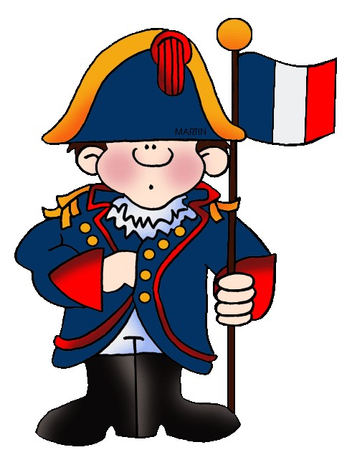
Historians study different types of events
through time. Historians group these events in-
to topics or themes. This makes it easier for
people who are interested in history to identify
historical changes and study the affect on peo-
ple in the past and through time.

Match the category to it’s definition.
Political  Economic  Social  Technology | How people earn money and spend their money.  To do with developments in technology and medicine  To do with war, power, government and rights.  People’s everyday life at work and at home.
Why do you think they are split into categories?
_________________________________________________________
_________________________________________________________
_________________________________________________________
Which do you think would be the most interesting category to study and why?
_________________________________________________________
_________________________________________________________
_________________________________________________________

Categorising Historical Events
Sort these events into the four categories. Put them in CHRONOLOGICAL order in you answer box!
 | 1918—Women are allowed to vote. | 1946—Child benefit was introduced in the UK.
 | 1947—National Health Service was set up. | 1872—First FA Cup final.
 | 1829 – first passenger steam train | 1908 – first pensions given to people over 70.
 | 1939 – second world war began. | 1801 – Britain and Ireland make one country.
 | 1981 – first home computer | 1839 – Charles Dickens wrote “Oliver  Twist”
 | 1970 – equal pay for men and women. | 1963 – First Beatles songs were recorded.
Political |  |  | Economic
Social |  |  | Technonolgy

Progress Page
You are going to read other people’s work and judge it. On this page SOMEONE ELSE is going to assess your work.
Circle if the person has included the following:
Person assessing:

Defined Primary and Used chronology Worked out information
Secondary Sources about someone by using
evidence.
You know the different You have categorised Put Historical event into categories used in sources as Primary and Sec- the four categories. history. ondary.
Give one thing that they have done well:
Give one thing that they could improve:

Assessment
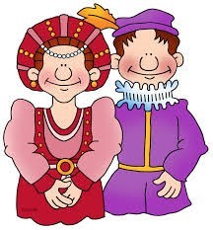
1. What does chronological order mean? (1)

2.What does BC mean? (1)

- What do we mean by AD (1)

- Julius Caesar first visited Britain in 55BC. He came back the following year was the year then? (1)

- How many years are in the following?(3)
- Millennium
- Decade
- Century
  - Put the following events in chronological order.(3)
Prince William and Kate get married (2011)
Queen Victoria dies (1901)
Queen Elizabeth II celebrates her silver jubilee (1977)

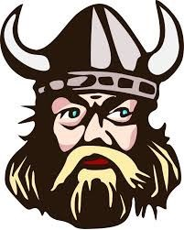
  - Give an example for each type of evidence. (3)
- Written
- Spoken
- Physical

Are the following Primary or Secondary sources? (5)
Canterbury Cathedral P/S
Richard III by William Shakespeare P/S
Dinosaur bones P/S
The Film “Titanic” P/S
Letters from Princess Diana at William and Harry. P/S
- Which of these events are political or economic? (4) a. House prices going up P/E
  - Britain become allies with America with the war
against terrorism P/E
  - First female president of USA P/E
  - Council tax replaces the Poll tax and rates P/E
10.Which of these events is technology or social? (4)
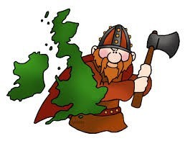
Buy 1 get 1 free on pub meals becomes popular in Britain T/S
The mobile phone was introduced. T/S
The electric car drops in price and becomes affordable. T/S
Music becomes downloadable from the internet. T/S
Teacher comment:

