Knowing Jesus
Bible Reading Plan
“Put on your new nature and be renewed
as you learn to know your Creator and become like him.”
-Colossians 3:10
The Knowing Jesus Reading Plan is designed to help you understand who Jesus is and help you experience Him in your daily life. Each week you will have five reading assignments to complete which allows you two free days to make-up any readings you may miss along the way.
- Set a regular time and place to meet with God that is free from distractions. Pray before you begin, “Lord, please speak to me through what I am about to read today.”
- Mark or highlight meaningful phrases or sentences that God brings to your attention as you read.
- Record in a journal, a paragraph or two daily, what God reveals t you through your reading. (Note: These are the things you have marked.)
- Spend a couple of minutes in prayer asking God to show you how to respond to what he said to you through your Bible reading. For example, “Lord, show me how to apply what I have learned today to my life and give me the strength to do it.”
Week 1
John 1 The Eternal Word
John 2 Jesus Turns Water Into Wine
John 3 Jesus Witnesses to Nicodemus
John 4 The Woman at the Well
John 5 The Son of God
Week 2
John 6 Feeding of the Five Thousand
John 7 The Feast of Tabernacles
John 8 The Great I AM
John 9 Jesus Heals a Blind Man
John 10 The Good Shepherd

Knowing Jesus
Bible Reading Plan
“Put on your new nature and be renewed
as you learn to know your Creator and become like him.”
-Colossians 3:10
The Knowing Jesus Reading Plan is designed to help you understand who Jesus is and help you experience Him in your daily life. Each week you will have five reading assignments to complete which allows you two free days to make-up any readings you may miss along the way.
- Set a regular time and place to meet with God that is free from distractions. Pray before you begin, “Lord, please speak to me through what I am about to read today.”
- Mark or highlight meaningful phrases or sentences that God brings to your attention as you read.
- Record in a journal, a paragraph or two daily, what God reveals t you through your reading. (Note: These are the things you have marked.)
- Spend a couple of minutes in prayer asking God to show you how to respond to what he said to you through your Bible reading. For example, “Lord, show me how to apply what I have learned today to my life and give me the strength to do it.”
Week 1
John 1 The Eternal Word
John 2 Jesus Turns Water Into Wine
John 3 Jesus Witnesses to Nicodemus
John 4 The Woman at the Well
John 5 The Son of God
Week 2
John 6 Feeding of the Five Thousand
John 7 The Feast of Tabernacles
John 8 The Great I AM
John 9 Jesus Heals a Blind Man
John 10 The Good Shepherd

Week 3
John 11 Lazarus Raised From the Dead
John 12 Triumphant Entry
John 13 The Last Supper
John 14 One Way to God
John 15 The True Vine
Week 4
John 16,17 Jesus Prays
John 18 Jesus Arrested
John 19 The Crucifixion
John 20 The Resurrection
John 21 Jesus Appears to His Disciples

For more Bible Reading plans, go to www.youversion.com. To find more reading plans from Laurel Ridge Church, go to laurelridgechurch.org/reading-plans.

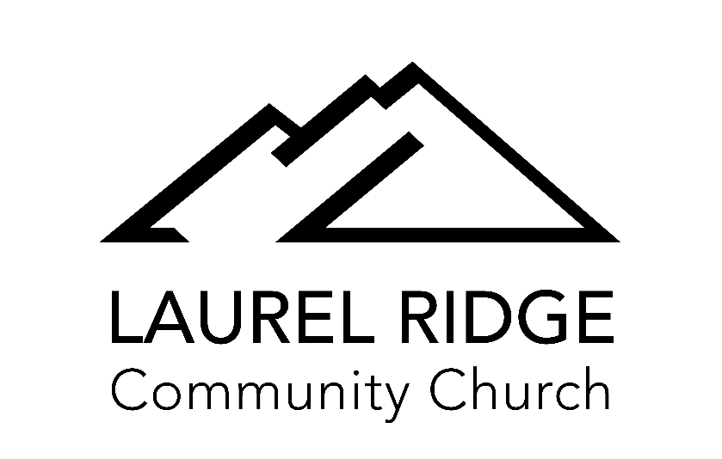
Seek God / Build Community / Unleash Compassion
2459 Laurel Road, Oakley, CA 94561 / 925-625-9500 / laurelridgechurch.org
Week 3
John 11 Lazarus Raised From the Dead
John 12 Triumphant Entry
John 13 The Last Supper
John 14 One Way to God
John 15 The True Vine
Week 4
John 16,17 Jesus Prays
John 18 Jesus Arrested
John 19 The Crucifixion
John 20 The Resurrection
John 21 Jesus Appears to His Disciples

For more Bible Reading plans, go to www.youversion.com. To find more reading plans from Laurel Ridge Church, go to laurelridgechurch.org/reading-plans.

Seek God / Build Community / Unleash Compassion
2459 Laurel Road, Oakley, CA 94561 / 925-625-9500 / laurelridgechurch.org

