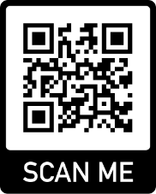
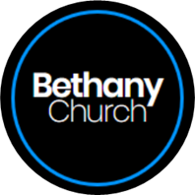
Bethany Church
1110 Echo Lane, Green Bay, WI 54304
920-494-8801 office@bethanygreenbay.org
@bethanychurch

Sunday School 2021-2022 – Registration / Media Release
Please fill out one form per child.

Student Information
Full Name:
 | First | Last | M.I.

Address:
 | Street Address | Apartment/Unit #

 | City | State | ZIP Code

Age: |  | Birth Date: |  | Grade:

Baptized | YES |  | NO | Date: | Church:
Confirmed |  | YES | NO | Date: | Church:
Sports/Activities Involved In:

Parent/Step Parent Information
Mother: |  | Father:
Step Mother: |  | Step Father:

Mother Cell # |  | Father Cell #
Step Mother Cell #: |  | Step Father Cell #:

Email Address for Sunday school Newsletters & updates:
Mother Email |  | Father Email

Emergency Contact (Other Than Parents)

Full Name: |  | Relationship:
Phone:

Medical Information
Behavioral/Conative Concerns that will help us with teaching:
Food Allergies |  | YES | NO
(If yes, explain)

Please turn over for Media and Medial Release forms to sign

Media Release

I, the legal parent/guardian of ___________________________________, hereby authorize and consent to the use of images or videos of my child/children listed above, with or without their name(s), by Bethany Church of Green Bay, WI for purposes including but not limited to: promotional materials, printed publications, internet posts including social media, television, and other media sources. I do this with full knowledge and consent and waive all claims for compensation for use or for damages. I release Bethany Church, its officers, trustees, employees, and agents from liability for any claims by me or any third party in connection with the use of the image of my child/children listed above.

This Media Release will be kept on file in the church office. If you would like to withdraw your permission, you may do so at anytime.
Print:
Signature: |  | Date:

Medical Release

I, __________________________________, am the parent or legal guardian of _________________________, who is attending and participating in activities at Bethany Church. I hereby authorize Bethany Church, volunteers, leaders, or employees that are 18 years of age or older, who supervise the activities at Bethany Church into whose care my child has been entrusted, to consent to medical care for my child. Bethany Church will call 911 if deemed necessary as well as the parents and/or emergency contacts.

Print:
Signature: |  | Date:

