BETHANY CHURCH
Bethanygreenbay.org
office@bethanygreenbay.org/ 920-494-8801
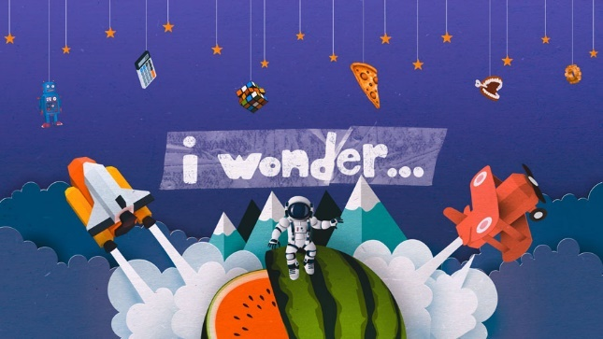
BLAST OFF!!!
SUNDAY SCHOOL 2021-2022

I Wonder……….
Hello everyone! We are looking forward to seeing many smiling faces on Sunday mornings!
We are excited this fall as we are on a new adventure to grow in our faith! We are on a mission to inspire, explore, and use new tools to help us see God working in our world! “I wonder…”
I wonder why… God made me? I wonder… should I help others? I wonder…. do I have to go to school?
We begin the fall with wondering… why God made each of us unique and learn what makes each of us special in this world.

Safety and Covid
Bethany wants to ensure the safety of the children. We use a team-teaching approach for a safe and fun learning experience. Bethany does not require masks. We will have hand sanitizer and cleaning supplies in each classroom. Extra masks will be on hand for those who want them.

Registration Forms
We ask that parents/guardians please fill out a new registration form. You should receive one in the mail. If you need another new form, please visit our website at www.bethanygreenbay.org or pick one up from the table in the lobby area.

Sunday School Breakfast and Teaching Time
This year parents, students, and teachers will have a time to talk and eat breakfast snacks in the Lower Lounge beginning at 9:00 am. At 9:15 am, Sunday School begins in the GLOW Room across from the Lower Lounge. Our Sunday School time together will run from 9:15 am to 10:15 am. Parents are asked to meet their children in the Lower Lounge at the end of the Sunday School time at 10:15 am for pickup.

Teachers and Leaders

3 years – 4 years
Mary Paque paquemike@gmail.com Sharon Sannes berries@netnet.net

4K & 5K Class
Lisa Nellis mlnellis0721@yahoo.com
Pat Breliant patbreliant@gmail.com

1st & 2nd Grades
Matt Flanagan mattflanagan14@gmail.com
Beth Haskins gbpls60@yahoo.com

3rd – 5th Grades

6th – 7th Grades
Matt Luepke mattluepke@gmail.com

8th - 10th Grades (Confirmation) 9:15 am Sunday
Stephanie Dutkowski
stephanie.dutkowski@gmail.com

9th - 12th Grades
Sharon Banning smnpieper@aol.com

Nicole Fieck nicopeterma@aol.com
Bridget Phillips-Peters bphillip@hotmail.com

Sunday School Calendar
The calendar will also be available on the website www.bethanygreenbay.org, under the Sunday School page.

This Year’s Learning Adventure
Our format this year will be a VBS style. We will have a 4-6 focus/theme and then we will begin a new theme. Our themes this year so far include Halloween celebrations, Christmas gifts, God’s love for us, and we will end the year with a trip to NEW Zoo. Oh yes, and don’t forget our Glow Room! It will have a disco ball, and black light for glow in the dark worship!

Students Receiving Bibles This Year

If your child is either 3 or 4 years old, or in 3rd or 4th grades, let us know. We can make sure he/she gets a Bible.

We will also have extra Bibles ready for new students or guests who join us! If your child (any age) would like new Adventure Bible, please call the church office at 920-494-8801 or email office@bethanygreenbay.org.

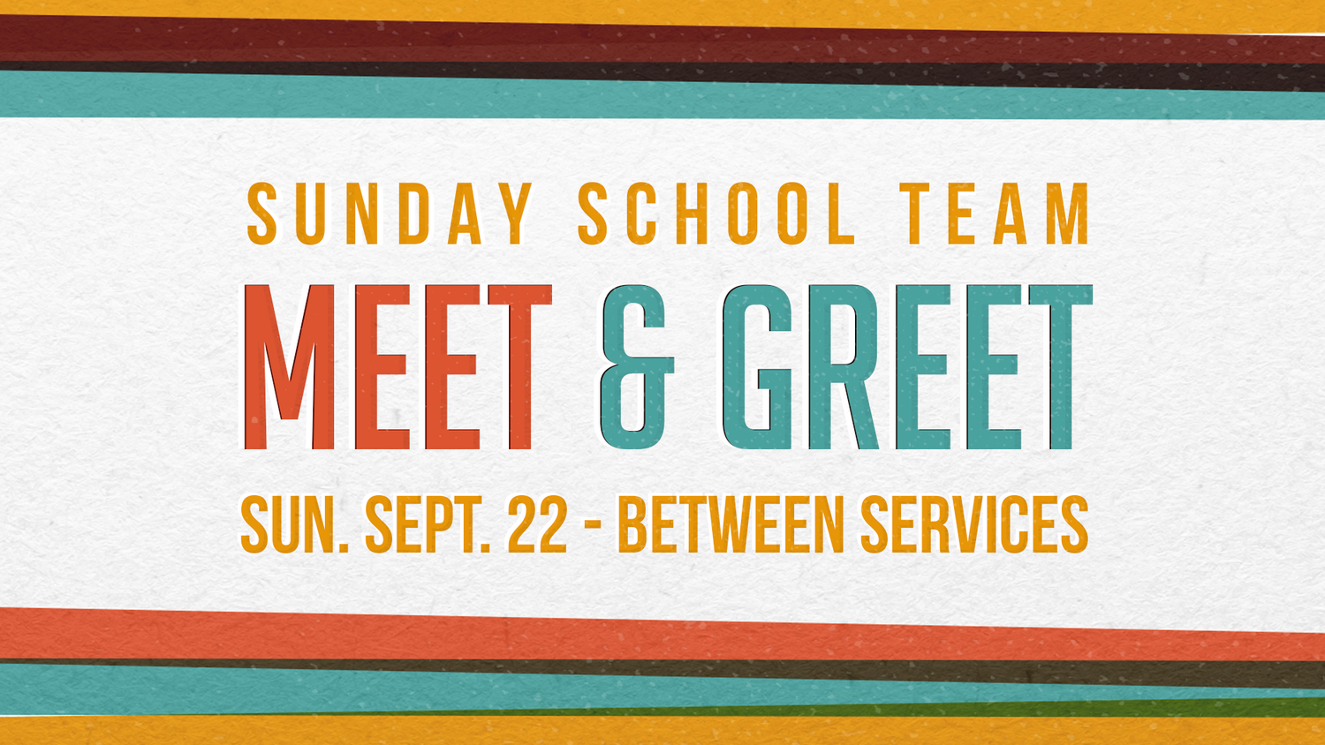
Sunday, September 12th from 9:15 am to 10:15 am

am

***Parents/Grandparents/Guardians are asked to be with their children
during the “Meet and Greet” so teachers can meet you as well.
**Feel free to move around as needed if you have more than one child**

Thank You To You All
The Education Team greatly appreciates the enthusiasm and commitment that parents have for teaching our children about the love of Jesus Christ. Bethany invites friends and guests participate in the Sunday School and Adult ministries as all ages learn and live out the mission of loving God, loving others, and serving in the community.

Contact Us
If you have any questions or concerns, please feel free to contact any of the teachers or the church office.

