Table of Contents

Officers 2020 2

Officers 2021 3

Financial Report 4

Budget 2021 7

New FBT Center Budget 10

Pastoral Report 11

Deacon Report 13

Trustees Report 14

Parsonage Remodel Report 15

New FBT Center Building Team Report 20

Director of Visitation and Women’s Ministries Report 24

Christian Education Team 25

FBT Club 26

Youth Ministry 27

Sunday School Pre K – 2nd grade and Children’s Church 28

3rd – 5th grade Sunday School 28

Junior High Sunday School 29

High School Sunday School 29

Adult Sunday School 30

Second Saturday Men’s Bible Study 30

Missions 31

Vacation Bible School 33

Operation Christmas Child 33

Care Ministry Team 34

Women’s Fellowship 34

Music Ministries 35

Attendance Report 36

Membership List 37

Blessing 40

**Fulton Baptist Temple Officers 2020**

**Deacon Board**

(term expires)

* Rusty McGrew 2020
* Andy Curtis 2021
* James Fred 2022
* Caleb Russell 2023
* Daniel Curtis 2024

**Trustee Board** (term expires)

* Blair Zimmerman 2021
* Scott Fred 2022
* Eli Fred 2023

**Clerk**

* Diana Smith

**Sunday School Superintendent**

* David Emery

**Treasurer**

* Aaron Rush

**Financial Secretary**

* Julie Fred

**Head Usher**

* David Fred

**Song Leader**

* Daniel Curtis

**Pianist**

* Karen Hutsell

**Assistant Pianist**

* Kristin Curtis

**Organist**

* Don St. Clair

**Director of Music**

* Daniel Curtis

**Christian Education Team**

**Children’s & Youth S.S & Junior Church Representative 4 year old thru 5th grade**

* Sara Zimmerman 2020

**Missions Representative**

* Kevin Robbins 2020

**Vacation Bible School Representative**

* Kristin Curtis 2020

**Adult S. S. Representative**

* Valerie Good 2019

**Children & Youth S.S. Representative 6th thru 12th grade**

* + Lori Kingery 2019

**Appointed to Christian Education Team by the FBT Constitution**

**FBT Clubs Commander**

* Andy Curtis

**Youth Representative**

* Rusty & Danielle McGrew

**Sunday School Superintendent**

* David Emery

**Pastor**

* Bruce Russell

**STAFF**

Church Office Administrator

Aaron Rush

**Fulton Baptist Temple Officers 2021**

**Deacon Board**

(term expires)

* Andy Curtis 2021
* James Fred 2022
* Caleb Russell 2023
* Daniel Curtis 2024
* Rusty McGrew 2025

**Trustee Board** (term expires)

* Blair Zimmerman 2021
* Scott Fred 2022
* Eli Fred 2023

**Clerk**

* Diana Smith

**Sunday School Superintendent**

* David Emery

**Treasurer**

* Julie Fred

**Head Usher**

* David Fred

**Song Leader**

* Andrew Smith

**Director of Music**

* Daniel Curtis

**Christian Education Team**

**Children’s & Youth S.S & Junior Church Representative 4 year old thru 5th grade**

* Sara Zimmerman 2022

**Missions Representative**

* Linda Fincher 2022

**Vacation Bible School Representative**

* Kristin Curtis 2022

**Adult S. S. Representative**

* Valerie Good 2021

**Children & Youth S.S. Representative 6th thru 12th grade**

* + Lori Kingery 2021

**Appointed to Christian Education Team by the FBT Constitution**

**FBT Clubs Commander**

* Linda Wade

**Youth Representative**

* Rusty & Danielle McGrew

**Sunday School Superintendent**

* David Emery

**Pastor**

* Jeremy Losier

**STAFF**

Church Office Administrator

Aaron Rush

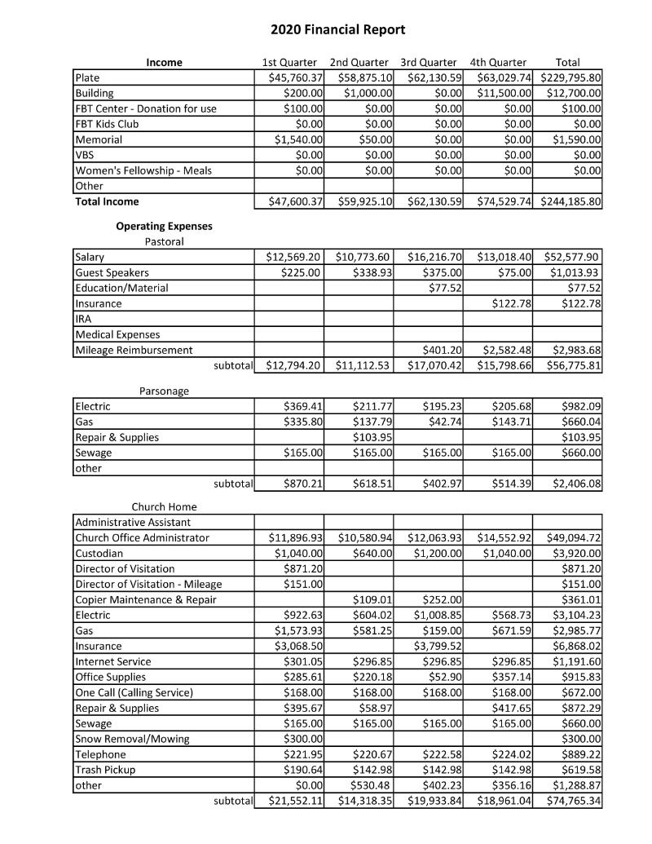

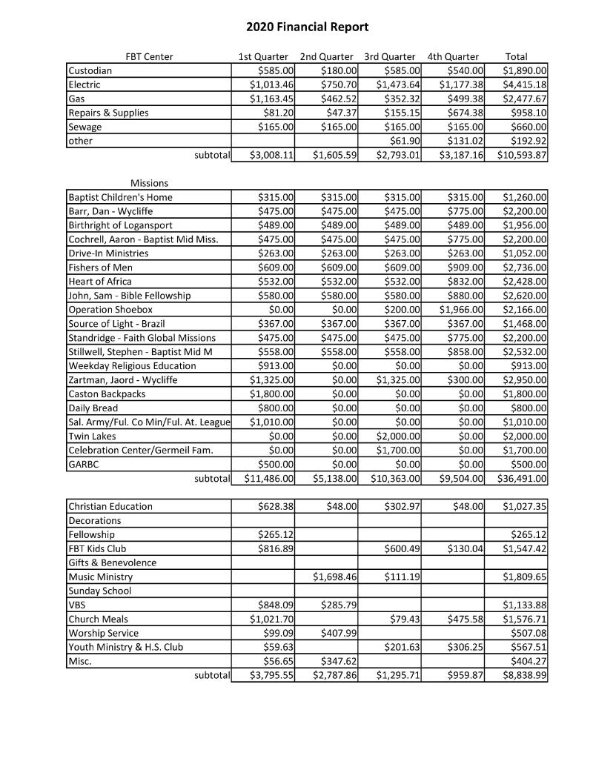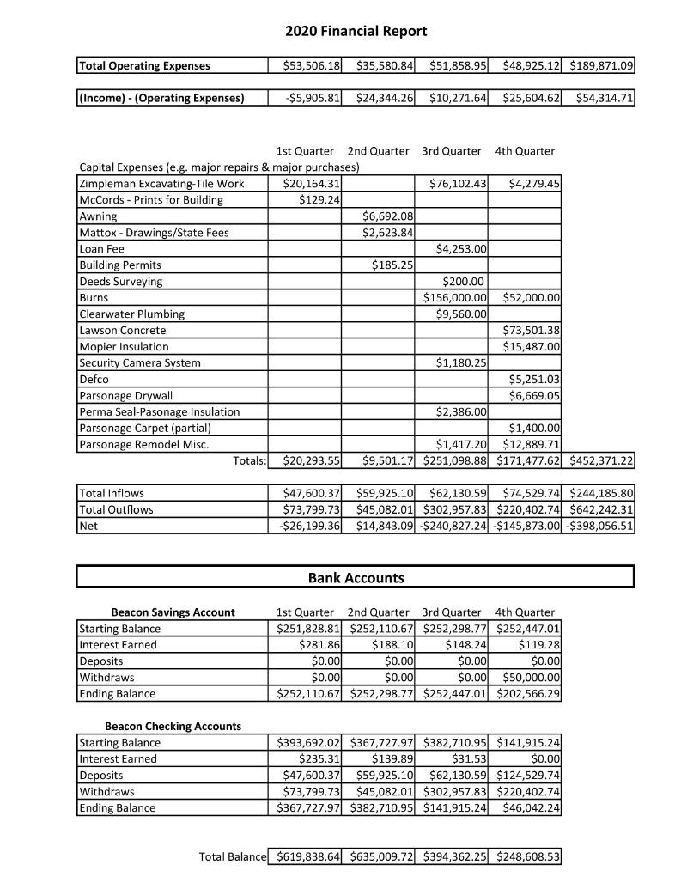







NEW FBT CENTER BUILDING BUDGET

Below is a chart showing the New FBT Expenses as of date shown. Currently the church has paid for 65% of the estimated expenses! Currently the project is under budget as only 22% of the “10% Overage” has been used. Remaining budget for 2021 is $311,243.83.



In Service to Christ,

Rusty McGrew

Rusty McGrew

PASTORS ANNUAL REPORT

Bruce Russell

January 1 - July 19, 2021

I am very pleased to see how the church, our deacons and Pastor Jeremy have ministered during these important days of transition.

My 2020 sermons continued to follow a chronological approach to the life of Christ (10:30) and the years of the church’s growth and development (9:15).

As we will all remember, the COVID-19 interruption radically changed our church schedule as we were closed for all public services from March 22 to May 10. The entire Rush family did a great job ministering to us via the internet. Aaron’s expertise and diligence made possible a meaningful service each week. Christi, Adam, Braden, and Eli provided very valuable doses of music, testimony, and encouragement each week.

The messages during the COVID-19 season were Biblical messages that related to the challenges and uncertainties that we all experienced.

Beth and I were so pleased to see the Lord lead our church and our new pastor during that time. I was very pleased and confident to turn the responsibilities of leading this great church over to Jeremy Losier on July 19, 2020.

On a personal note, Beth and I are ministering at Faith Baptist Church in North Manchester. We love the work that God has called to lead, but we will always miss all of you at our “home church”.

Sincerely yours,

Bruce Russell

Bruce Russell

PASTORS ANNUAL REPORT

Dear Fulton Baptist Temple Church Family,

Thank you, church family, for the wonderful opportunity it is to be your pastor and minister to our congregation of the Fulton Baptist Temple. It is a blessing to see how God brought our family to this ministry, and we are excited to get fully engaged into the many ministries of our church.

2020 was an interesting year for our pulpit ministry for sure! Whether it was live stream, prerecorded service, or live services, our pulpit was used to edify the saints, preach the gospel, and make disciples. The first service has been an exegetical study through the Psalms in a series titled, “Psalms: God’s Songs for Life.” The second service has been a study through the “Real Christianity” series. This has been a fulfilling study that has allowed us to look at the basics of Christianity. This will make a great small group study eventually.

I had the opportunity to visit a few of our church family in their homes, but have not made any hospital visits as of yet. I have had the opportunity to minister to some of our congregation in their toughest times, and was able to be there for them. My goal is to visit all of our church members by the beginning of August. I want to be a blessing, and I want to encourage our church to love Jesus. My plan is to visit our church families on Thursday afternoons and evenings.

We are so blessed to serve along side the many competent leaders of our church. It is my delight to serve with and learn from them. I believe we have a great core of leaders that are very willing to help with the many needs of the church.

I attend and assist youth group and FBT Clubs where I can, but our leaders and helpers are already in a routine. Our youth ministries are such a blessing, and it is exciting to see the vibrant energy of our youth! Due to the Covid, the Caston Christian Club has been put on hold, hoping to get involved ASAP.

2020 has been a year of transition and focus with the way FBT has been operating. Never did we think a pastoral change and a pandemic would happen in the same year, however, I believe our church will be stronger than ever this coming year. I look forward in being there for you all, and I love being your pastor.

Sincerely yours,

Jeremy Losier

Pastor

Fulton Baptist Temple

“For we preach not ourselves, but Christ Jesus the Lord; and ourselves your servants for Jesus’ sake.” - 2 Corinthians 4:5

106 W DUNN ST FULTON, IN 46931 (574) 857-3315

DEACONS REPORT

Deacons: Rusty McGrew, Andy Curtis, James Fred, Daniel Curtis and Caleb Russell

The year 2020 may have been a very trying and incomprehensible for the entire world; however, as we are often reminded nothing is impossible for God! The past year was a great year for the Fulton Baptist Temple. The deacons of the church made decisions that had not even been considered before. Due to the COVID 19 pandemic the deacons and Pastor Bruce felt it was in the best interest of our members and community to close the church from the middle of March through May. During this time a small group of members broadcast a Sunday morning service over the internet while preaching to an empty church! FBT Club and Youth Group activities were canceled through the remainder of the Spring school year. Summer activities and VBS were canceled soon after. This was a difficult time for the church. Relationships that had been built and growth that could be seen in the ministry seemed to come to a standstill. Many would not be blamed for taking a moment to pause all future activities of the church; however, this temptation was not once considered by FBT. With so much fighting against the church the deacon board continued to push forward with the goals before us. The first goal was to keep the construction of the new FBT Center on track. This goal was accomplished (please see FBT Building Team report)! The second goal before the deacon board was to hire a new Pastor to replace retiring Pastor Bruce Russell. God works all things out according to His timing and the deacon board was about to experience the will of God. In 2019 the church joined the GARBC and with that Pastor Russell reached out to Twin Lakes Camp in Hillsboro, IN, and met Jon and Donna Beight. Jon came and presented Twin Lakes Camp to the church in the Spring. After the service Jon and Donna met with the deacons and got to know our church in more detail. The deacons expressed our concern of finding the right pastor with Jon and Donna and asked them to keep us in mind of anyone who would be a good fit. A few short weeks later the deacon board received an email requesting that we contact Jeremy Losier in regards to hiring a new pastor of FBT. Within days Jeremy had been contacted and the decision was made to invite Jeremy to come and candidate with our church on July 12. Jeremy, Tiffany, Charlie, and Charlotte Losier were voted in as Pastor of FBT at a special business meeting July 19. Pastor Bruce resigned effective immediately at the same meeting in order to prepare for Jeremy’s arrival. Jeremy and Tiffany had obligations that did not allow them to move to Fulton permanently until October. During these months the parsonage was remodeled in preparation of their arrival. Also, FBT was able to have the Sonshine preschool led by Lisa Zimpleman to move into the Church basement. This was a great opportunity to serve this community! COVID 19 continued to push FBT into making tough decisions throughout 2020; however, the Lord did not waver in His faithfulness to our church and ministries! 2020 was a great year for Fulton Baptist Temple!

In Service to Christ,

Rusty McGrew

Rusty McGrew

TRUSTEES

Trustees: Scott Fred, Eli Fred and Blair Zimmerman,

Church:

* Replace canvas on east entrance.

Parsonage:

* Replace soffit.
* Replace basement windows with cement blocks.
* Upgraded electric to 200 amp underground service.  All wires in the house have been replaced.
* Complete renovation of upstairs which included adding a bath tub and redesigning all rooms.
* New windows in upstairs.
* Replace hidden unused stairs with closets.
* Spray foam in all open walls and ceiling during renovation.
* New washer and dryer.
* New carpet and replaced floor in kitchen and bathrooms.
* New paint in every room.

A huge thank you to Mark Babb and his helpers for all the hours of planning and work they put into remodeling the parsonage. Also to everyone, church members, church attendees and members of the community who put numerous hours in helping remodel the parsonage thank you.

During the spring of 2021 the exterior of the parsonage will be resided.

In Service to Christ,

The Trustees

2020 Church Parsonage Remodel

The project began in August to add a bathtub to the upstairs half bath and to update the wiring. In order to add that bathtub upstairs, the kitchen ceiling and south wall would need to be removed to run new plumbing and electrical to the upstairs. All electrical in the house was dangerously over loaded with three lines having had electrical fires previously. 100 percent rewire of the parsonage was necessary. $17,800.00 had been approved by the church for an electrical up grade. After a tour of the parsonage and input from members it was also decided that the laundry in the basement needed to be relocated upstairs. After a visual walk-through it was further determined a past chimney fire had severely burned all the north second story roof rafters and all of the north half of the east roof as well (March 5, 1957). All of these needed to be reinforced and the roof lines six inch sag fixed. Further inspection found the west outer wall of the parsonage to the north half had been detached at the top when someone at some point cut the upper floor joists out to add a stairway. This stairway went from where the current coat closet is just west of the front door to the second story which in now the Master bedroom dress closet and Master sitting room area. However, the bottom of the stairs was dry walled over and hidden.

With all the structural problems needing to be fixed and no further budget to do it the deacon board and trustees decided to have Mark Babb and his crew do a complete gut of the second story some of which had never been completed for living space. The deacon board gave the ok for the crew to use the $17,800.00 electrical budget and $4000.00 for second floor bath and laundry to gut entire upstairs, old northwest stairway, kitchen ceiling, and rewire the entire house.

First Week – 14 small single axle dump truck loads of material were removed from parsonage upstairs. Many church members helped with the demolition.

Second Week – Eli Fred, Scott Fred, James Fred and Mark Babb removed the northwest stairs and electrical. Linda Wade came to remove staples from the floor.

Third Week – Framing in the Master closets northeast and east north corner of the parsonage second story. This was designed to support the roof rafters that were doubled to repair the fire damaged rafters. The six-inch sag in the roof line was corrected. Master bedroom loft was also prepped to become living space 14 feet x 16 feet after previously being an attic. Hunter Babb helped Mark Babb remove insulation.

Fourth Week - Replaced floor joists in second story to reattach west wall north half to the main structure where stairway had been added at some point. Decking was added to joists to create what is now the Master dress closet and sitting room area.

Fifth Week – Framed Master bedroom and door opening that is now located where Pastor Jeremy Losier, his father, Bob Losier and Mark Babb had removed the second story chimney. (The first story portion of the chimney still remains in the first story wall). New upstairs bathroom/laundry and door framed, wall closet, doorway for west and east bedrooms upstairs framed.

Sixth Week – Coat closet downstairs framed, backer boards in all rooms where drywall corners and angles would be needed were installed. All electrical boxes, switch boxes and junction boxes where we needed them installed in new ceilings and walls

Seventh and Eighth Weeks – Adren Lewis took charge of all wiring for new areas and downstairs rewire. 28 recessed LED lights added, more than 100 electrical boxes added, a new 200 Amp service from back porch to pantry. All old boxes replaced as well. Maria Jankowski assisted Adren Lewis. Midweek we had a blessing and Steve Freels (Pee Wee) showed up to help Adren. Maria was then instrumental for placing 500 plates throughout the house to protect electrical wires from the future drywall screws.

Ninth Week – New plumbing for new bathroom/laundry in the second story completed. The entire kitchen ceiling was removed. That led to six layers of kitchen floor being removed taking seven small dump truck loads. Abby Robbins and her four boys showed up to help remove the kitchen floor. This created a new problem when it was discovered that the floor joists in front of the dish washer had been water soaked and warped badly. Scott Fred provided an I-beam that Scoot, Levi Martin and Mark Babb installed to level the joists. The joists were slowly jacked up over two weeks, and then new lumber was installed to strengthen the floor joist.

Tenth Week – Finished all wiring in the house and double checked all wires to make sure the house was ready for drywall, studs marked, and plumbing finished. Several walls downstairs had to be cut to remove old wires and install new boxes and wire. Loft floor laid. Pete Duvall assisted Mark Babb a couple of evenings. Spray foam was applied to the all second story ceilings and walls.,

Eleventh and Twelfth Weeks – Drywall! Several guys carried drywall upstairs, and Aaron Rush during a light misty rain braved standing in the bucket of a loader tractor operated by Scott Fred to insert drywall through an upstairs window. A total of 196 sheets of drywall were used. Not safe but God protected. Installing loft drywall was tough with several guys involved. While drywall was being hung, Daniel Curtis and his son Isaac worked on screwing down all floors in the second story as old nails in floors were not doing the job. Mary Babb, Julie Fred, Aaron Rush and Mark Babb taped off trim and windows all day Saturday.

Thirteenth Week – Paint. All interior walls painted white including the downstairs trim painted white to match old trim. Upstairs trim painted gray. Outside underground electrical finally buried and new meter installed. All electric switched from old 100 amp service on back porch to 200 amp service in pantry. New 100 amp service ran underground to garage. (Note; September 1954, one car block garage erected, cost $458.65 cash and $200 for the lot, the work was done by Marvin Zabst).

Fourteenth Week – Installed lights, switches, receptacles, and trim.

Fifteenth Week – Kitchen ceiling and trim work was completed. Four new windows from Hack’s Construction arrived and were installed upstairs by Pastor Jeremy Losier, Austin Goforth, and Mark Babb.

I, Mark Babb, could never have completed this enormous job in 105 days without the help of many people from the community and members of the congregation.

Workers from FBT congregation;

Eli Fred, Scot Fred, James Fred, Julie Fred, Bill Fred, Megan Fred, Ashely Fred, Aaron Rush, Braden Rush, Linda Wade Linda Fincher, Daniel Curtis, Isaac Curtis, Ella Curtis, Kristin Curtis, Andy Curtis, Hunter Babb, Jill Zartman, Mary Babb, Pastor Jeremy Losier, Emily Mangelsdorf, Abby Robbins, Jackson Robbins, Dylan Robbins, Malakai Robbins, Rylie Robbins, Ruth Ann Miller, Charlie and Margie Binkerd. Apologies to anyone whose name was omitted

Food Provided;

Dick Working, Deb Curtis, Linda and Barry Baldwin, Kristin Curtis

Material Donated;

Mike Hack, Hack’s Construction, Mike Babb, Mark Babb, Fred Farms

Workers;

Adren Lewis, Maria Jankowski, Steve Freels, Levi Martin, Pete Duvall, Bob Losier, Gary Wilken

Note No work was done to the existing second story half bath.

$24,761.96 was spent on the remodel thus far; there is a small amount due on the carpet

The following two pages are photos of the parsonage remodel.

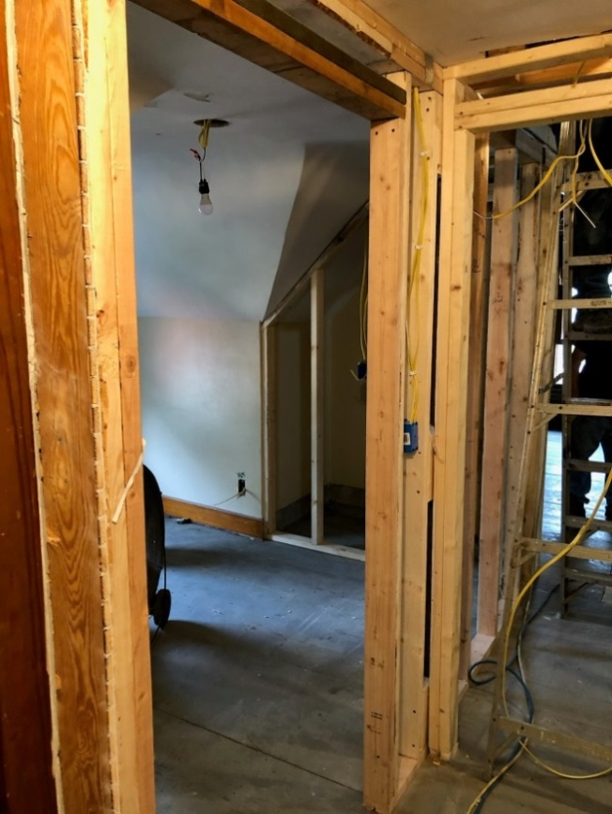 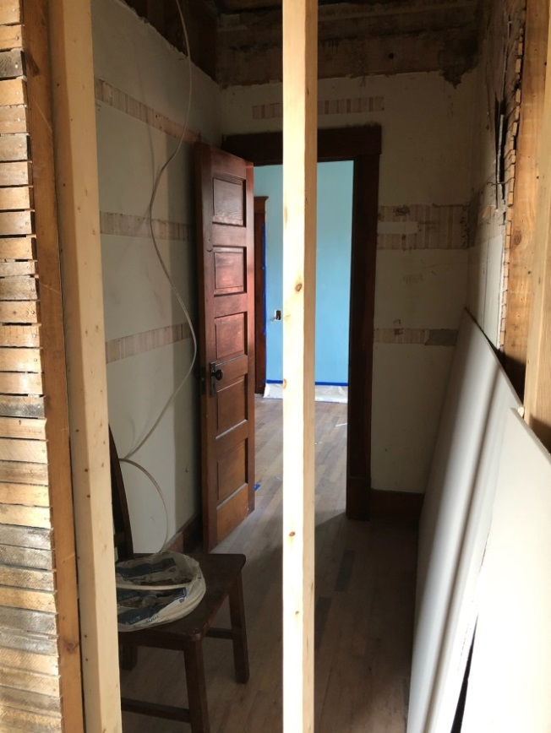

Photo by Eli Fred Photo by Eli Fred

In hallway looking north at doorway Downstairs bedroom closet enlarged for bedroom and master bedroom and framed

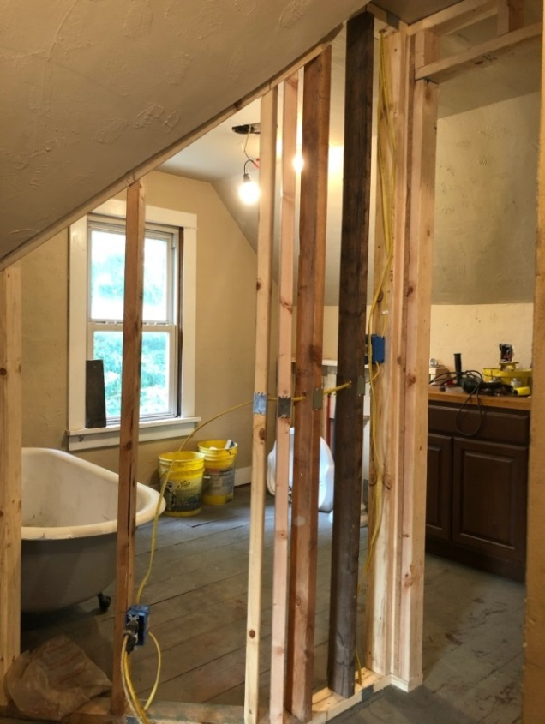

Photo by Eli Fred

New bathroom upstairs at top of stairs

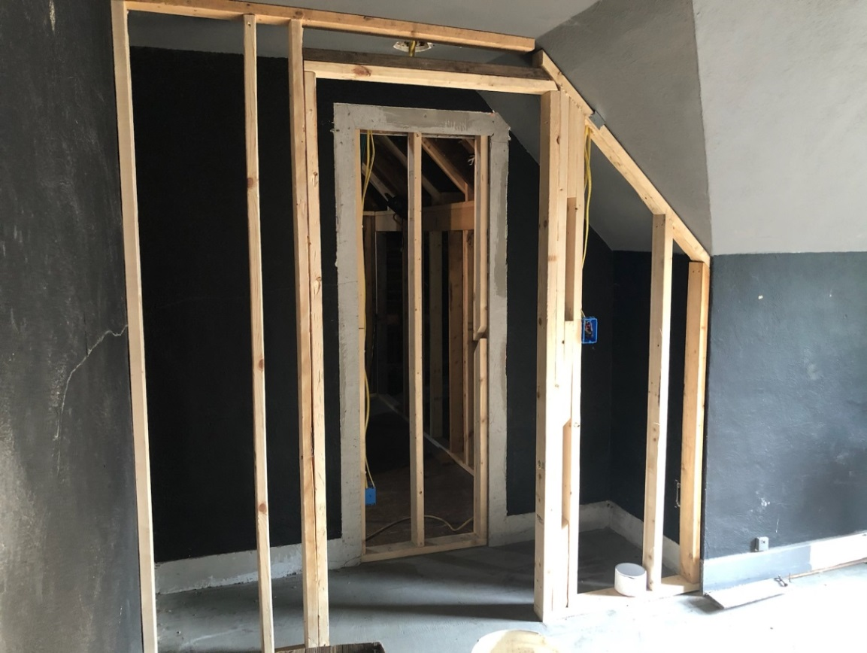

Photo by Eli Fred

Other kids’ bedroom closet

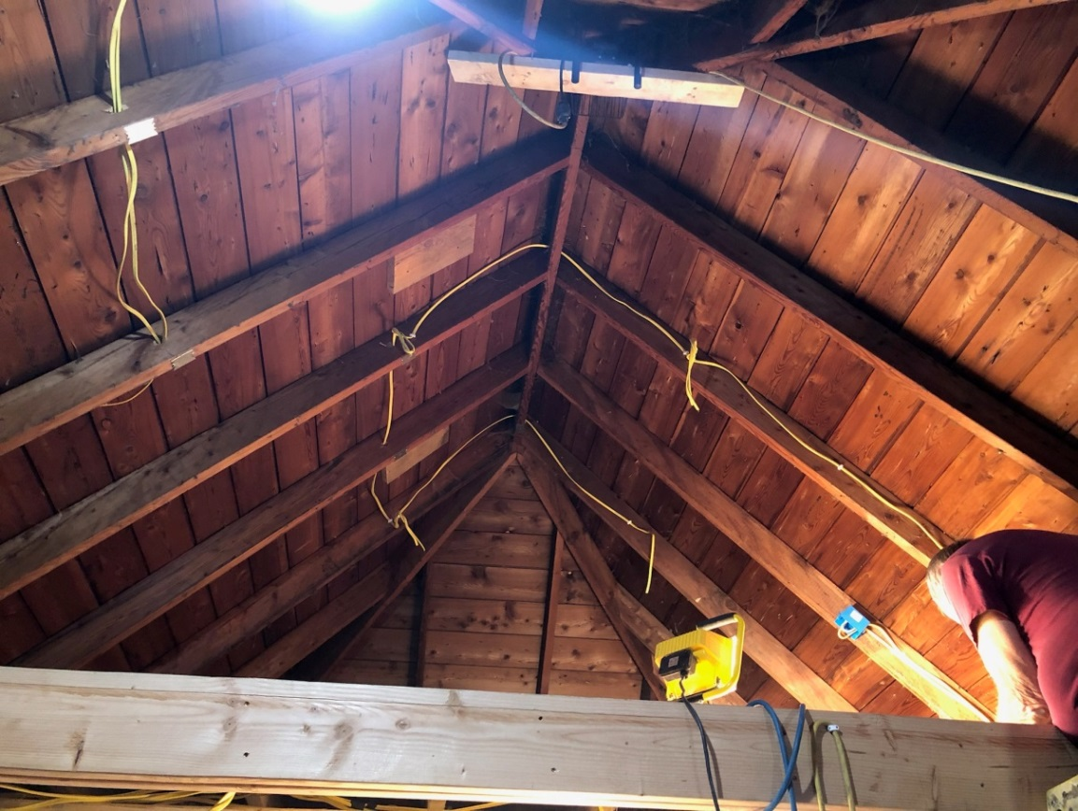

Photo by Eli Fred

Loft above master bedroom being wired

NEW FBT CENTER BUILDING TEAM

One of the main projects of the church was the new FBT Center. With land already purchased the building team only needed to wait for the weather to clear up in order to start the Project in the spring. The dirt began to move early in the spring and it was not long before the poles of the building were in the ground. At the conclusion of 2020 the shell of the building is complete. All inside concrete, walls, spray foam, plumbing, electrical, and driveway have all been completed! The building is huge! The prospects of a home missions project such as the new FBT Center has become a reality. Through the end of 2020 the project is on budget and much of the work has been moved inside for the winter. The goal is to be completely in the new building by VBS 2021.

In Service to Christ,

Rusty McGrew

Rusty McGrew

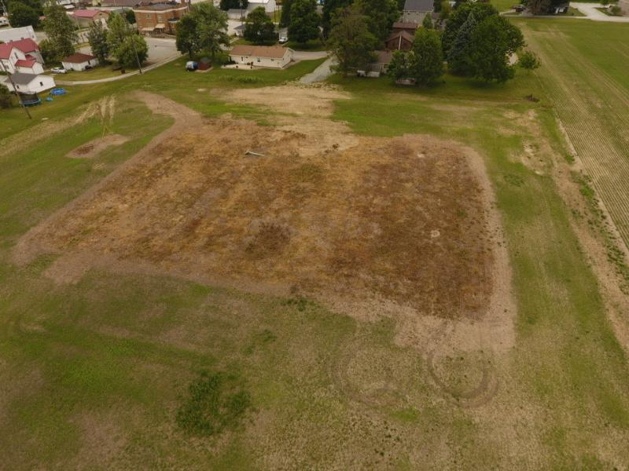

Photo by Eli Fred

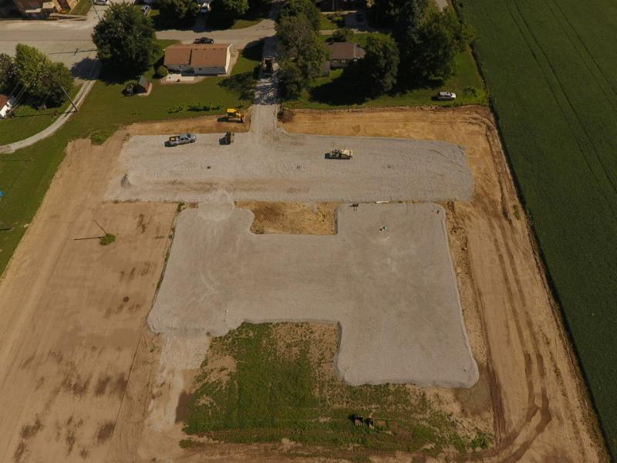

Photo by Eli Fred

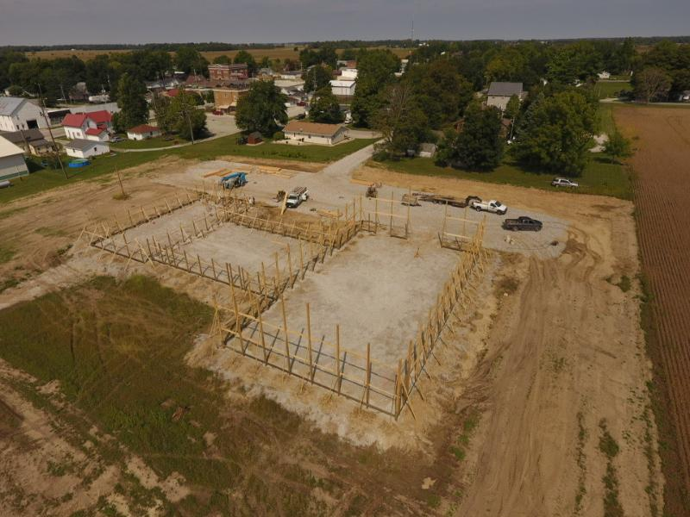

Photo by Eli Fred

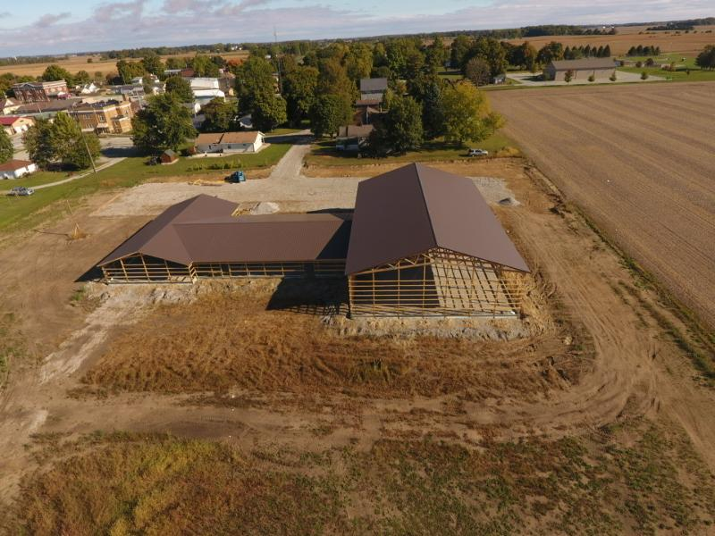

Photo by Eli Fred

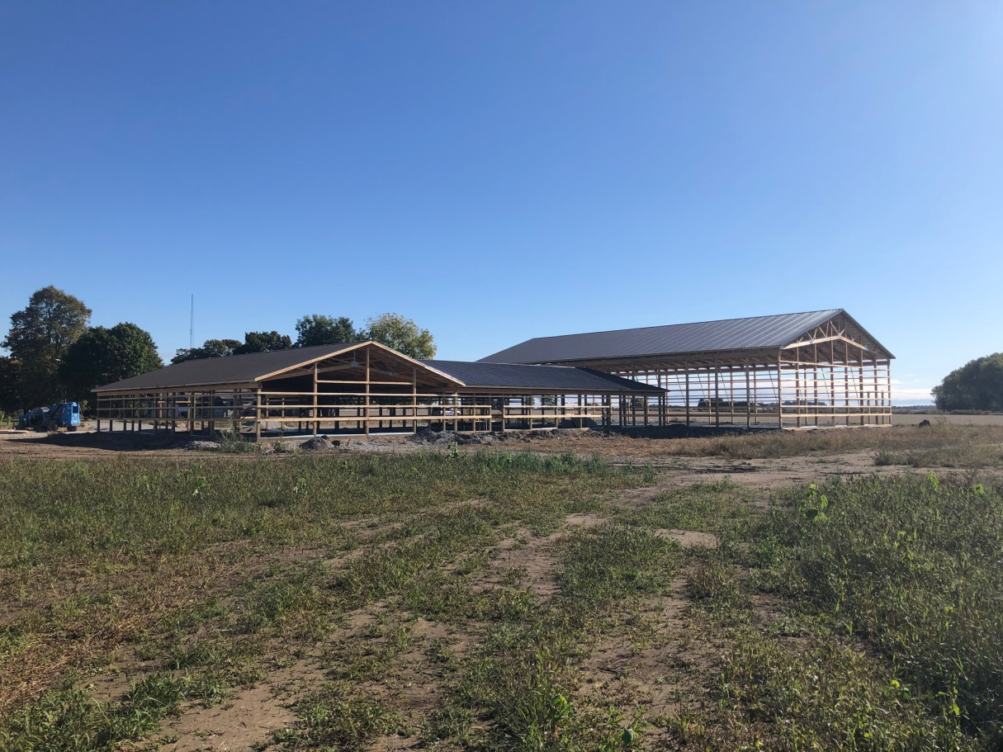

Photo by Eli Fred

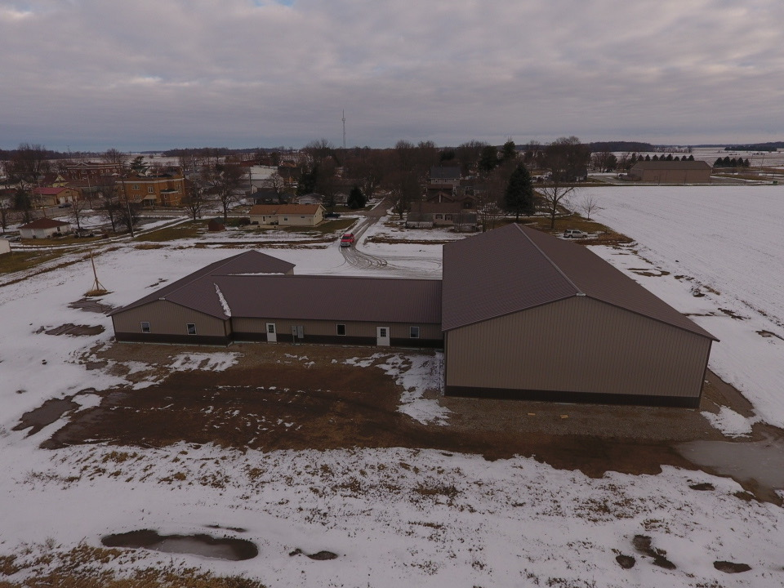

Photo by Eli Fred

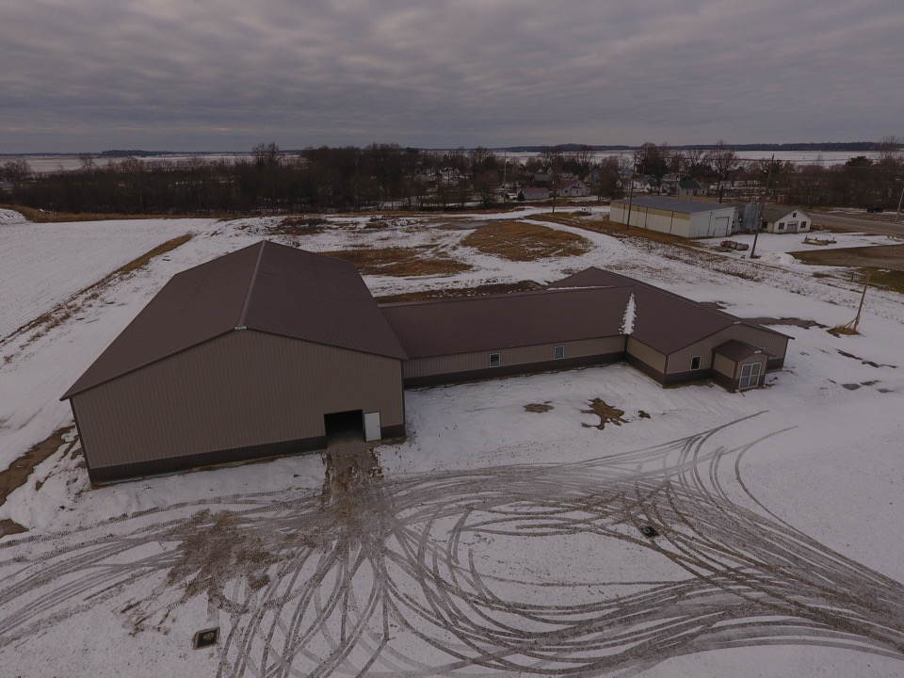

Photo by Eli Fred

DIRECTOR OF VISITATION and WOMENS MINISTRY

This has been an unusual time for all the ministries of the Fulton Baptist Temple. Obviously, our ministry of visitation was greatly limited by the concerns of COVID-19.

I made over fifty personal visits this year during January and February. I made many calls, as did many of you, during the months of March, April, and May during our church’s “shutdown”.

During the months of June and July, I was in New York providing hospice care for my sister. Only a few calls were made during this time.

I have been blessed to carry our church’s outreach to so many over these many years. We have seen many of our most faithful friends walk to their reward. I was blessed to have been there with them.

Sincerely yours,

Beth Russell

Beth Russell

CHRISTIAN EDUCATION TEAM

Team Members are:

Andy Curtis, FBT Clubs

Rusty &Danielle McGrew, Youth

Kristin Curtis, VBS

Sara Zimmerman, Children & Youth Sunday school & Junior Church representative 4 year old thru 5th grade

Valerie Good, Adult Sunday school

Kevin Robbins, Missions

Lori Kingery, Children & Youth S.S. representative 6th thru 12th grade

Pastor Bruce Russell

Pastor Jeremy Losier

David Emery, Sunday School Superintendent

The Grand Prix was January 29, with 68 cars in the race and over 200 people in attendance. Average FBT Club attendance during 2019 -2020 clubs year was in the mid-sixties and attendance at Jr. High & High School Youth Group was between 25 and 30.

Covid 19 lockdowns began in mid-March and disrupted all activities for the rest of the year.

We had three graduating high school seniors this year, Aubrey Dague, Noah Howdeshell and Sarah Mangelsdorf. A NLT Life Application Study Bible was presented to each of them.

VBS was not held.

FBT Clubs began September 16, as long as Caston School was in session FBT Clubs were held. The length of clubs was shortened and some activities could not be enjoyed however average attendance thus far has been 65 for elementary and 30 for middle school & high school. There was no Carnival due to Covid 19 the Grand Prix was also cancelled.

A gift of $1700.00 was sent to the church Lifliz Beraca in Jeremie, Haiti, to pay the rent on their church building for one year. Their pastor is Pierre Emile Moise.

A gift of $2000.00 was given to Twin Lakes Camp, in Hillsboro, IN. Director Jon Beight spoke here early in the year and played a part in connecting us with Pastor Jeremy. Twin Lakes Camp has been added to the list of missions we support each year.

Gideon, Shad Sibert gave the Gideon presentation on October 25.

David Emery

David Emery

Christian Education Team Chairman

FBT CLUB K thru 5th grade

This year we encountered new challenges and had some forced changes, but God is still good and He is still working. Covid-19 arrived mid second semester of the 2019-2020 session. We were able to complete the semester, but we were unable to finish with the annual FBT Sunday program and lunch. At this point we weren’t sure what the future held for our meetings.

When it was time for the 2020-2021 season to start, we knew it was going to look different, but we were determined to move forward to share the gospel and teach the kids about God and His Word. We were able to meet almost every week with social distancing and masks. We also adjusted the schedule to accommodate smaller groups and shortened the evening to 1 hour. We still had a good group of kids who faithfully came throughout the fall. All the adult helpers worked with a small group of kids each week helping them to understand a Bible story and memorize verses. For the lesson each night, we told God’s story starting in Genesis and finishing the first semester with the birth of Jesus. The main point we want the kids to remember is “God created everything, He made it perfect, we broke it and sin and death entered the world, and God sent Jesus to fix it.” We will continue into 2021 learning about Jesus’ earthly life and finishing with Jesus’s death and resurrection. We praise and thank God for His faithfulness and provision! We appreciate the dedication of the adult helpers and their desire to see the Gospel reach the heart of these children! To God be the glory!

Thank you.

Daniel Curtis

YOUTH MINISTRY

2020 was definitely one of the most interesting times for youth group! During the spring school semester, we were forced with the decision to cancel all youth group activities for the remainder of the spring semester. The abrupt halt in youth group activities was a huge blow to the ministry; however, it was not the end of all youth group activities for 2020. Although the youth group did not meet during the summer months, the group came back full force in the fall of 2020. Youth Group activities were moved to the main sanctuary of the church in order to better distance and spread out due to current COVID 19 guidelines. Meetings in the Fall were mostly held outside and weather cooperated with a very warm and dry fall. The outside activities included games and snacks at the church yard north of the church, and a bonfire hosted by the Sr High Boys! As the winter weather moved in activities were moved in doors to much excitement and success. This year presented a smaller Sr High group and a larger Jr High group. Attendance ranged anywhere from 30-45 students including a group of 27 junior high students on average.

Leaders were Rusty & Danielle McGrew, Caleb & Julie Russell, Pastor Jeremy Losier, James and Courtney Fred, Eli & Bre Fred, and Blair Zimmerman!

SUNDAY SCHOOL and CHILDREN’S CHURCH

Pre K - 2nd grade

This has been a fun and crazy year! We are continuing to use "Answers Bible curriculum". We are in the New Testament and are in year 3 and just finished quarter 3 and have just started on quarter 4 "Living as Christians"!  The kids have really enjoyed it and are doing such a great job with their memory verses!! We are running an average of 3-5 kids.

For Junior church we continue to use "just us little guys" and online program and it has been great! We have been having 5 -12 kids in that. My helpers are absolutely amazing and I couldn't do it without them!

Sincerely in Christ

Sara Zimmerman

Sara Zimmerman

3rd - 5th Grade Sunday School

The 3rd-5th Grade Sunday School class has averaged a rowdy 11 students! Six of the students are in 5th grade. The students have been studying the Answers in Genesis curriculum starting with the beginning of Genesis.

Teacher Rusty McGrew, Assistant Danielle McGrew.

In Service to Christ,

Rusty McGrew

Rusty McGrew

JUNIOR HIGH SUNDAY SCHOOL

In the 2020 year, the junior high SS has averaged about 6 attendees. Regular attendees were Ella Curtis, Megan Fred (until promotion), Ashley Fred, Braden Rush, Jackson Robbins, Drew McGrew, and Savannah Zimmerman. Our material for the year covered the Crucifixion through Pentecost, with a special series during the Christmas season.

It continues to be a privilege and an honor to teach foundational Biblical truths to our Jr Highers as they are beginning to transition from children to young adults.

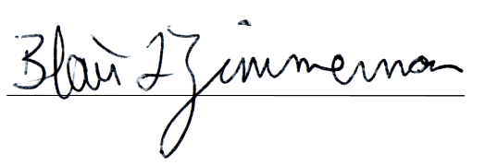Thank you for the opportunity,

In Christ,

HIGH SCHOOL SUNDAY SCHOOL

Dear Church Body,

Things are going really well with Sunday School. We average 3 students each week. We are on the third quarter of the second year of the Answers Bible curriculum. I plan to use the same material this next year.

In Christ’s Love,

Lori Kingery

Lori Kingery

Teacher

ADULT SUNDAY SCHOOL

Andy Curtis continued to teach the adult Sunday school class. We began the year studying from the book of John, after that our lessons were in the book of Thessalonians. In March of 2020 the COVID 19 virus caused our church to be shut down. A few months later, it reopened, but with the dwindling Sunday school attendance, the class was suspended. We hope to be able to return to this class when all health restrictions are lifted.

Valerie Good

ADULT SUNDAY SCHOOL

We meet Sunday mornings at 9:15. Each week we discussed the previous week’s sermon.

In Service to Christ,

Daniel Curtis

SECOND SATURDAY MEN’S BREAKFAST

The men of the church have been meeting for breakfast at 7 a.m. on the second Saturday of each month for breakfast and coffee! During the breakfast one chapter of the Bible is read out loud and discussed. This year the group finished Hebrews and started Romans. Attendance has averaged between 10 and 15 men!

In Service to Christ,

Rusty McGrew

Rusty McGrew

MISSIONS 2020

Baptist Children’s Home $1260.00

Foster care in the U.S., Limited adoption counseling

Orphanage in India

www.baptistchildrenshome.org

Barr, Dan and Brittany $2200.00

Wycliffe Bible Translators

Mission School - Philippines

wycliff.org

[brittany_barr@sil.org](mailto:brittany_barr@sil.org)

dan_barr@sil.org

Birthright of Logansport $1956.00

www.birthright.org/en/landingpage/lp-logansport

Cochrell, Aaron and Stephenie $2200.00

Baptist Mid Missions

Cusco, Peru, South America

[www.cochrells2peru.com](http://www.cochrells2peru.com)

cohrellas 1@gmail.com

Drive-In Ministries $1052.00

Film evangelism at camp facilities in MI and FL

Expanding oversea film evangelism outreach

www.drive-inministries.com

Fishers of Men (Mexico) $2736.00

Julie (Zaragoza) Claausen

Refuge Ranch (orphanage) and medical missions

[www.fishersofmenmexico.org](http://www.fishersofmenmexico.org/)

[www.fishersofmenmexico.blogspot.com](http://www.fishersofmenmexico.blogspot.com/)

fishersofmenmexico@gmail.com

Heart of Africa, Inc $2428.00

Garrett, Tom and Laura

[www.heartofafrica.org](http://www.heartofafrica.org)

[tom.garrett56@gmail.com](mailto:tom.garrett56@gmail.com)

Sam John, Dr. $2620.00

Bible Fellowship of India

[johns@dil.in](mailto:johns@dil.in)

Operation Shoebox, a project of Samaritan’s Purse $2166.00

**Samaritan's Purse** Box 3000 Boone, NC 28607

www.samaritanspurse.org/

MISSIONS 2020

Source of Light (Brazil) $1468.00

Evangelism and discipleship through correspondence

[antoniobibiano@sol.com.br](mailto:antoniobibiano@bol.com.br)

www.sourcelight.org

Standridge, Steven, and Stephanie $2200.00

TEAM – USA

Florence, Italy - church planting

standridgesss@gmail.com

Stilwell, Stephen and Evelyn $2532.00

Baptist Mid-Missions

Church, camp, and seminary development in Peru, South America

<sestilwell@stilwells.org

Weekday Religious Education $913.00

Release time Bible classes in Cass county schools

Zartman, Jarod $2950.00

www.rce-international.org

Serving in International Academy in St. Petersburg, Russia

[j_rod_z_22@hotmail.com](mailto:j_rod_z_22@hotmail.com)

Caston Backpack $1800.00

Daily Bread $800.00

Fulton County Ministerial Association (Food Bank) $430.00

Salvation Army of Cass County $430.00

Twin Lakes Camp $2000.00

Jon Beight, Executive Director

Address: 1451 E. **Twin Lakes** Rd. Hillsboro, IN 47949

Email: [outdoors@twinlakescamp.com](mailto:outdoors@twinlakescamp.com) Office:[765-798-4000](tel:765-798-4000)

Lifliz Beraca in Jeremie, Haiti $1700.00

One year rent for church building

Other & Guest Missionary Speaker $150.00

General Association of Regular Baptist Churches $500.00

A year-end gift of $300 was given to the Barr’s, Cochrell’s, Fisher’s of Men, Heart of Africa, Sam John, Standridge’s, Stillwell’s and Zartman’s, that is included in the above numbers for each.

**Total Missions giving for 2020 $36491.00**

*14.94% of total income

Kevin Robbins

Mission Team

VBS 2020

Due to Covid 19 we were unable to have VBS this year.

Sincerely,

Kristin Curtis

Kristin Curtis

2020 VBS Director

OPERATION CHRISTMAS CHILD – 2020

Following the shipping of shoeboxes in November 2019, little did we know that 2020 would be such a challenging year? This group of amazing ladies took it upon themselves to start creating for Operation Christmas Child 2020. Rolling off of the kitchen tables and sew machines, we had; pillowcase dresses, puppets, tag blankets, picture books, streamers, jump ropes, and so much more.

Once again in 2020 the group crafted 150 shoeboxes to be sent to third world countries. For 2021 they informed me we are going for a total of 180 shoeboxes, which breaks down to 30 boxes in six age groups. I know they have already started working and we can do it.

I can't begin to express my appreciation to the Fulton Baptist Temple for their support in the ministry of this project. The budget of $400.00 is used to purchase supplies, and items we cannot make such as; bowls, spoons, soap, and wash cloths. Above the budget of $400.00 the church also provides the shipping fees for these boxes which is a huge contribution and we thank you so much.

I respectfully ask the Church to once again support and budget for this project in the amount of $400.00 plus shipping fees for 2021.

I can only imagine the smiles on the faces of these young lives that have received a shoebox and invitation to accept Jesus Christ. God is good.

Respectfully submitted,

Peggy Dague

Peggy Dague

2020 CARE MINISTRY TEAM

The care ministry team consists of five women faithfully sharing the responsibility of sending cards to church members and visitors at the discretion of the team.

The types of cards sent were birthday, wedding, anniversary, new baby, sympathy and baptism.

Birthday -- 226

Anniversary -- 65

All Other -- With love, respect and sincerity

It is the intention of the team to make this a part of our own mission work. We have been added to the budget to offset the cost of stamps.

This report was respectfully submitted by the Care Ministry Team.

WOMEN’S FELLOWSHIP

During the year of 2020 there were no meetings held due to the Covid 19 Virus restrictions

During this time President Diane Raber made a call around to the ladies of the fellowship to announce she would be stepping down from her position.

Next year will have to be determined by the new Covid restrictions coming forth.

2020 Officers

President – Diane Raber

Secretary – Donna Emery

Treasurer Team – Diane Raber and Donna Emery

Respectfully Submitted

Donna Emery

MUSIC MINISTRIES

**Sound System Technicians**

Daniel Curtis

Aaron Rush

Blair Zimmerman

**Praise Team, Contemporary Service**

Christi Rush

Adam Rush

Jill Zartman

**Praise Team Traditional Service**

Kristin Curtis

Daniel Curtis

Kevin Robbins

Adam Rush

Adam Tripolone

**Praise Team For Covid Lockdown Service**

Christi Rush

Adam Rush

Braden Rush

Eli Rush

The music team purchased a Roland electronic V Drum kit and necessary accessories. Total amount of purchase was $1809.65.

**First Hour Attendance 2020**

|  |  |  |  |  |  |
| --- | --- | --- | --- | --- | --- |
|  | 1st quarter | 2nd quarter | 3rd quarter | 4th quarter | average |
| Contemporary service | 33 |  | 29 | 30 | 31 |
| Adult Sunday School | 15 | **C** | 9 | 9 | 11 |
| Children’s Sunday School | 27 | **O** | 23 | 25 | 25 |
| Nursery | 0 | **V** | 0 | 0 | 0 |
| Greeters | 3 | **I** | 0 | 0 | 0 |
| Youth Sunday School | 4 | **D** | 4 | 4 | 4 |
| Total | 82 | 0 | 65 | 68 | 71 |

|  |  |  |  |  |  |
| --- | --- | --- | --- | --- | --- |
| **Averages** | **2015** | **2016** | **2017** | **2018** | **2019** |
| Contemporary service | 37 | 42 | 42 | 34 | 32 |
| Adult Sunday School | 9 | 9 | 7 | 19 | 16 |
| Children’s Sunday School | 22 | 21 | 25 | 27 | 28 |
| Nursery | 4 | 1.5 | 1.5 | 1 | 1 |
| Greeters | 3 | 3 | 3 | 3 | 3 |
| Youth Sunday School | 4 | 3.5 | 4.5 | 5 | 5 |
| Total | 79 | 80 | 82 | 89 | 85 |

**Second Hour Attendance 2020**

|  |  |  |  |  |  |
| --- | --- | --- | --- | --- | --- |
|  | 1st quarter | 2nd quarter | 3rd quarter | 4th quarter | average |
| Traditional service | 126 | COVID | 99 | 84 | 103 |
| Traditional nursery | 3 | COVID | 2 | 3 | 3 |

|  |  |  |  |  |  |
| --- | --- | --- | --- | --- | --- |
| **Averages** | **2015** | **2016** | **2017** | **2018** | **2019** |
| Traditional service | 142 | 146 | 144 | 146 | 135 |

**Total Number of Individuals Attending 2020**

|  |  |  |  |  |  |
| --- | --- | --- | --- | --- | --- |
|  | 1st quarter | 2nd quarter | 3rd quarter | 4th quarter | average |
| Both Services 2020 | 154 | COVID | 117 | 100 | 124 |

|  |  |  |  |  |  |
| --- | --- | --- | --- | --- | --- |
|  | 1st quarter | 2nd quarter | 3rd quarter | 4th quarter | average |
| Both Services 2019 | 146 | 170 | 172 | 155 | 161 |
| Both Services 2018 | 170 | 187 | 166 | 173 | 174 |
| Both Services 2016 | 169 | 171 | 170 | 149 | 165 |
| Both Services 2015 | 160 | 159 | 155 | 154 | 157 |
| Both Services 2014 | 148 | 154 | 164 | 160 | 157 |
| Both Services 2013 | 164 | 169 | 161 | 160 | 161 |
| Both Services 2012 | 137 | 170 | 147 | 155 | 152 |

**Fulton Baptist Temple Active Membership List 2020**

Glen Albright

Vicki Albright

Charles Baird

Dorothy Baird

Mary Baker

Barry Baldwin

Linda Baldwin

Leslie Good Beagle

Trisha Bennett

Ashley Berry

Charles Binkerd

Marjorie Binkerd

Wilma Bryant

Craig Bugno

Sue Bugno

Kaitlyn Bugno

Linda Clouse

Andy Curtis

Debra Curtis

Daniel Curtis

Kristin Curtis

Ella Curtis

Isaac Curtis

Jim Dague

Peggy Dague

Steve Ellis

Karla Ellis

David Emery

Donna Emery

David Fincher

Linda Fincher

Sonja Folger

David Fred

Julie Fred

Eli Fred

Bre Fred

James Fred

Kourtney Fred

Scott Fred

Lisa Fred

Megan Fred

Ashley Fred

William Fred

Debe Fred

Larry Friedrich

Gloria Friedrich

Mark Gardner

Lesia Gardner

Larry Gearhart

Greg Gearhart

Cheryl Gearhart

Lester Good

Valerie Good

Barb Hites

Marilou Hoehne Lynne Hoehne

Armstrong

Tracy Howdeshell

Alex Howdeshell

Nolan Hutsell

Benaiah Hutsell

Kaitlyn Hutsell

Karen Hutsell

Bill Jones

Pat Jones

Alan Kingery

Lori Kingery

Amber Kraniak

Wendy Lauderback

Ella Lockwood

David Mangelsdorf

Emily Mangelsdorf

Rusty McGrew

Danielle McGrew

Drew McGrew

Simon McGrew

Larry Mikesell

Bonnie Mikesell

Barb Miller

Mary Miller

Ruth Ann Miller

Carter Moss

Jim Muehlhasen

Sally Muehlhasen

Dick Nead

Patty Nead

Tammy Olinger

Joyce Powlen

Phil Powlen

Darla Powlen

Gary Raber

Diane Raber

Jackson Rentschler

Jillian Rentschler

Lori Remley

Judy Rimpler

Kevin Robbins

Abby Robbins

Randy Rogers

Betty Rogers

Richard Roller

Shannon Roller

Selena Rouch

Aaron Rush

Christi Rush

Adam Rush

Braden Rush

Eli Rush

Bruce Russell

Beth Russell

Caleb Russell

Julie Russell

Alan Smith

Kathy Smith

Jeff Smith

Diana Smith

Andrew Smith

Adrianna Smith

Mark Smith

Sam Smith

Don St. Clair

Marilyn St. Clair

Alan Taylor

Liz Taylor

Jacob Taylor

**Fulton Baptist Temple Active Membership List 2020**

Danny Taylor

Tara Taylor

Brent Thomas

Elizabeth Thomas

Olivia Thomas

Cindy Trent

Gage Thomas

Adam Tripolone

Jennifer Tripolone

Linda Wade

Aaron Wilson

Stephanie Wilson

Jarod Zartman

Randy Zartman

Jill Zartman

Harriet Zartman

Ryan Zimpleman

Lisa Zimpleman

Emma Zimpleman

Blair Zimmerman

Emma Zimmerman

Sara Zimmerman Xavier Zimmerman

Savannah Zimmerman

Trinity Zimmerman

**Total 148**

**New Members 2020**

By Baptism

NONE

TRANSFER

NONE

**DEATHS**

NONE

**Inactive Membership List 2020**

Rebecca Baldwin

Heather Bugno

Amy Miller Clark

Joshua Craig

Nathan Craig

Ryan Craig

Steven Curtis

Rita Dewitt

Annie D’ornellas

Mark D’ornellas

Bill Eber

Shelly Ewing

Donald Fisher

Donna Gearhart

Misty Gearhart

Tim Good

Heather Green

Betty Lou Harvey

Sandy Henderson

Anita Hoehne

Cindy Horn

Phyllis Hudkins

Jenny Remley

Konkle

Andrea Mangelsdorf

Lucinda Mikesell

Bruce Miller

Will Miller

Jeanne Mills

Larry Mueller

Kris Mueller

Jon Mueller

Michael Paschen

Tina Paschen

McKenzie Paschen

Emilee Parsons

Laura Parsons

Keith Parsons

Connie Reffitt

Cindy Rentschler

Colleen Rentschler

Laura Rentschler

Curt Richter

Haley Rouch

Ryan Rouch

Ruth Ann Rudicel

Becky Schram

Amy Seeman

Sonja Lynn Showley

Janie Shriver

Jenny Smith

Bill Spangler

Matt Stevens

Casey Ward Susit

Oliver Wade

Amy Widman

Ray Widman

Melinda Willis

Alicia Zartman Hall

Carolyn Zartman

Erica Zartman

Silas Zartman

Jack Zimpleman

**Total Inactive Membership 62**

May the Lord bless you

and protect you.

May the Lord smile on you

and be gracious to you.

May the Lord show you his favor

and give you his peace.

Numbers 6:24 – 26

The Hebrew concept of peace (*shalom*) is all embracing and includes the concepts of completeness, security, health, tranquility, contentment, friendship and peace with God and man.