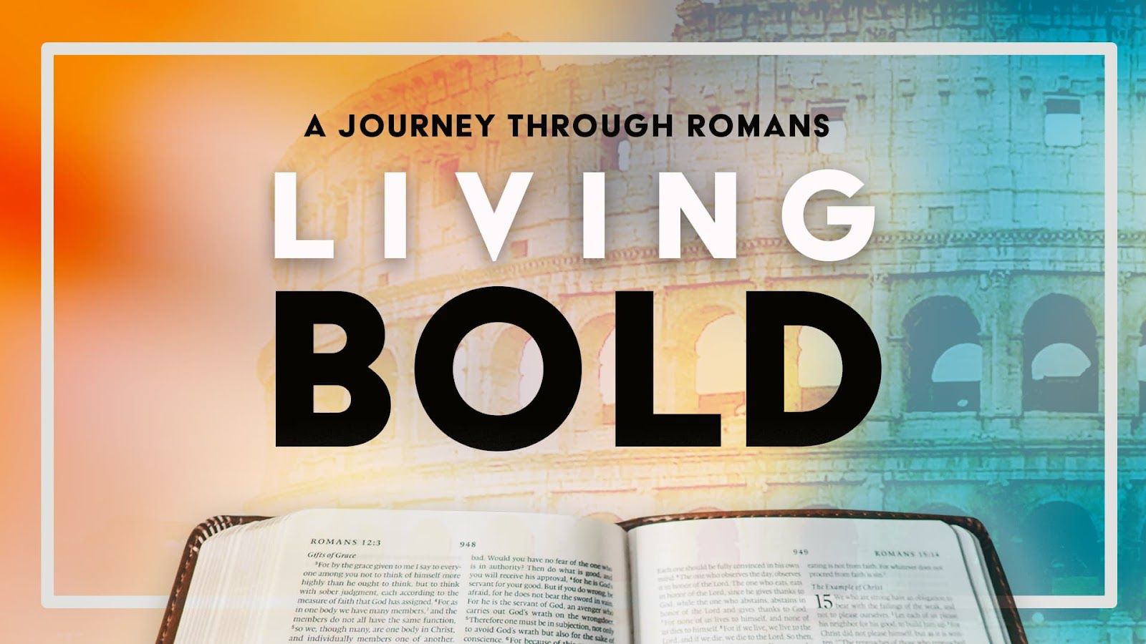

Message 6: The Assurance
Deep Dive Supplemental Notes on Chapters 9-11

In Romans 9–11, Paul returns to the immediate problem the letter is meant to address—the conflict between Jewish and Gentile Christians. We addressed this in “The Problem” message in week one when we looked at Chapters 1-3. You can listen to that message On Demand at www.cityunited.church/media.

Romans Chapter 9
- The Nine Spiritual Advantages of God’s Sovereign Selection (9:1–5)

A. Paul’s grief over Israel (9:1–3): The apostle is so burdened over Israel’s unbelief that he is willing to suffer eternal damnation if that would help them come to Christ.

B. God’s gifts to Israel (9:4–5)
1. They are a special nation (9:4a).
2. They have been adopted by God (9:4b, 5).
3. They have had God’s glory revealed to them (9:4c).
4. They have been given the covenants (9:4d).
5. They have been given the law (9:4e).
6. They have the privilege of worshiping him (9:4f).
7. They have the messianic promises (9:4g).
8. They have a godly ancestry (9:5a).
9. They are the people from which Christ came (9:5b).
II. The Five Personal Examples of This Sovereign Selection (9:6–29)

- The example of Ishmael and Isaac (9:6–10): God chose Isaac (Abraham’s son through Sarah) over Ishmael (Abraham’s son through Hagar)

B. The example of Esau and Jacob (9:11–13)
1. What God did (9:12b–13): He chose Jacob (the second-born twin son of Isaac) over Esau (the firstborn twin).
2. When God did it (9:11a, 12a): He made this choice long before they were even born.
3. Why God did it (9:11b): He did it to show that his sovereign decrees are not based on what yet-unborn human beings might or might not do.

C. The example of Pharaoh (9:14–24)
1. The facts involved (9:15–18)

a. God determined to pardon sinful Israel with undeserved grace (9:15–16).
b. God determined to punish sinful Pharaoh with deserved judgment (9:17–18).

2. The fairness involved (9:14, 19–24)
a. In light of this, is God righteous? Yes! (9:14, 21–24).
(1) As a potter creates vessels, God creates nations (9:14, 21–22).
(2) As a potter controls those vessels, God controls nations (9:23–24).
b. In light of this, is man responsible? Yes! (9:19–20): As the vessels have no right to criticize the potter, the nations have no right to criticize the Lord.

D. The example from Hosea (9:25–26): This Old Testament prophet predicted that God would not limit his grace to Israel but would save repenting Gentile peoples; Hosea called these Gentiles “children of the living God” (Hos. 2:23; 1:10).

E. The example from Isaiah (9:27–29): Paul quotes from Isaiah to demonstrate God’s sovereignty concerning Israel.

1. Out of the millions of Israelites, only a small remnant will be saved (Isa. 10:22–23) (9:27–28).
2. Even the remnant would perish apart from the grace of God (Isa. 1:9) (9:29).
III. The Two Grand Conclusions concerning This Sovereign Selection (9:30–33)

- Through faith the Gentiles have found righteousness without even seeking it (9:30).

B. Through the law Israel has not found righteousness even after seeking it (9:31–33).

1. The seeking (9:31–32): They tried to be saved by works.
2. The stumbling (9:33): They have stumbled over Christ the rock, as predicted by Isaiah (Isa. 8:14; 28:16).
Romans Chapter 10
Paul overviews God’s righteousness and Israel’s present rejection.
I. The Prayer concerning God’s Righteousness (10:1–3)
A. The prayer (10:1): Paul prays for Israel’s salvation.
B. The problem (10:2–3): Israel possesses:
1. Zeal without knowledge (10:2–3a)
2. Works without faith (10:3b)
II. The Source of God’s Righteousness (10:4–5)
A. It is found in Christ (10:4).
B. It was foretold by Moses (Lev. 18:5) (10:5).
III. The Availability of God’s Righteousness (10:6–8)
A. Negative (10:6–7): One need not search the heavens or descend into the deep to find it.
B. Positive (10:8): It is, through Christ, as near as one’s mouth and heart! Moses predicted this in Deuteronomy 30:12–14.
IV. The Reception of God’s Righteousness (10:9–10): Both one’s heart and mouth are involved.
A. It is conceived in the heart (10:9b–10a).
B. It is confirmed by the mouth (10:9a, 10b).
V. The Scope of God’s Righteousness (10:11–13)
A. It is impartial (10:11–12): It does not distinguish between Jews and Gentiles.
B. It is universal (10:13): Anyone calling on the name of the Lord will be saved.
VI. The Presentation of God’s Righteousness (10:14–15): Paul presents a compelling case for faithful witnessing.
A. A sinner must call on the Lord to be saved (10:14a).
B. A sinner must believe in order to call (10:14b).
C. A sinner must hear in order to believe (10:14c–15): Isaiah described the results: “How beautiful … are the feet of those who bring good news” (Isa. 52:7).
VII. The Rejection of God’s Righteousness (10:16–21)
A. Israel has heard the Good News (10:18): Paul proves this by quoting from Psalm 19:4.
B. Israel has refused to heed the Good News (10:16–17, 19–21).
1. Isaiah predicted this (10:16–17, 20–21): See Isaiah 53:1; 65:1–2.
2. Moses predicted this (10:19): See Deuteronomy 32:21.

Romans Chapter 11
Paul overviews the wisdom of God and Israel’s future restoration.

- This Future Restoration Is Assured because Israel’s Present Rejection Is Not Total (11:1–10, 11b–24).

A. The factions of Israel (11:1–10): Paul divides Israel into two groups.
1. The minority group (11:1–6)
a. As represented by Paul in the New Testament (11:1): His own conversion shows that God has not rejected all Israelites.
b. As represented by Elijah in the Old Testament (11:2–6): This powerful prophet, along with 7,000 other Israelites, did not bow to Baal (see also 1 Kings 19:18).

2. The majority group (11:7–10): Three Old Testament men predicted that God would harden the hearts of unbelieving Israel.
a. Moses (Deut. 29:4) (11:7–8a)
b. David (Ps. 69:22–23) (11:9–10)
c. Isaiah (Isa. 29:10) (11:8b)

B. The fullness of the Gentiles (11:11b–25): This phrase refers to a specific period of time.

1. The definition of this period (11:25): It is the time span involved in the completion of the body of Christ, consisting of both Jews and Gentiles, beginning at Pentecost and ending at the Rapture.

2. The details concerning this period (11:11b–24)
a. The purpose (11:11b–12): One purpose is to make Israel jealous to be in God’s favor again.
b. The preacher (11:13–15): Paul has been appointed by God himself to help make this a reality.
c. The parable (11:16–24): Paul employs an olive tree to illustrate all this.
(1) The roots of the tree are made up of Abraham and other godly Old Testament men (11:16).
(2) Some of the original branches have been broken off, referring to unbelieving Jews (11:17a).
(3) Now some branches from a wild olive tree have been grafted in, referring to believing Gentiles (11:17b–23).
(4) The once-removed original branches will someday be grafted back in, referring to the future repentant Israel (11:24).
II. This Future Restoration Is Assured because Israel’s Present Rejection Is Not Final (11:11a, 26–36).
- The Israel of God (11:11a, 26–32)

1. The foretelling (11:11a, 26–27)

a. Israel restored through the promised Christ (11:26): Isaiah predicted that the Deliverer would accomplish this (Isa. 59:20).
b. Israel restored through the promised covenant (11:27): Isaiah predicted that God would keep his covenant with Israel (Isa. 59:21).

2. The faithfulness (11:28–32): All the above will come to pass, for God’s gifts and calling are irrevocable.

B. The God of Israel (11:33–36): Paul praises God by uttering one of Scripture’s greatest doxologies.

