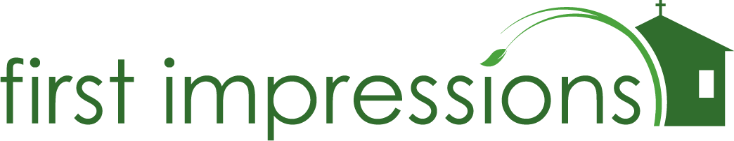

Dear Family,

There’s an old saying, “you never get a second chance at a first impression”. It is so true and has never been truer than today. Our first impression says five things in thirty seconds.
1. We will steward our resources well and maintain what we are blessed with. So, we will care for your soul here just as dearly.
2. We care about our testimony to the outside world. So, we will minister to honor the reputation of the gospel to our city.
3. We value our neighborhood and will do our part to maintain it. So, we will bring beauty and love to our neighbors.
4. We value safety. So, we will be safe to be trusted with the care of your children, your hopes, your fears, and we will work to stay that safe.
5. We care about what houses our most precious things. So, we will deeply care about you, your family, and all you hold dear.

We live in a society that just doesn’t have time to look past the surface to the heart of a church. So, we must communicate loudly and clearly, all that we are with everything we are. Our building is our first impression.
We need your partnership in communicating all that we are to our city. To do that, we are starting our “First Impressions” initiative. “First Impressions” is our special effort together to raise funds for our immediate priorities which communicate all that we are to our city. This exciting initiative is above and beyond your tithe or regular giving to the church. You can participate in a variety of ways, for example, by giving to a project as a one-time gift, or by monthly commitment. Here is how you can participate…

… by focusing on one area and giving to one or more of those specific areas.
2020 Projects
January to May Chairs – Buy one chair for you and your family and your “Just One” person. $47 per chair
COMPLETED! Total $9,400

2021 Projects
July: Gutters for the perimeter of the building $11,000
September - Parking lot resurface. $24,500
Sidewalk on 17th St $6,500
Third Story renovation $30,000
TOTAL $78,000
Or a monthly commitment for the next three years of $25 a month for a total of $900.00
Or a monthly commitment for the next three years of $40 a month for a total of 1,440.00
Thank you for your prayerful consideration as we move ahead and start with a good impression, which also has an impact on our city as we seek to make our facility a place where the city can be welcomed home and belong. Please pray and ask the Lord how to be involved.

In Christ's Adventure,
Rick

