7th Sunday After Pentecost
Proper 12

July 24, 2022

The season after Pentecost Sunday and leading up to Advent is referred to as Ordinary Time. It does not mean the time is boring and mundane, but rather “Ordinary” refers to the “ordinal” way that the church calendar counts the Sundays from Pentecost until the Season of Advent. Historically the church has used this time to more fully flesh out Christ’s work in the lives of her people, in the church as a whole, or in Christ’s Kingdom over all the earth. Robert Webber writes that during Ordinary Time,
Many worship traditions follow lectionaries that highlight the work of the Spirit in the mission of the church in the world. Other churches organize their worship life around a lectio continua, continuous readings from a given section of Scripture. Some worship traditions have also called this season ‘Kingdomtime,’ focusing on the kingdom of God that is present now and the one that will be realized in more profound ways in the future….
[Thus] the various Sundays are not connected by a particular theme. In Advent we await the coming of Christ; during Christmas, we celebrate his arrival; and at Epiphany, we proclaim that Christ is manifested to the world as Savior. During Lent, we prepare for the death; in Holy Week, we reenact his death; then in Easter, we celebrate his resurrection and complete the Easter cycle with the celebration of the coming of the Holy Spirit. But in the nonfestive season of the church year, there is no unified theme that ties the Sundays together.
At Advent Houston, we want to use this “nonfestive” season to focus on our particular mission in this particular time and place that God has for particular individuals like us. We want to minister to one another in the distinct ways that we need to hear the good news of what Jesus has done, and we want to practice our faith in light of the truth that Christ has died, Christ is risen, and Christ will come again.

REFLECTION

[1] I give you thanks, O LORD, with my whole heart;
before the gods I sing your praise;
[2] I bow down toward your holy temple
and give thanks to your name for your steadfast love and your faithfulness,
for you have exalted above all things
your name and your word.
[3] On the day I called, you answered me;
my strength of soul you increased.
…
[7] Though I walk in the midst of trouble,
you preserve my life;
you stretch out your hand against the wrath of my enemies,
and your right hand delivers me.
[8] The LORD will fulfill his purpose for me;
your steadfast love, O LORD, endures forever.
Do not forsake the work of your hands. (ESV)
-Psalm 138:1-3; 7-8

[2] Son of man, prophesy against the shepherds of Israel; prophesy, and say to them, even to the shepherds, Thus says the Lord GOD: Ah, shepherds of Israel who have been feeding yourselves! Should not shepherds feed the sheep? [3] You eat the fat, you clothe yourselves with the wool, you slaughter the fat ones, but you do not feed the sheep. [4] The weak you have not strengthened, the sick you have not healed, the injured you have not bound up, the strayed you have not brought back, the lost you have not sought, and with force and harshness you have ruled them…. [11] For thus says the Lord GOD: Behold, I, I myself will search for my sheep and will seek them out. [12] As a shepherd seeks out his flock when he is among his sheep that have been scattered, so will I seek out my sheep, and I will rescue them from all places where they have been scattered on a day of clouds and thick darkness. (ESV)
- Ezekiel 34:2–4; 11-12

*Call to Worship – From Psalm 138
Leader: All the kings of the earth shall give you thanks, O LORD,
People: For they have heard the words of your mouth,

Leader: And they shall sing of the ways of the LORD,
People: For great is the glory of the LORD.

Leader: For though the LORD is high, he regards the lowly,
People: I give you thanks, O LORD, with my whole heart.

*Song – Crown Him with Many Crowns
Crown Him with many crowns,
The Lamb upon His throne.
Hark! How the heavenly anthem drowns
All music but its own.
Awake, my soul and sing Of Him
Who died for thee,
And hail Him as thy matchless King
Through all eternity.

Crown Him the Lord of love,
Behold His hands and side,
Rich wounds, yet visible above,
In beauty glorified.
No angel in the sky
Can fully bear that sight,
But downward bends His wond'ring eye
At mysteries so bright.

Crown Him the Lord of life,
Who triumphed o'er the grave,
Who rose victorious to the strife
For those He came to save.

His glories now we sing,
Who died, and rose on high
Who died eternal life to bring,
And lives that death may die.

Crown Him the Lord of heav'n,
One with the Father known,
One with the Spirit through Him giv'n
From yonder glorious throne,
To Thee be endless praise
For Thou for us hast died;
Be Thou, O Lord, through endless days
Adored and magnified.

Crown Him the Lord of years,
The Potentate of time,
Creator of the rolling spheres,
Ineffably sublime.
All hail, Redeemer, hail!
For Thou has died for me;
Thy praise shall never never fail
Throughout eternity.

Prayer of Adoration Book of Common Prayer
Leader: We give you thanks, most gracious God, for the beauty of earth, sky and sea; for the richness of mountains, plains, and rivers; for the songs of birds and the loveliness of flowers. We praise you for these good gifts, and grant that we may continue to grow in our grateful enjoyment of your abundant creation, to the honor and glory of your Name.

Leader continues to pray in thanksgiving and adoration.

Old Testament Reading Genesis 18:20-32
[20] Then the LORD said, “Because the outcry against Sodom and Gomorrah is great and their sin is very grave, [21] I will go down to see whether they have done altogether according to the outcry that has come to me. And if not, I will know.”

[22] So the men turned from there and went toward Sodom, but Abraham still stood before the LORD. [23] Then Abraham drew near and said, “Will you indeed sweep away the righteous with the wicked? [24] Suppose there are fifty righteous within the city. Will you then sweep away the place and not spare it for the fifty righteous who are in it? [25] Far be it from you to do such a thing, to put the righteous to death with the wicked, so that the righteous fare as the wicked! Far be that from you! Shall not the Judge of all the earth do what is just?” [26] And the LORD said, “If I find at Sodom fifty righteous in the city, I will spare the whole place for their sake.”

[27] Abraham answered and said, “Behold, I have undertaken to speak to the Lord, I who am but dust and ashes. [28] Suppose five of the fifty righteous are lacking. Will you destroy the whole city for lack of five?” And he said, “I will not destroy it if I find forty-five there.” [29] Again he spoke to him and said, “Suppose forty are found there.” He answered, “For the sake of forty I will not do it.” [30] Then he said, “Oh let not the Lord be angry, and I will speak. Suppose thirty are found there.” He answered, “I will not do it, if I find thirty there.” [31] He said, “Behold, I have undertaken to speak to the Lord. Suppose twenty are found there.” He answered, “For the sake of twenty I will not destroy it.” [32] Then he said, “Oh let not the Lord be angry, and I will speak again but this once. Suppose ten are found there.” He answered, “For the sake of ten I will not destroy it.” (ESV)

Leader: The Word of the LORD
People: Thanks be to God.

Epistle Reading Colossians 2:6-19
[6] Therefore, as you received Christ Jesus the Lord, so walk in him, [7] rooted and built up in him and established in the faith, just as you were taught, abounding in thanksgiving.

[8] See to it that no one takes you captive by philosophy and empty deceit, according to human tradition, according to the elemental spirits of the world, and not according to Christ. [9] For in him the whole fullness of deity dwells bodily, [10] and you have been filled in him, who is the head of all rule and authority. [11] In him also you were circumcised with a circumcision made without hands, by putting off the body of the flesh, by the circumcision of Christ, [12] having been buried with him in baptism, in which you were also raised with him through faith in the powerful working of God, who raised him from the dead. [13] And you, who were dead in your trespasses and the uncircumcision of your flesh, God made alive together with him, having forgiven us all our trespasses, [14] by canceling the record of debt that stood against us with its legal demands. This he set aside, nailing it to the cross. [15] He disarmed the rulers and authorities and put them to open shame, by triumphing over them in him.

[16] Therefore let no one pass judgment on you in questions of food and drink, or with regard to a festival or a new moon or a Sabbath. [17] These are a shadow of the things to come, but the substance belongs to Christ. [18] Let no one disqualify you, insisting on asceticism and worship of angels, going on in detail about visions, puffed up without reason by his sensuous mind, [19] and not holding fast to the Head, from whom the whole body, nourished and knit together through its joints and ligaments, grows with a growth that is from God. (ESV)

Leader: The Word of the LORD.
People: Thanks be to God.

*Song – How Deep The Father’s Love for Us
How deep the Father's love for us
How vast beyond all measure
That He should give His only Son
To make a wretch His treasure
How great the pain of searing loss
The Father turns His face away
As wounds which mar the Chosen One
Bring many sons to glory

Behold the man upon a cross
My sin upon His shoulders
Ashamed, I hear my mocking voice
Call out among the scoffers
It was my sin that held Him there
Until it was accomplished
His dying breath has brought me life
I know that it is finished

I will not boast in anything
No gifts, no power, no wisdom
But I will boast in Jesus Christ
His death and resurrection
Why should I gain from His reward?
I cannot give an answer
But this I know with all my heart
His wounds have paid my ransom

Prayers of the People
People: Almighty God, the fountain of all wisdom, you know our necessities before we ask and our ignorance in asking: Have compassion on our weakness, and mercifully give us those things which for our unworthiness we dare not, and for our blindness we cannot ask; through the worthiness of your Son Jesus Christ our Lord, who lives and reigns with you and the Holy Spirit, one God, now and for ever. Amen.

Leader continues to intercede on behalf of the community, the Church, and the world.

Leader: We pray all of this in the name of Jesus who taught us to pray, saying…
People: Our Father, who art in heaven,
hallowed be Your Name,
your kingdom come,
your will be done,
on earth as it is in heaven.
Give us this day our daily bread.
And forgive us our debts,
as we forgive our debtors.
And lead us not into temptation,
but deliver us from evil.
For Yours is the kingdom,
and the power, and the glory,
for ever and ever. Amen.

*Gospel Reading John 10:1-18
[1] “Truly, truly, I say to you, he who does not enter the sheepfold by the door but climbs in by another way, that man is a thief and a robber. [2] But he who enters by the door is the shepherd of the sheep. [3] To him the gatekeeper opens. The sheep hear his voice, and he calls his own sheep by name and leads them out. [4] When he has brought out all his own, he goes before them, and the sheep follow him, for they know his voice. [5] A stranger they will not follow, but they will flee from him, for they do not know the voice of strangers.” [6] This figure of speech Jesus used with them, but they did not understand what he was saying to them.

[7] So Jesus again said to them, “Truly, truly, I say to you, I am the door of the sheep. [8] All who came before me are thieves and robbers, but the sheep did not listen to them. [9] I am the door. If anyone enters by me, he will be saved and will go in and out and find pasture. [10] The thief comes only to steal and kill and destroy. I came that they may have life and have it abundantly. [11] I am the good shepherd. The good shepherd lays down his life for the sheep. [12] He who is a hired hand and not a shepherd, who does not own the sheep, sees the wolf coming and leaves the sheep and flees, and the wolf snatches them and scatters them. [13] He flees because he is a hired hand and cares nothing for the sheep. [14] I am the good shepherd. I know my own and my own know me, [15] just as the Father knows me and I know the Father; and I lay down my life for the sheep. [16] And I have other sheep that are not of this fold. I must bring them also, and they will listen to my voice. So there will be one flock, one shepherd. [17] For this reason the Father loves me, because I lay down my life that I may take it up again. [18] No one takes it from me, but I lay it down of my own accord. I have authority to lay it down, and I have authority to take it up again. This charge I have received from my Father.” (ESV)

Leader: The Gospel of the LORD
People: Praise be to you, LORD Christ.

Sermon Rev. Taylor Leachman
“Creating God in Our Image”

Passing of the Peace
Leader: The Peace of the LORD be always with you.
People: And also with you!
RETURN OF CHILDREN
During the Offertory, “ADVENTURERS” teachers will bring the children back to the Sanctuary. Feel free to pick up younger children at this time as well. You may also wait to retrieve them, as childcare is provided for the duration of the service.

WELCOME

Offertory & Private Prayer

*Affirmation of Faith Nicene Creed
(The Nicene Creed is an ecumenical creed that was written at the Council of Nicea in 325AD)

ALL: We believe in one God the Father Almighty, Maker of heaven and earth, and of all things visible and invisible.
And in one Lord Jesus Christ, the only-begotten Son of God, begotten of the Father before all worlds, God of God, Light of Light, Very God of Very God, begotten, not made, being of one substance with the Father by whom all things were made; who for us men, and for our salvation, came down from heaven, and was incarnate by the Holy Spirit of the Virgin Mary, and was made man, and was crucified also for us under Pontius Pilate. He suffered and was buried, and the third day he rose again according to the Scriptures, and ascended into heaven, and sitteth on the right hand of the Father. And he shall come again with glory to judge both the quick and the dead, whose kingdom shall have no end.
And we believe in the Holy Spirit, the Lord and Giver of Life, who proceedeth from the Father and the Son, who with the Father and the Son together is worshipped and glorified, who spoke by the prophets. And we believe one holy catholic and apostolic Church. We acknowledge one baptism for the remission of sins. And we look for the resurrection of the dead, and the life of the world to come. Amen.

Confession of Sin
Leader: Most holy and merciful Father, we acknowledge before you our sinful nature and our many offenses.
People: We are prone to do evil and slow to do good.

(Silence)

Leader: You alone know how often we have sinned in wandering from your way, in wasting your gifts, in forgetting your love.
People: Lord, we are ashamed and sorry for all the ways that we have displeased you.

(Silence)

Leader: Father, teach us to hate our rebellious acts, cleanse us from our secret faults, and forgive our sins for the sake of your Son.
People: Help us to love you with all our heart and mind and strength.

(Silence)

Leader: And give us the power of your Holy Spirit so that we may walk in your ways and serve you all of our days. Amen.

(Silence)

*Assurance of Pardon John 10:7-11, Matt 18:12-14
Leader: Jesus says. “I am the gate [for the sheep]; whoever enters through me will be saved. They will come in and go out and find pasture. The thief comes only to steal and kill and destroy; I have come that [you, my sheep] may have life, and have it to the full. I am the good shepherd. The good shepherd lays down his life for the sheep”

Leader: “What do you think? If a man owns a hundred sheep and one of them wanders away, will he not leave the ninety-nine on the hills and go out and look for the one of them that wandered off? And if he finds it, I tell you the truth that he is happier about the one sheep than about the ninety-nine that did not wander off. In the same way your Father in heaven is not willing that any of [you] little ones should be lost.” Almighty God have mercy on you, forgive you all your sins through our Lord Jesus Christ, strengthen you in all goodness, and by the power of the Holy Spirit keep you in eternal life.

Leader: Almighty God have mercy on you, forgive you all your sins through our Lord Jesus Christ, strengthen you in all goodness, and by the power of the Holy Spirit keep you in eternal life.

Celebration of Holy Communion
People: We do not presume to come to this, Your Table, O merciful Lord, trusting in our own righteousness, but in your manifold and great mercies. We are not worthy so much as to gather up the crumbs under your Table. But you are the same Lord whose property is always to have mercy. Grant us therefore, gracious Lord, so to eat the flesh of your dear Son Jesus Christ, and to drink his blood, that our sinful bodies may be made clean by his body and our souls washed through his most precious blood that we may evermore dwell in him, and he in us. We pray through Jesus Christ our Lord, Amen.

Leader: The LORD be with you.
People: And also with you.

Leader: Lift up your hearts.
People: We lift them up unto the LORD.

Leader: Let us give thanks to the LORD, our God.
People: It is right to give him thanks and praise.

Leader: It is very good and right, our duty and privilege, to at all times, and in all places, give thanks unto you, O Lord, holy Father, almighty and everlasting God. Therefore with Angels and Archangels, and with all the company of heaven, we laud and magnify your glorious Name; evermore praising you, and saying…

People:
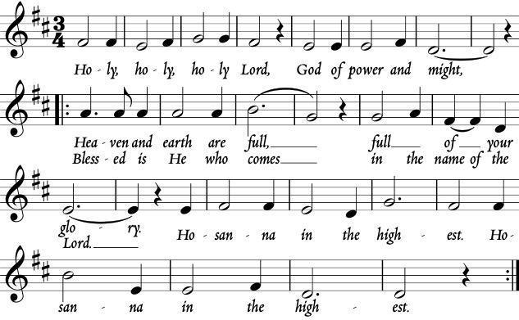

Words of Institution

Leader: Let us proclaim the mystery of faith:

All: Christ has died.
Christ is risen.
Chris will come again.

Leader: Christ, our Passover, has been sacrificed for us.
People: Therefore, let us keep the feast.

Leader: Let us give thanks to the LORD, our God.

We serve both wine and grape juice for communion.
Grape juice is available in the center of the communion trays; wine is available on the edge.
All communion bread is gluten free.
Advent welcomes all baptized Christians to participate in the lord’s table. this includes all Christians, whether members at advent or at another church. Children who have been baptized and admitted to the table by the elders of this church or the leadership of another church are also welcome to the table.
If you're still investigating Christianity, not sure what you believe, or simply choose not to participate, you may either remain in your seat or come forward, cross your arms over your chest, and receive a blessing. Feel free to use the prayers printed in the bulletin below as well. Non-communing children are encouraged to come forward to receive a blessing while their parents receive communion.

Communion Song – Dear Refuge of My Weary Soul
Dear refuge of my weary soul,
On Thee, when sorrows rise
On Thee, when waves of trouble roll,
My fainting hope relies
To Thee I tell each rising grief,
For Thou alone canst heal
Thy Word can bring a sweet relief,
For every pain I feel

But oh! When gloomy doubts prevail,
I fear to call Thee mine
The springs of comfort seem to fail,
And all my hopes decline
Yet gracious God, where shall I flee?
Thou art my only trust
And still my soul would cleave to Thee
Though prostrate in the dust

Hast Thou not bid me seek Thy face,
And shall I seek in vain?
And can the ear of sovereign grace,
Be deaf when I complain?
No still the ear of sovereign grace,
Attends the mourner's prayer
Oh may I ever find access,
To breathe my sorrows there

Thy mercy seat is open still,
Here let my soul retreat
With humble hope attend Thy will,
And wait beneath Thy feet,
Thy mercy seat is open still,
Here let my soul retreat
With humble hope attend Thy will,
And wait beneath Thy feet

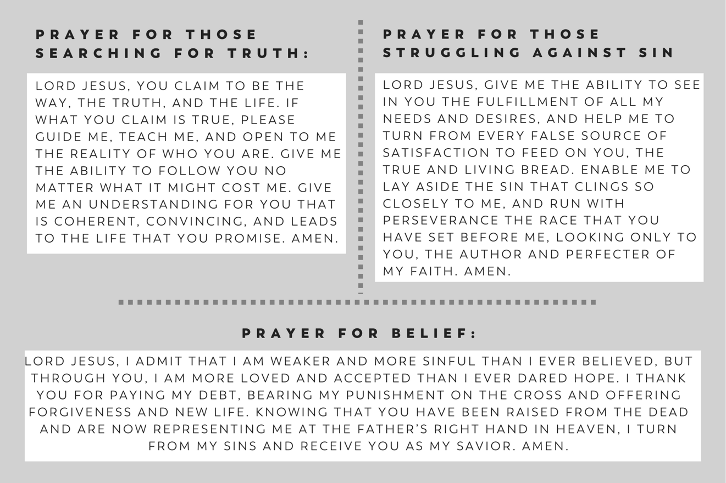

*Song – Boldly I Approach
By grace alone somehow I stand
Where even angels fear to tread
Invited by redeeming love
Before the throne of God above
He pulls me close with nail-scarred hands
Into His everlasting arms

When condemnation grips my heart
And satan tempts me to despair
I hear the voice that scatters fear
The Great I Am The Lord is here
Oh praise the One who fights for me
And shields my soul eternally

Chorus
Boldly I approach your throne
Blameless now I'm running home
By your blood I come
Welcomed as your own
Into the arms of majesty

Behold the bright and risen Son
More beauty than this world has known
I”m face to face with love Himself
His perfect spotless righteousness
A thousand years, a thousand tongues
Are not enough to sing His praise

Bridge
This is the art of celebration
Knowing were free from condemnation
Oh praise the One, praise the One
Who made an end to all my sin

*Closing Prayer of Thanksgiving and Mission

*Benediction
Leader: May the God of hope fill you with all joy and peace in believing, so that by the power of the Holy Spirit you may abound in hope.

Announcements
SAVE THE DATE!
We will officially launch our regular Sunday Worship on August 21. We will have four weeks of preparatory services beginning July 24–which are open to all but will not be publicly advertised.

PROOF READING
Join us on August 3 at 7:00 pm at the Leachmans’ home (4517 Evergreen St, 77401) for a discussion and review of the book Jesus and John Wayne by Kristin Kobes Du Mez. We will have dinner, discussion, a cocktail inspired by the book, and dessert.

Please check out our other events by visiting adventpres.org/events or scanning the listed QR code.

Media Release
Advent Houston shares photos taken at our events in our monthly newsletters, on our website, or on social media for the purpose of promoting and highlighting the church’s mission. By being present, you consent to being photographed and having these photos shared. For individuals who are not comfortable being visible in a shared photograph, please notify the church at admin@adventpres.org to opt out of the media release.

Advent Presbyterian Church of Houston
2617 Bissonnet St
Suite 200, #227
Houston, TX 77005

(713) 364-6748‬

http://adventpres.org

ADVENT’S HOUSTON EXISTS TO EMBRACE, EMBODY, AND EXTEND THE GRACE OF JESUS TO THE TEXAS MEDICAL CENTER, RICE UNIVERSITY, AND THE GREATER WEST UNIVERSITY AREA.

