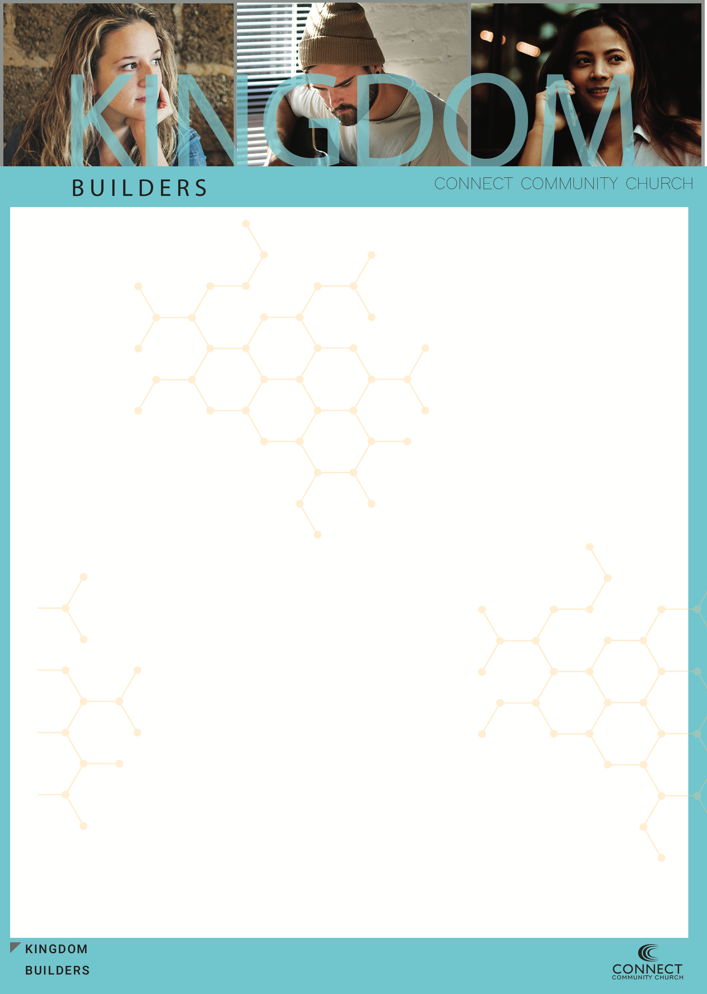

1. We should allow the Kingdom of God and the King to ________ us

**Hebrews 5:14 (NASB)   
14  But solid food is for the mature, who because of practice have their senses trained to discern good and evil.**

2. In order to be a citizen of this ________ we need to know the ways of the Kingdom.

3. God is trying to carve a __________ out of modern culture.

**2 Peter 1:2-3 (NASB)   
2  Grace and peace be multiplied to you in the knowledge of God and of Jesus our Lord;   
3  seeing that His divine power has granted to us everything pertaining to life and godliness, through the true knowledge of Him who called us by His own glory and excellence.**

4. Kingdom people have “____ ____” convictions around _______ and the

power of God to give them everything they need for this life.

5. We are not _________ people of the Kingdom. We need to be _______ to

be Kingdom people.

6. Our _________ is our ___________ for Life. It’s this foundation that the

________ can build His _____________on.

**Proverbs 22:6 (NASB)   
6  Train up a child in the way he should go, Even when he is old he will not depart from it.**



7. There are going to be certain ___________ in our lives that will never

_________. _______

8. They can be __________ on and _____________ on forever. They are

____________ and _________ like God!

9. “Rock solid” never-changing ___________ in your life is the __________

that your children will _________their life on.

10. The __________they have _____________ witnessed is what they will

become.

11. ___________ a set of Biblical convictions will point you and everyone

following you in the right ___________ in life.

12. There’s no _______ formula. It’s ________in the making but it will be

_________ it.

13. Don’t make __________ for inconsistency. If you have decided that

___________ is a conviction, then don’t __________.

14. You have to ______ your _________ and your __________ through the

strainer of the Word of God and the Holy Spirit.

15. Once you decide on some firm ______________, the convictions

Themselves, will ______ you, your kids and __________ disciples

from harm.

**Psalm 119:2-6 (NASB)   
2  How blessed are those who observe His testimonies, Who seek Him with all their heart.   
3  They also do no unrighteousness; They walk in His ways.**



**4  You have ordained Your precepts, That we should keep them diligently.   
5  Oh that my ways may be established To keep Your statutes!   
6  Then I shall not be ashamed When I look upon all Your commandments.**

**Proverbs 2:11 (NASB)   
11  Discretion will guard you, Understanding will watch over you,**

**Proverbs 4:5-6 (NASB)   
5  Acquire wisdom! Acquire understanding! Do not forget nor turn away from the words of my mouth.   
6  "Do not forsake her, and she will guard you; Love her, and she will watch over you.**

**Imagine for a moment that you were starting a family today!**