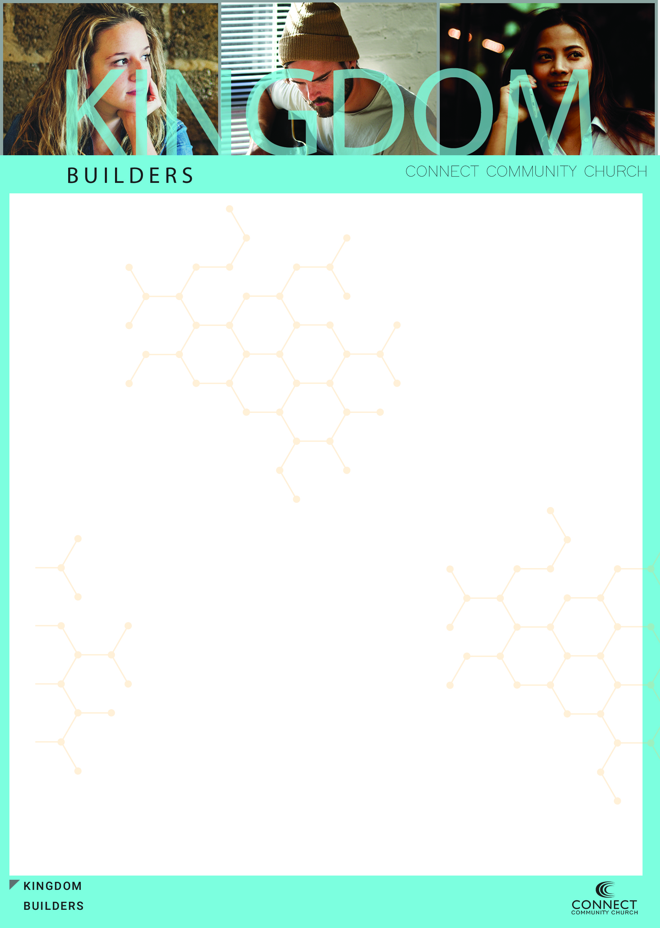

The Kingdom is made up of __________who are a part of a _______ cultural occupying ______ for change that are living in a _______ world

We can _______ to culture, but we can’t _________ the culture

**John 17:14-19 (NASB)   
14  "I have given them Your word; and the world has hated them, because they are not of the world, even as I am not of the world.   
15  "I do not ask You to take them out of the world, but to keep them from the evil one.   
16  "They are not of the world, even as I am not of the world.   
17  "Sanctify them in the truth; Your word is truth.   
18  "As You sent Me into the world, I also have sent them into the world.   
19  "For their sakes I sanctify Myself, that they themselves also may be sanctified in truth.**

We can only ________ culture when we are __________ than culture

“Counter – Culture” means we are going the _________ direction of culture

We should live our lives in such a ___________ way that it brings attention to Jesus not our _____________

Not an outward ________ but an inward _________

We are an ___________ force

We have come to take _________ for the kingdom of God

What we mean by territory is _________

We are on a ______ _________ mission



We are in ________ territory and need to know that there will be __________

Hostile to our ______, hostile to our __________, hostile to our way of ______

Even in hostility it must always be about ________

**The Kingdom Difference**

______________ is a matter of ___________

We can’t settle for a “circle the ________” mentality, but we must be close _______, ________ and __________ at a different level.

Our Community must have an ________ strength and an outward ____________

Our Community must have Kingdom _____________

The Kingdom is a place where people can be ________ to the Savior Jesus Christ and grow in that _____________. It’s a place of such strong ______ that has such dramatically different _________, and by that, presents a clear _________ of what it is to ________ according to what Jesus has taught us. The kingdom is a place of _________ and a place of ________. Those of us who are a part of the Kingdom realize that we are in an “all out” fight to _________the Kingdom by _________ new people to Jesus and expanding His __________ wherever and whenever we can.