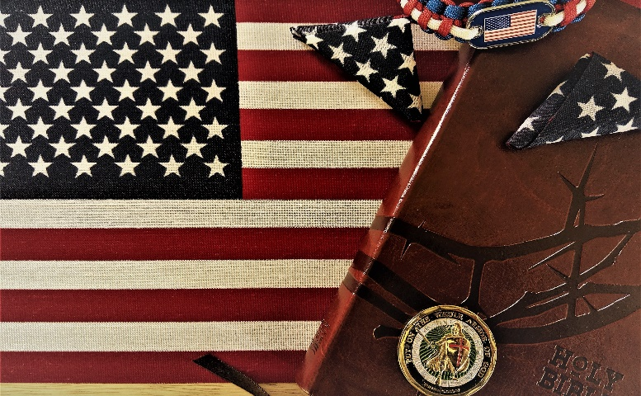

Debut

***in this issue >>>***

***current topics >>>***

*Go check out our Webpage on Trinity UMC’s site.*

*Deployed Spouses Dinner*

*Pocket Flag Project*

*Military Fellowship*

*Website*

*Recommended Devotional*

perform his/her duty and the family/friends left behind to hold everything together without them. It never fails that when we

Statement for the ministry is **“To engage our local military community with the Gospel, walking with them and their families, as they carry the burden of sacrifice for their fellow man and country.”**

Many of us have served in the military and some of us are still serving. Because of our experiences, we know the burdens that can be felt by both the service member trying to

the mission. We, also, do not want the family and friends serving on the home front to feel alone or over burdened. We are here to walk with you. To pray with you. To serve you in anyway we can. We are here to show the love of Christ to those who are in service to others. And we are excited to see what God does through this ministry and the people He allows us to serve.

leave home, things seem to go wrong. Whether it is the washer dying or car problems. Those left at home are picking up the pieces the best they can and manage on their own. We do not want our service members to have to worry about those things while they’re trying to complete

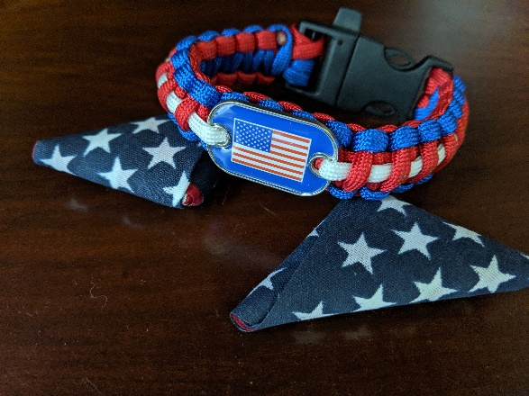

*Trinity UMC’s webpage has been updated and looks great. You can check that out at* [*www.trinityumc-jax.org*](http://www.trinityumc-jax.org)

*Click connect from the home page and select Serving Your Six Ministry to see our new page. On this page you can find information about our upcoming events, recommended devotionals, and how to contact us for prayer and support.*

There is also a new Instagram and Facebook page coming soon. You will be able to follow those from the website as well.

their families. The intention is to help in any aspect possible to assist in carrying some of the burden our military and their families carry. Whether it is providing meals or helping with car and home maintenance. We want to be available to assist however we can. The mission

Serving Your Six ministry is a new mission with a focus of meeting the mental and emotional needs of our service members and

**“as they carry the burden of sacrifice for their fellow man and country.”**

***1 Thessalonians 2:8 Because we loved you so much, we were delighted to share with you not only the gospel of God but our lives as well.***

*Launching a Military Mission for Christ!*

**Issue**

*Our newest Ministry*

*Servinge*

***Your Six***

**A Monthly Insight into our Military Community**

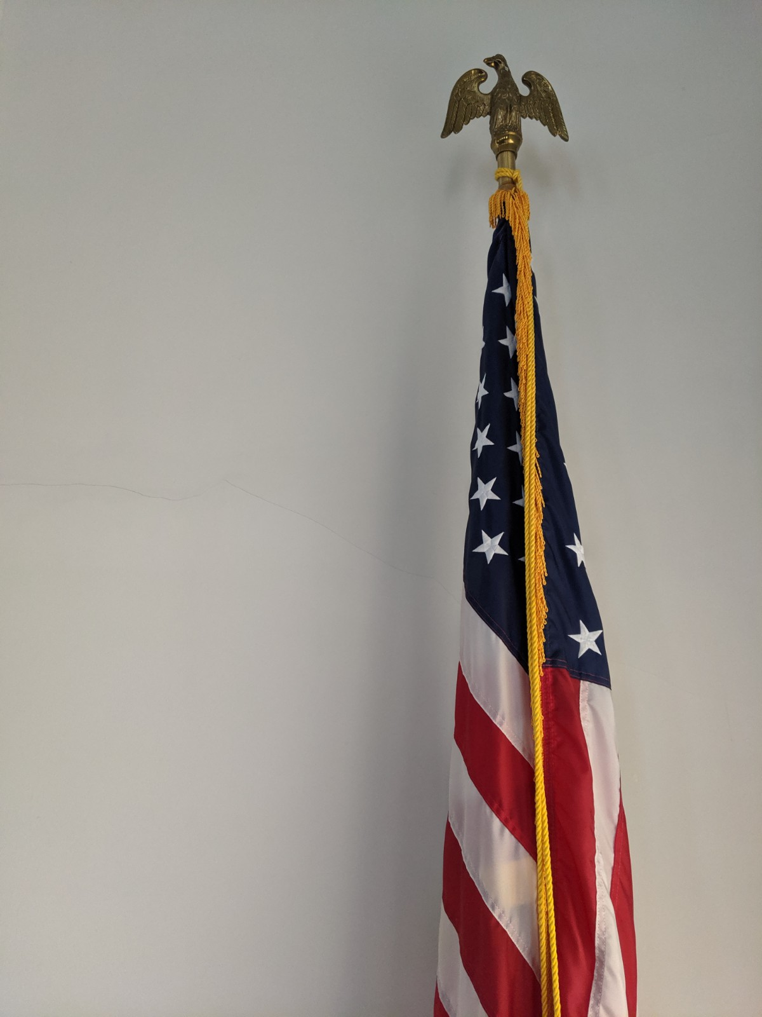

*about dinner. We are hosting the third Monday of every month. The times will be from 5:00pm thru 7:00pm. We can not wait to see you and serve you.*

*We are offering a dinner for family members of people that are deployed or away serving in some capacity. This dinner is open to all family and friends. We would love to fellowship with you and eat a meal where you can relax.*

*Childcare will be provided so you can just sit back and enjoy time with others who are going through the same things you are.*

*We will provide a meal from various resturants each month. These meals are free and there to give you a break from worrying*

Called to Serve by Tony Monetti and Penny Monetti shares some insights from a military couple that has lived and experienced many of the things those serving face.  It is funny and insightful and it touches on the emotions faced in those chaotic times of balancing family and the military

*Deployed Spouses Dinner*

**Folding Flags**

*If you are interested in folding flags to support this ministry, feel free to contact us through the website and let us know.*

**Deploying**

***If you or someone you know is deploying, we would love to pray for them while they are gone. If you will go to the website and submit their name through the Serving Your Six Ministry page at*** <http://www.trinityumc-jax.org/serving-your-six-ministry>

We will be in prayer for them and their friends and family awaiting their return.

*Recommended Devotional*

***Outreach >>>***

*In addition to learning about the U.S. flag and the sacrifices of our military, volunteers fold and package flags to send to our front line and deployed troops. Included with each flag is a card that says:****“A flag for your pocket so you can always carry a little piece of home. We are praying for you and we are proud of you. Thank you for defending our country and our freedom.”****There is room on each card for volunteer groups to include a personal message or return address for thank you notes.*

***It is our goal to get as many pocket flags as we can into the pockets of our deployed troops. They serve as a pocket full of home, hope, love and support.***

*The Pocket Flag Project was conceived in October 2001 when LuWanda Ford visited with fellow Boy Scout leaders who were veterans of the Vietnam and Gulf Wars. Both Scout leaders carried small, folded flags in their left shirt pockets and shared how important these flags were, and are, to them.*

*Inspired, Ford adapted the idea into a project for her Cub Scouts to develop patriotism and pride for our country while supporting our military troops. After folding and packaging 100 flags, the Scouts presented them to local Naval Reserve representatives. Her 9-year old son  told an attending reporter that the flags were going “to all the soldiers in the war”. The Pocket Flag Project has since grown into an international non-profit project.*

***Serving Your Six Ministry >>>***

*Pocket Flag Project*