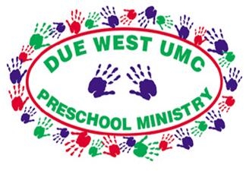

DWUMC Preschool Summer Camp Registration Forms
Due West UMC Preschool is offering 3 summer camps for children age 3 (fully potty trained) – 6 (just finished kindergarten). Each theme based camp will have cooking, science experiments, crafts, playground time and play time. *The children at our camps do not have to attend Due West UMC Church or Preschool.

Each session costs $150.00. $50.00 is due upon registration to hold your spot and is nonrefundable. Final Payment is due 7 days prior to the camp. There is a $10 sibling discount per session.
The camps are Monday-Thursday from 9:00 a.m. – 1:00 p.m.

Please check the camps you would like your child to attend.
_____ June 8 – 11 Water Fun
_____June 15 – 18 Capes and Crowns
_____June 22 – 25 God Bless America

Child’s Name:______________________________________________
Age: __________________Birthday:____________________________
Parents Name:_____________________________________________
Phone Number:____________________________________________
Email Address:_____________________________________________
Who else can pick up your child:____________________________
___________________________________________________________
Contact Michelle Davalos at 770-590-0982 or mdavalos@duewest.org with questions.

