Parent Information Packet
Lake Yale Conference Center
July 18-22, 2022

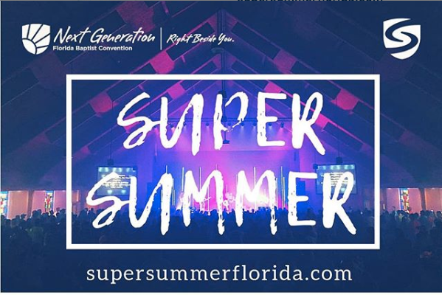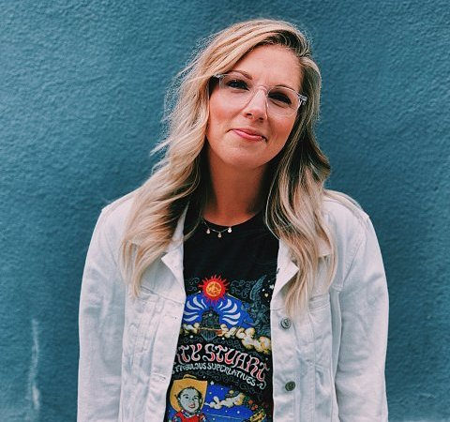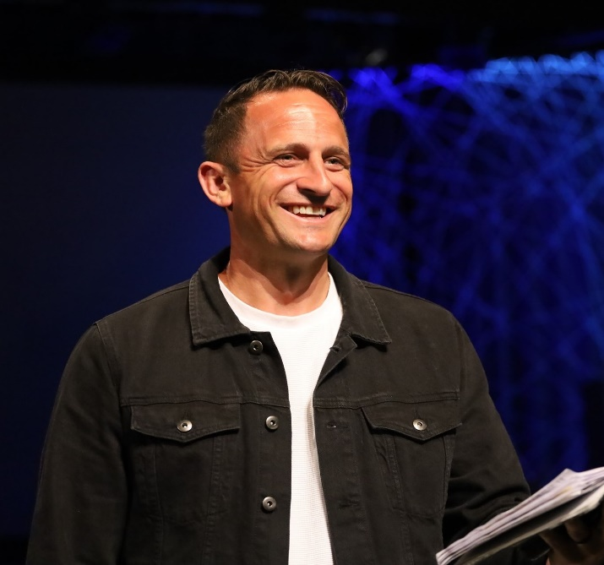

Super Summer Details:

- WHEN: July 18-22, 2022
- WHERE: Lake Yale Conference Center, Leesburg, FL
- AGE: Students who have completed 6th-12th grade
- COST: $400 per person (Cost includes all travel, lodging, meals, recreation, and programs at Super Summer)

What is Super Summer?
Super Summer is a camp sponsored by the Florida Baptist Convention. Super Summer Florida takes place each summer on the campus of Lake Yale Baptist Conference Center, in Leesburg, Florida. Super Summer serves campers who have completed 6th—12th grade.
What will my student do at Super Summer?
Super Summer is an awesome camp experience where your student will grow closer to God, experience powerful music and speakers, and have fun with lots of recreation, including crazy games, team events, paintball, a ropes course, fishing , team mega relay, creative arts breakout sessions, and more!
Learn More here:
https://www.supersummerflorida.com
https://www.instagram.com/flbaptistnext

LAKE YALE CAMP & CONFERENCE CENTER
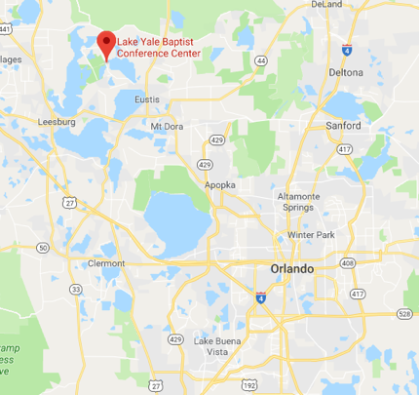
- 2 separate camp areas, North and South Camp, that can hold up to 260 guests in bunk-style dorms.
- Each lakeside camp has 8 dorm buildings with 12 bunk beds and 2 counselor’s rooms.
- For more information visit https://www.lybcc.com/

Important Dates

Sunday, February 20 – $50 deposit due (non-refundable)

Wednesday, February 16 – Student Growth Group begins
(In-Person on Wednesdays @ 7pm)
Friday, April 29 – Last day to add students / leaders

Friday, June 17 – Balance due

Payment Options

You may pay the deposit and balance due for your student to go to camp in the following ways. Also, after making your initial $50 deposit, you may make payments along the way between now and June 17 to pay the remaining $350.

- Text any amount plus the keyword Journey Camp to short code 45777
i.e. $50 Journey Camp to pay the $50 deposit
- Pay online at www.BocaJourney.com/SuperSummer (via PayPal)

- Pay by check. Make check payable to Journey Church and write Super Summer and your child’s name on the memo line
SPEAKER: BRIAN MILLS
Brian serves as the Senior Pastor at Trinity Baptist Church in Yukon, OK. His life of faith has taught him to trust in God and take up his cross daily. He was brought to Christ at 10, but humbly repented at the age of 16. He teaches students to choose for themselves to be crucified with Christ.
He is also a published author, speaker, and former Youth pastor. Brian has done his fair share of travelling around the world, taking the gospel with him.
Socials : Instagram | Facebook |Twitter
- @brianmills247

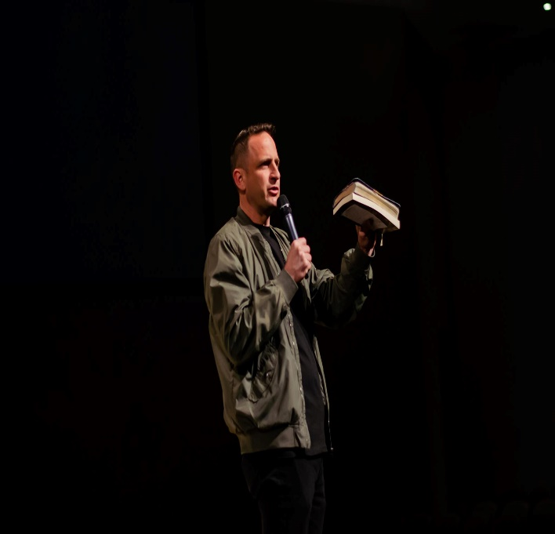

WORSHIP LEADER: BETHANY BARR PHILLIPS
Bethany, her husband Andy, and their daughter live in Alabama and faithfully serve where God has called them, as a travelling worship leader.

Her desire for the Gospel message to be proclaimed reigns true in all sessions in which she leads worship. When talking about her new album “Bring the Heart to Life,” Bethany said, “We want to tell people Jesus is who He says He is and, through trusting in Him by Holy Spirit, He will bring your heart to life.”

Socials: Instagram | Facebook
- @betbarrphillips
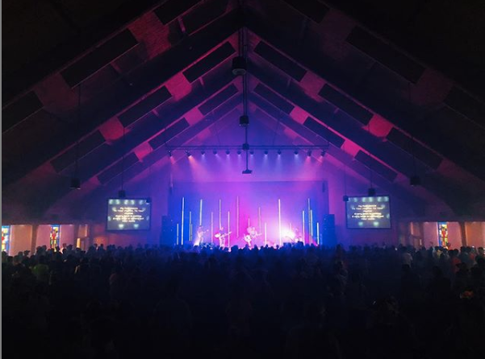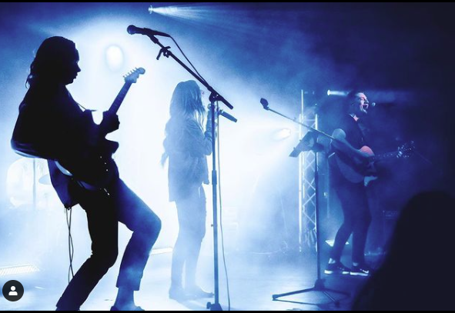

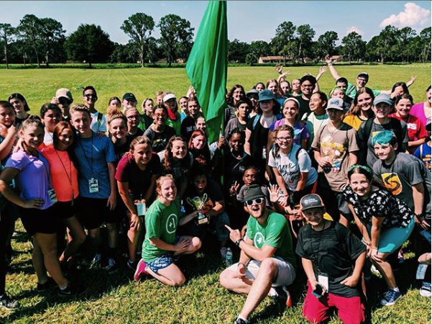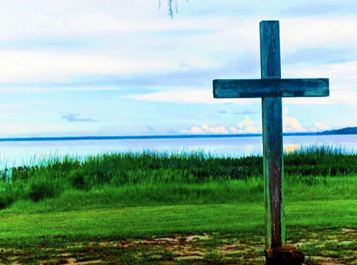

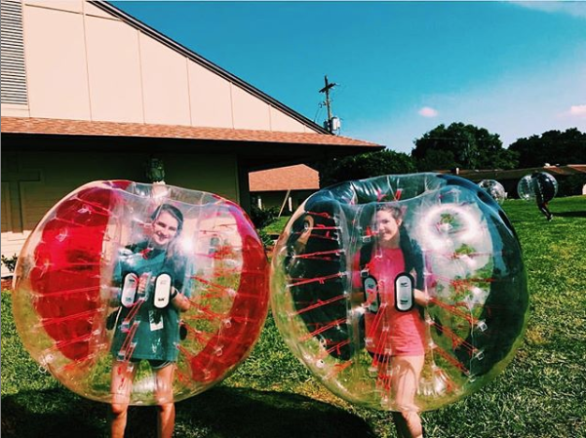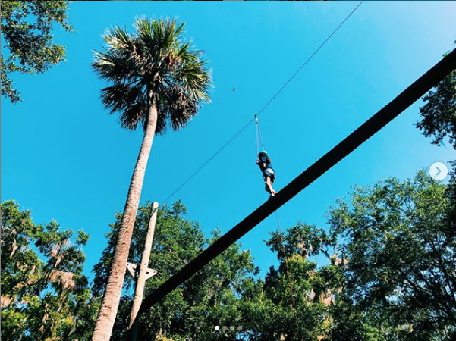

July 18-22, 2022
www.BocaJourney.com/SuperSummer

