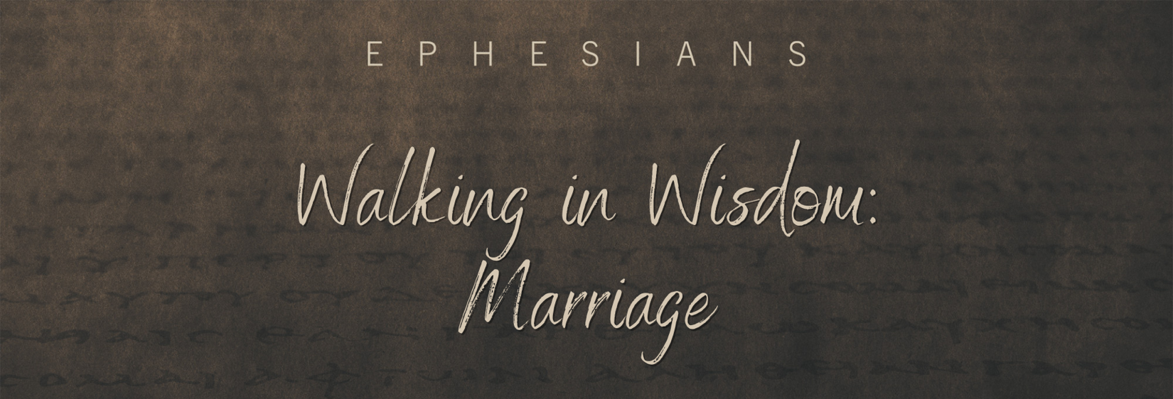

Sunday, July 24, 2022
Pastor Keith Thompson
Ephesians 5:22-33

- Wives are to ___________ to their own husbands as the church ____________ to Christ (22-24, 33b).

- Husbands are to ___________ their own wives as Christ ____________ the church (25-32, 33a).

