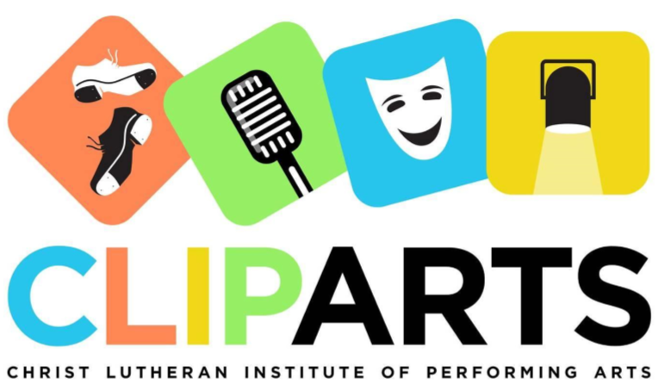
CLIPArts Goal:
To provide a tangible expression of the love of Jesus Christ to at-risk kids in the community through a performing arts program that allows them to foster creativity and to grow and develop socially and emotionally in a safe and encouraging environment.
As you may know, our program is built for students from low income houses or gang infused areas, who otherwise may not be able to afford training in liberal arts.
One eighth of our children are from foster homes, thirty percent of students have a parent, sibling, or grandparent incarcerated, and ninety percent qualify for low-income assistance. Several have parents with a chronic or terminal illness. The greatest strength of our program is the ability we have to reach out to those in great need.
CLIPArts Prayer Partners:
One of the ways we reach out to the children in our program is through a prayer journal. The prayer journal is a window into the lives of these children, in which they meet with volunteers or members of the CLIPArts board and talk about what is going on in their lives that week, big and small. The prayer journal is proof that whatever darkness these kids may go through, there is a bright light inside of them that perseveres through each hardship, and through your support, you are growing that light.

