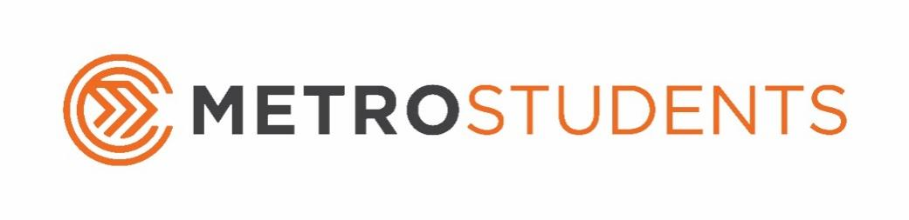

Summer 2021 Calendar
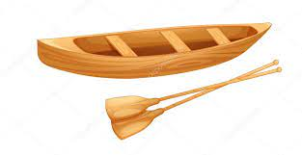
May
- 30th - Sunday: No Metro Students (Memorial Day)
June
- 6th - Sunday: No Metro Students
- 9th - Wednesday: Float Trip (Information Online)
- 13^{th -} Sunday: Metro Students
- 16th – Wednesday: Mid-Week Madness: Ruler Hockey 4-6pm
- 20th – Sunday: No Metro Students (Father’s Day)
- 21st-24th - Monday–Thursday: Metro Students Camp - Bigstuf Live
- 27th – Sunday: Metro Students
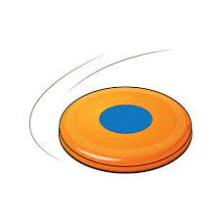
- 30th – Wednesday: Mid-Week Madness: Pollo / Movie 4-6pm
July
- 4th - Sunday: No Metro Students (Independence Day)
- 7th - Wednesday: Battlegrounds: Capture the Flag 6-8pm
- 11th - Sunday: Metro Students
- 14th - Wednesday: Mid-Week Madness: Olympics 4-6pm
- 18th - Sunday: 7th Grade Boot Camp 12:30pm - No Metro Students
- 21st - Wednesday: Mid-Week Madness: 9 Square 4-6pm
- 25th – Sunday: Metro Students
- 28th – Wednesday: Mid-Week Madness: Nerf War 4-6pm
August
- 1st – Sunday: Metro Students - Promotion Night
- 8th - Sunday: Metro Students
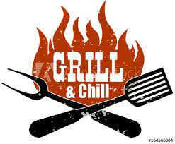
- 15th – Sunday: Metro Students
- 22nd - Sunday: Metro Students
- 29th - Sunday: Metro Students
September
- 5^{th -} Sunday: Grill and Chill Picnic

