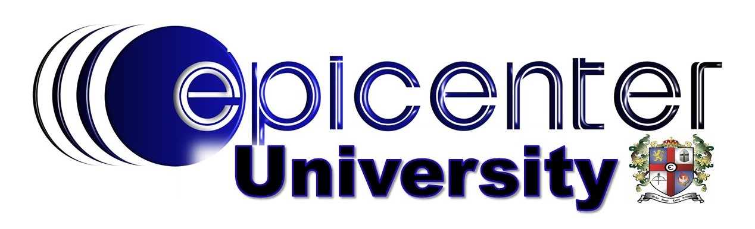
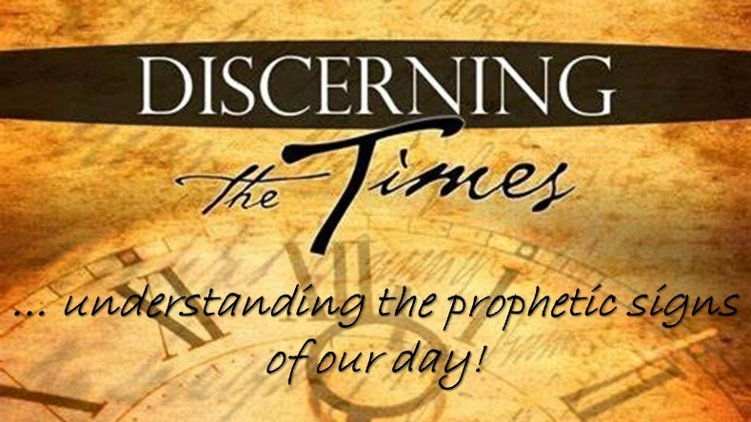
Wednesday Nights
June 8 – July 27, 2022
6:30pm – 8:00pm
ER @ The Epicenter
A 7-week equipping course that will help you to better understand current events from a biblical worldview.

SUMMER COURSE REGISTRATION

First Name* Last Name*

Email Address* Cell Phone*

Do you text? YES NO (please circle one)

Are you on Facebook? YES NO (please circle one)

Do you use Facebook Messenger? YES NO (please circle one)
Course Requirements:

* a commitment to attend a minimum of five (5) of the seven (7) weeks of equipping
* a commitment to be personally responsible for acquiring notes from a fellow student, should you miss a week
* a commitment to be ON TIME, if not early, for each week’s session
* a commitment to be present for the entire session each week … 6:30pm – 8:00pm

Course Needs:
* a 3-ring binder/notebook
* a personal Bible, both Old Testament & New

