JULY2022
What’s happening this month…  Monday, 7/4- Preschool Closed for Independence Day. Everyone have a safe and wonderful 4th of July!  Tuesday, 7/5- Everyone will enjoy a frozen red, white, and blue treat today! There is no charge for this.  Thursday, 7/7- We will bounce the day away! We will have a fun bounce house in the gym today so everyone can enjoy! Please bring $5 to help cover the cost.  Friday, 7/8- Red, White, and Blue Day. The fourth has come and gone but we will continue to celebrate!  Monday, 7/11- Sports Show and Tell. Have your child bring something to show and talk about their favorite sport!  Thursday, 7/14- Jersey Day! Your child can wear their favorite jersey, uniform, or just a t-shirt supporting their favorite team today!  Tuesday, 7/19- Animal Show and Tell. Your child can bring a toy or stuffed animal to share with their class.  Wednesday, 7/20- Dress ready for a safari or in your favorite animal print today.  Friday, 7/22- Pizza lunch! See your child’s teacher for more details.  Monday, July 25 – Tuesday, August 2: Preschool CLOSED. We will see you on August 3rd for the first day of the fall semester! |  | Preschool News  We are half way through the summer of 2022, time flies when you’re having fun! We have loved getting to know all of our new families and always enjoy being with our old friends, too.  Thank you all for being patient with us while we worked through the fob system difficulties. We think we have it all figured out now. If you have any further issues with your fob, please let us know. If you need an extra fob we can make that happen as well.  Crystal will be in the office this month so if you need anything you can call or email her at crystal@universitycofc.org  We are looking forward to having a super fun rest of our summer together.
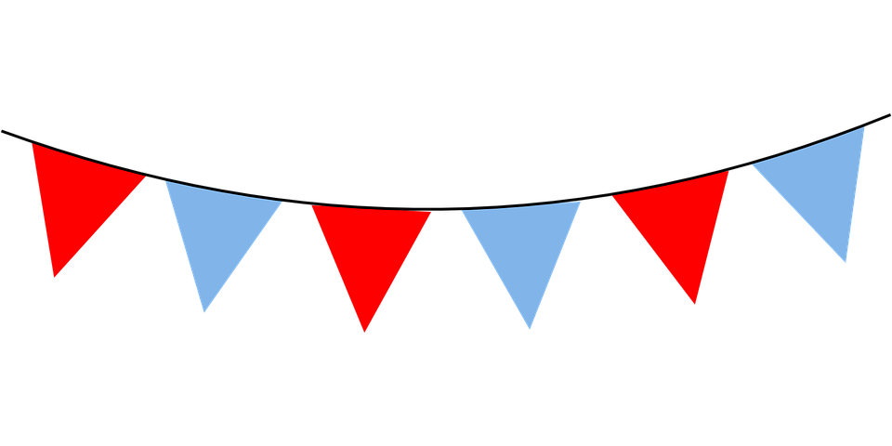

STORY HEADLINE

Story Subline
At any time, you can easily change the text of any section in this document by simply clicking and typing. The template is prepared so that formatting stays in tact with the new information you include.  To update formatting, from the Home tab, you can use the Quick Styles gallery for the built in styles. You can also format text directly by using the other controls on the Home tab. |  |  | On the Design tab, you can change the theme, the colors, and the fonts of the document. This will update the entire document to the main color scheme and font scheme that you pick, with the click of a button!  To change any of the images, simply click on them and choose “Change Picture” from the Picture Tool tab. For the image on the first page, double click in the header to access the image and update it as necessary.
Another Headline Here | You can easily change the formatting of selected text in the document text by choosing a look for the selected text from the Quick Styles gallery on the Home tab. On the Insert tab, the galleries include that are designed to coordinate with the overall look of your document. You can use these galleries to insert tables, headers, footers, lists, cover pages, and other document

