St Mary’s Kids at Home

Here is your discussion sheet to use as a family at home.
This term we are talking about the Miracles of Jesus.
This week’s topic is Jesus is our friend.

Question Time
- What makes your friends special to you?
- How do you show love to your friends?
- What event in your life has brought you closest to God?

Bible Time
Get your bibles out and read the story of Jesus and the paralyzed man - Mark 2:1-12. Discuss what you think we can learn from the love shown by the friends of the paralysed man.

Prayer Time
Take some time together to pray and invite the Holy Spirit.
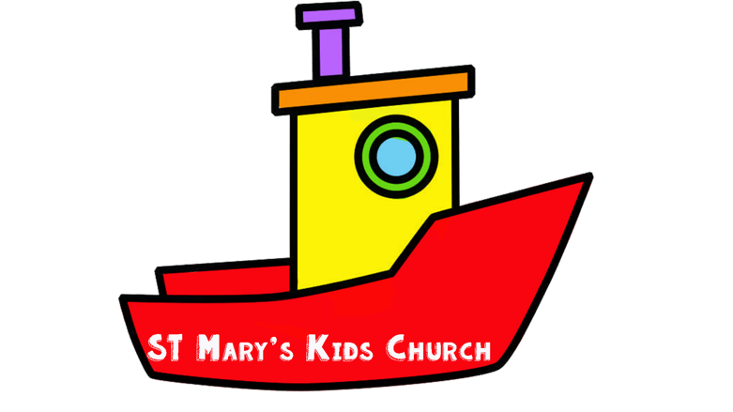
Pray for people who are sick and pray for love and care in your friendships.

