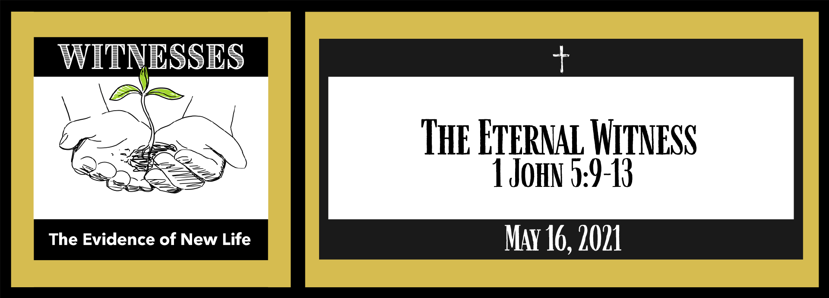Study Questions for WITNESSES: The Eternal Witness

Read 1 John 5:9-13

God’s Story
- In 1 John 5:9 the writer compares two kinds of testimony. What two testimonies are compared?
- 1 John 5:10 mentions where our testimony resides. Where is that?
- 1 John 5:10 says that we can make God a liar. How do we do that?
- What is the testimony we have been given, according to 1 John 5:11?
- The writer of John finishes by saying those who have the Son of God have life. 1 John 5:13 then explains why John wrote the First Epistle. Why did John write his First Epistle?

My Story
- Have you ever had to testify in court about something? What was your testimony? How was that testimony different from your testimony of faith?
- If you truly believe something, do you tell other people about it? Do you find it as easy to talk about these beliefs as your faith beliefs? Why or why not?
- What are your doubts about the testimony of 1 John or the scripture concerning your faith?
- If someone asked you to give your testimony about Jesus Christ, what would you say?
- Do you believe you have eternal life through Jesus Christ? Why or why not?

