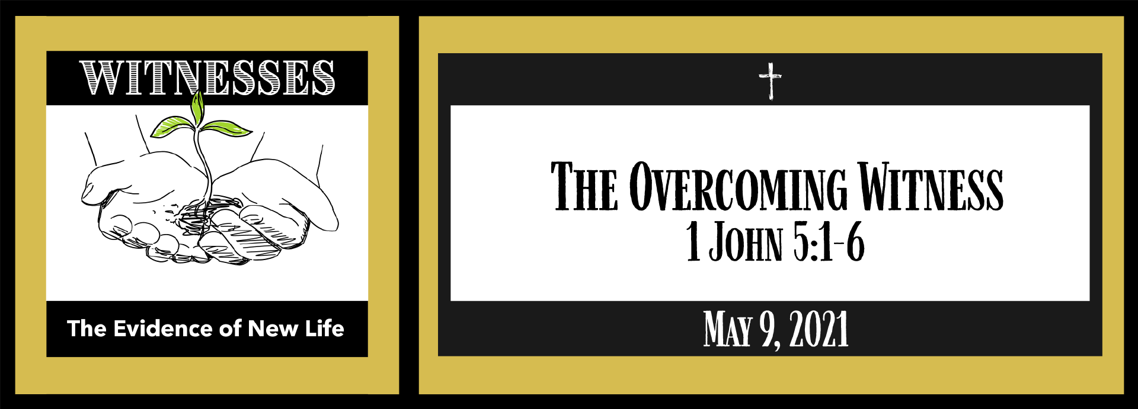
Study Questions for WITNESSES: The Overcoming Witness

Read 1 John 5:1-6

God’s Story
- 1 John 5:1 states the outcome of believing Jesus is the Christ. What is that outcome?
- How do we know that we love God and the children of God according to 1 John 5:2?
- 1 John 5:3 states what love of God is. What is it?
- 1 John 5:3 says that the commandments of God are not burdensome. Why not according to 1John 5:4?
- The writer of 1 John 5:4-5 mentions those who conquer the world. Who are they?

My Story
- What is the benefit of believing Jesus is the Christ in your life?
- Stop and think about the love of God and the love we are called to share with others. How do you know if you are living in that love?
- Do you know what the love of God is? How would you describe it?
- The ten commandments were given as a gift to God’s people. Why do some people view them as burdensome?
- Think of a time when you faced a challenge in which you called upon your faith. What happened? What role did your faith have in bringing you through the experience?

