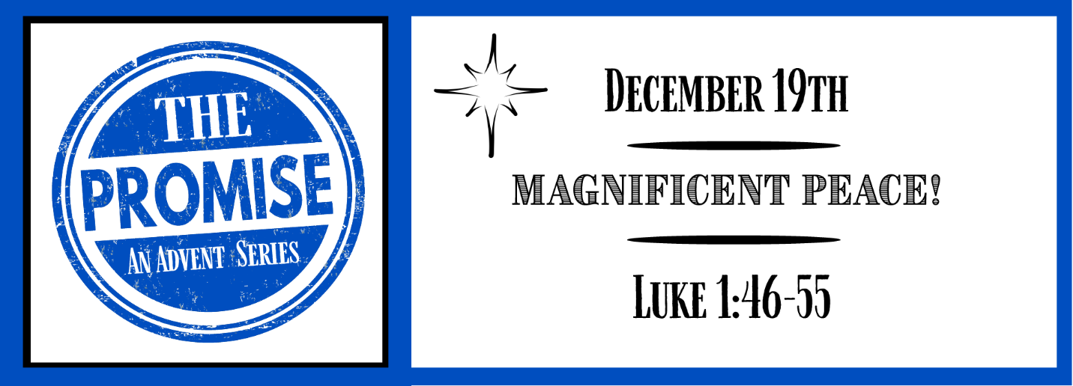
Study Questions for THE PROMISE: Magnificent Peace!

Read Luke 1:46-55

God’s Story
- Why does Mary rejoice and magnify the Lord according to Luke 1:46-49?
- Who is the recipient of God’s mercy according to Luke 1:50?
- Mary declares the order of things in God’s kingdom in the same way Jesus describes it in the Beatitudes (Matthew 5:1-12). What is the place of the poor in this new world order, according to Luke 1:51-53?
- Who does Mary say God has helped in Luke 1:54?
- What is the basis of God’s help for Israel, according to Luke 1:55?

My Story
- What things in your life cause you to want to rejoice and magnify the Lord?
- In what ways have you received God’s mercy in your life?
- In what ways is the order of things in God’s kingdom different from the order of things in your experience of life in this country?
- How have you experienced the help and favor of God in your life?
- What is the Old Testament basis or foundation of the help you receive from God through Christ Jesus?

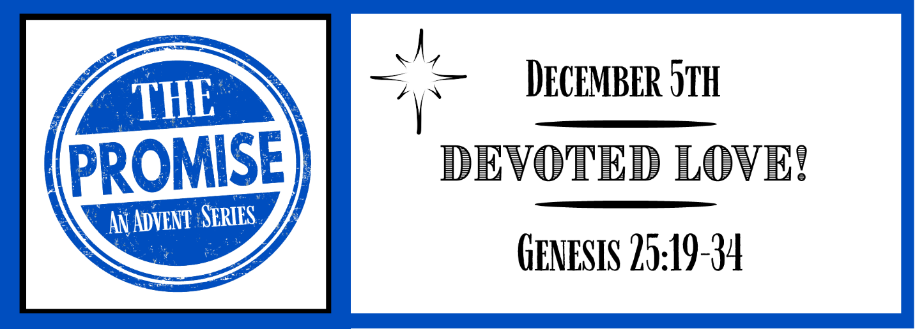
Answers to Last Week’s Questions
THE PROMISE: Unexpected Joy!
(Luke 1:39-45, 57-66)

- Mary the mother of Jesus goes to visit Zechariah and Elizabeth according to Luke 1:39-41. What does Elizabeth experience upon meeting Mary? Answer: Her baby leaps in her womb.
- What does Elizabeth give or declare to Mary according to Luke 1:42-45? Answer: A blessing
- When Elizabeth gave birth, someone rejoiced with her. Who rejoiced with Elizabeth according to Luke 1:58? Answer: Her neighbors
- According to Luke 1:59-63, what was peculiar about Elizabeth and Zechariah naming their child John? Answer: It was not a family name or his father’s name
- A miracle happens when the child of Elizabeth and Zechariah is named. What happened according to Luke 1:64-66? Answer: Zechariah recovers his ability to speak

