Study Questions for THE PROMISE: Impossible Hope!

Read Genesis 21:1-21

God’s Story
- In Genesis 21:1-5, God what does God announce to Sarah and Abraham?
- What was Sarah’s response to God’s announcement according to Genesis 21:6-7?
- In Genesis 21:8-14 what surprising thing did Sarah ask Abraham to do with Hagar and Abraham’s first son Ishmael?
- What life threatening situation occurred with Hagar and Ishmael in the desert according to Genesis 21:15-16?
- How did God respond to Hagar and Ishmael’s dilemma according to Genesis 21:17-21?

My Story
- What astounding things have happened in your life that you never have dreamed possible?
- What was your response to this unexpected occurrence?
- When have you been jealous of another person who seemed to compete with your attention or the attention you felt another member of your family deserved?
- Have you ever been in a life threatening situation? What happened?
- In what ways might God have been present to help you get out of that life threatening situation? Were you aware of God’s presence at the time?

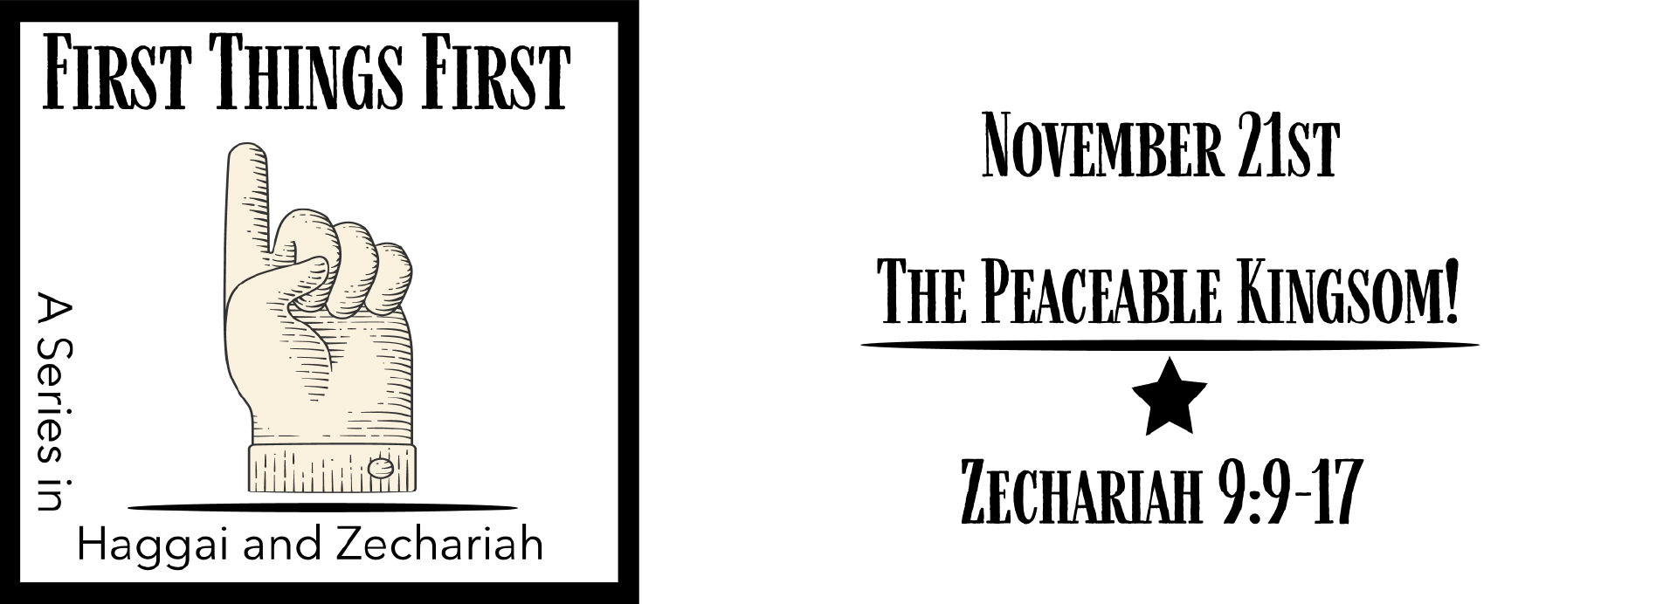
Answer to Last Week’s Questions
FIRST THINGS FIRST: The Peaceable Kingdom
(Zechariah 9:9-17)

- In Zechariah 9:9 the prophet tells the people of Jerusalem to rejoice. What is the reason for the joy? Answer: Their king is coming.
- What will the promised kind do that seems atypical of what kings normally do, according to Zechariah 9:10? Answer: Ride on a donkey.
- Zechariah 9:11-12 announces some promises that the king brings. What are those promises? Answer: Set prisoners free and restore to them double what they lost.
- In what ways will the promised king be a different kind of warrior, according to Zechariah 9:13-14? Answer: He will fight the battle using the people as his weapons.
- Zechariah 9:15-17 paints a picture of the future. What will be happening in the future according to the vision? Answer: God will save his people and they will have plenty to eat and drink.

