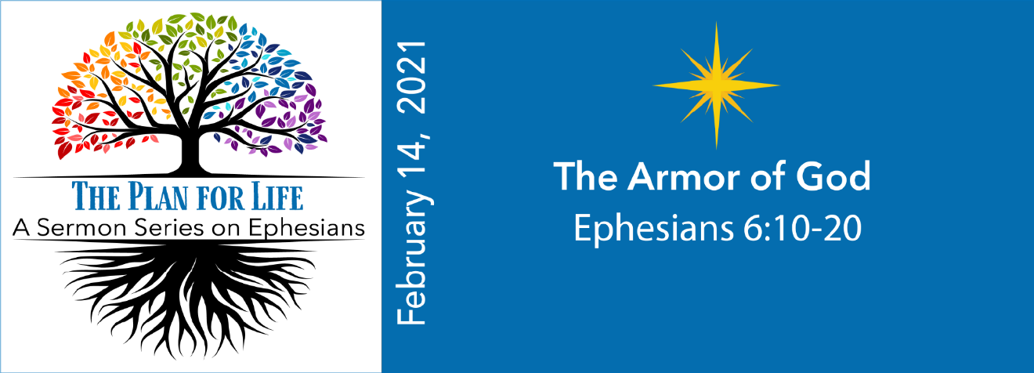
Study Questions for THE PLAN FOR LIFE: The Armor of God

Read Ephesians 6:10-20

God’s Story
- In Ephesians 6:10-11. St. Paul encourages the Ephesians to stay strong in the Lord. How does he suggest they do that?
- St. Paul suggests we live in a state of battle in Ephesians 6:12. Against what are we in battle?
- Ephesians 6:13-17 repeats Paul’s encouragement. What picture does Paul draw to emphasize his earlier point?
- There is a critical practice that will enable Christians to enter the battle St. Paul describes according to Ephesians 6:18-20. What is that practice?
- Lastly, St. Paul describes himself as an ambassador in Ephesians 6:20. What kind of ambassador does he say he is?

My Story
- When facing challenges and embattlements, what spiritual tools or resources do you use?
- Do you believe in spiritual battles? Think of a time when you think you experienced something like St. Paul describes. What was happening?
- How does the image of spiritual armor help you envision some of the tools God has availed you in confronting the battles of your life? What other analogies might you come up with that fit the spiritual tools you use?
- How often do you pray? What are the circumstances? Is it your first “go-to” or your last? How might you make prayer a first order practice in your life?
- In 2 Corinthians 5:20, St. Paul calls Christians “ambassadors for Christ.” How is that different or the same as the kind of ambassador St. Paul describes himself to be in Ephesians 6:20? What kind of ambassador are you?

