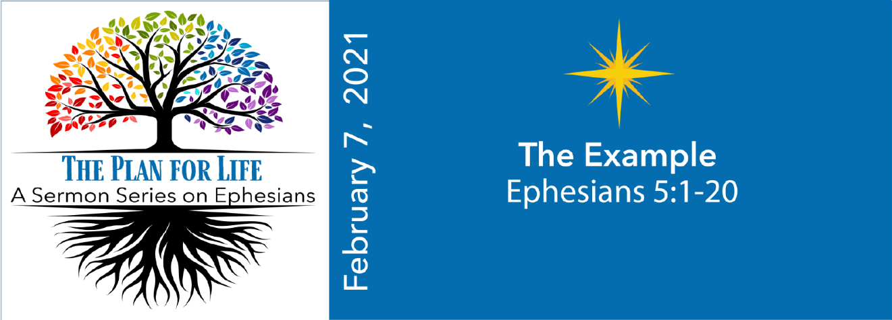
STUDY QUESTIONS FOR THE PLAN FOR LIFE: THE EXAMPLE

Read Ephesians 5:1-20

God’s Story
- Ephesians 5:1 encourages Christians to follow an example. Whose example are we to follow?
- The example mentioned in verse 1 is described in Ephesians 5:2. What is the example of God’s plan for life?
- Ephesians 5:3-5 describes a way of life that is incompatible with God’s plan for life. What practices that were common in Ephesus indicate a way of life that is out of sync with God’s plan for life? What might make these two ways of living incompatible?
- St. Paul cautions the Christians of Ephesus about people who may try to deceive them. According to Ephesians 5:6-7, how might these people deceive the people?
- Ephesians 5:8-20 spells out two paths that lead to different outcomes. What are the two paths described?

My Story
- Think of someone who was a great role model for your life. How did their example help shape you into being the person you are today?
- Consider the person you thought of in the question above. How would you describe the qualities of this role model’s example to someone who never met them?
- Think of a time when you were faced with two options or roads in life that offered potentially different outcomes. Describe the two options and their perceived likely outcomes. Which one did you choose and why? What was the outcome?
- Deception is a common social pariah in the modern world. How do you discern who is trustworthy and who is likely to deceive you? What are some ways you can improve the odds of avoiding deception?
- Consider the two paths of life described in Ephesians 5:8-20. Which of these two paths seems more aligned with your current life? What insight do you derive from reflection on this question?

