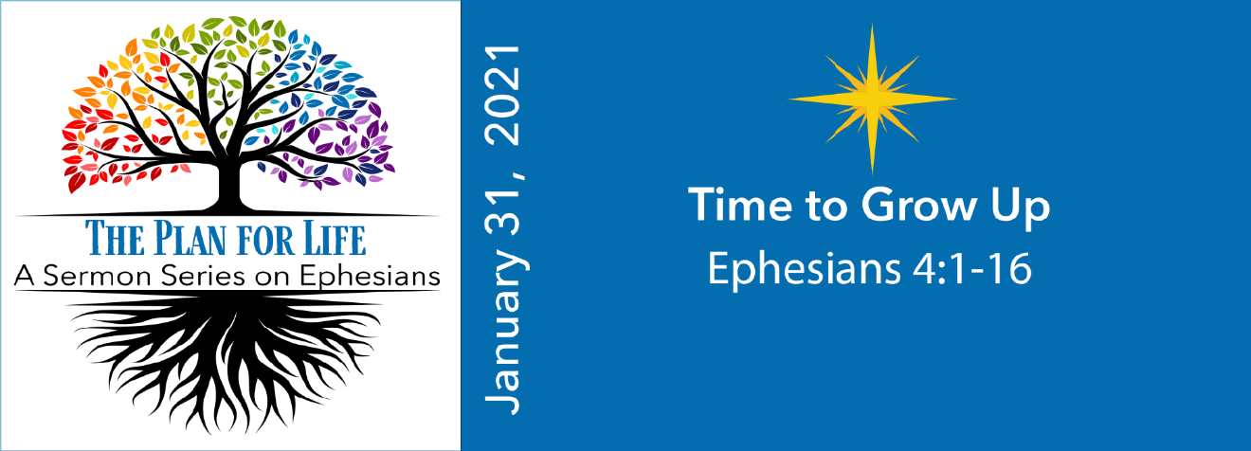
Study Questions for THE PLAN FOR LIFE: Time to Grow Up

Read Ephesians 4:1-16

God’s Story
- Paul encourages the Ephesians to live a life worth of their calling in Ephesians 4:1-3. What does that life entail?
- In Ephesians 4:4, Paul uses the word “one” multiple times to summarize our unity in God. What things does he list to describe the basis of our unity?
- Ephesians 4:7, says that we have each been given something as apportioned by Christ. What have we been given?
- According to Ephesians 4:11-13, what is the purpose of pastors and teachers?
- Ephesians 4:14-16 explains why it is important that we grow up in Christ. Why is that?

My Story
- Are you living a life worthy of your calling according to Ephesians 4:1-3? Why or why not?
- Think about unity in Christ as described in Ephesians 4:4. Why do you think this kind of unity allows for a wide diversity of people, tastes, lifestyles and interests among members of the Body of Christ?
- What are some gifts that you believe God gave you to use for the upbuilding of the Body of Christ? Are you using those gifts? Why or why not?
- If Paul explains the purpose of pastors and teachers in Ephesians 4:11-13, what is the purpose of regular church members?
- Do you believe you are maturing in your faith? Why or why not?

