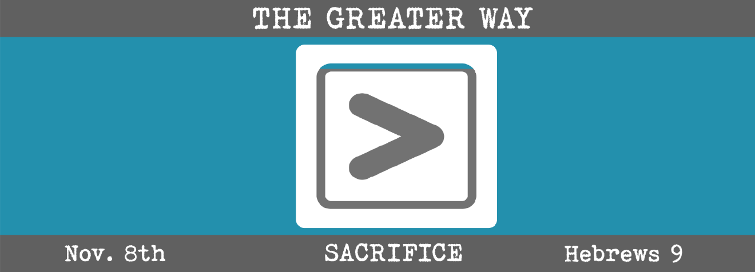

Study Questions for THE GREATER WAY: SACRIFICE

Read Hebrews 9:13-28

God’s Story
- Hebrew 9:13 compares the sacrifice of goats and bulls to the crucifixion of Jesus. What are the similarities and differences between these two worship sacrifices?
- “A death has occurred that redeems” according to Hebrew 9:15. What does it redeem?
- According to Hebrew 9:18, the first covenant was inaugurated by something. What was used to inaugurate the first covenant?
- Hebrews 9:24 says Jesus did not enter a sanctuary made with human hands. What did he do instead?
- According to Hebrews 9:26, Jesus appeared once and for all at the end of the age. What was the purpose of his appearing?

My Story
- When you think of making sacrifices as acts of worship, what do you think is the most important thing to offer or sacrifice to God on account of the grace you have received?
- We often think of death in very negative terms. Does the death of Jesus impact the way you view death?
- The Bible is full of signs used to communicate something of what is happening in many stories. Think of the commitments you have made in your life. What are some of the outward signs of those commitments?
- We often tend to think of church as the building where we worship. How does Hebrews 9:24 help you revise your ideas of church and worship.
- Why do you think Jesus’ arrival and sacrifice on the cross was sufficient that it only had to happen one time to one man to change the world?

