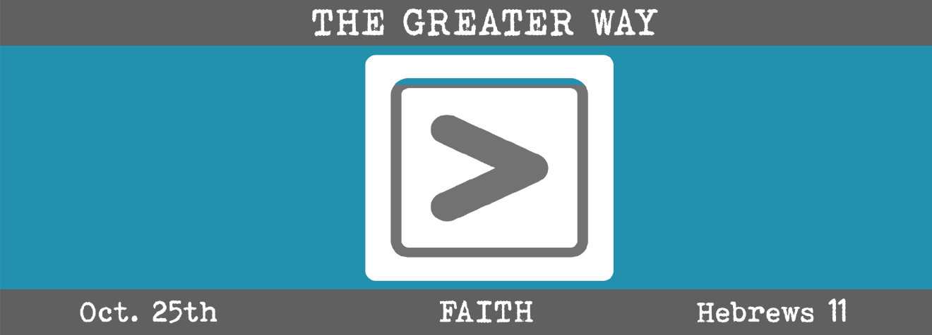

Study Questions for THE GREATER WAY: FAITH

Read Hebrews 11:1-6,8, 13-16

God’s Story

- In Hebrews 11:1, the writer defines faith. What is faith, according to the passage?
- By faith we understand, says the writer in Hebrews 11:3. What do we understand?
- In Hebrews 11:4-6, several Old Testament figures are mentioned. What were their names?
- Hebrews 11:8 mentions the original patriarch of our faith. Who was that?
- In one of the most provocative passages on faith in the Bible, we are told that all of our predecessors of the faith died without seeing the promises of God fulfilled in their lifetime. Read Hebrew 11:13-16. How does this passage change your perspective on the timelines of God’s promises to you as a child of God?

My Story
- What is your personal definition of faith? How would you define it if you were asked to write a definition for the dictionary?
- Faith understanding is different from knowledge that we normally associate with information or facts. How is it different? Read over Hebrews 11:3 several times before answering.
- Who were your most immediate ancestors in faith? Do you know something they hoped for that they had not received before joining the Church Triumphant? What was it? Now that they are that side of glory, do you think they’ve received it? Why or why not.
- Who is the first ancestor in your family tree that you are aware of? What was that person’s name? What do you know about them? How does knowing something about an ancient ancestor help you to know more about yourself or your family?
- Think of something you hope and dream about. What is it? How will you feel if on your last day you have not accomplished what you hoped for or dreamed about? Do you think you will have chances in eternity to accomplish it?

