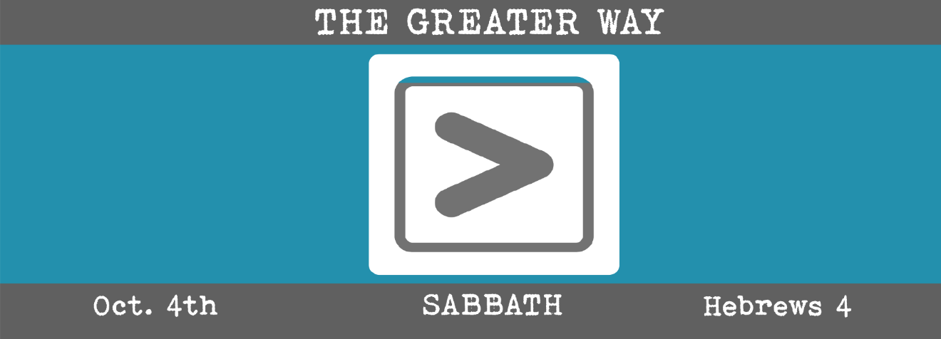

Study Questions for THE GREATER WAY: SABBATH

Read Hebrews 4:1-3, 9-13

God’s Story
- The writer of Hebrews says something is open in Hebrews 4:1. What is open?
- Hebrews 4:2 says that the good news came to the Hebrew people prior to Jesus’ arrival. Why did the good news to the Hebrews not benefit some people?
- Hebrews 4:3 says that our rest was finished before the foundation of the world. How does a person enter that rest?
- Hebrews 4:9 mentions sabbath rest. For whom is the sabbath created?
- According to Hebrews 4:11, the failure to enter the sabbath rest of God is equated with the bad behavior of some Hebrew people. What is that bad behavior?

Our Story
- What is the sabbath? Look it up in Google. How is it observed in Jewish communities? How is it observed in Christian communities?
- What is the association of the sabbath with rest? Why does it seem to be a good life enhancing practice to observe?
- The 4th chapter of Hebrews implies that sabbath rest is something eternal that was created before the world was created and something that will exist into eternity. What do you think the writer is referencing? Perform a Bible word search on the word rest and sabbath. What did you discover?
- Look up the words of Jesus related to the word rest and sabbath. What does Jesus appear to mean by these words?
- How is a failure to enter sabbath rest evidence of a lack of faith and a willful disregard for God’s intention for our lives?

