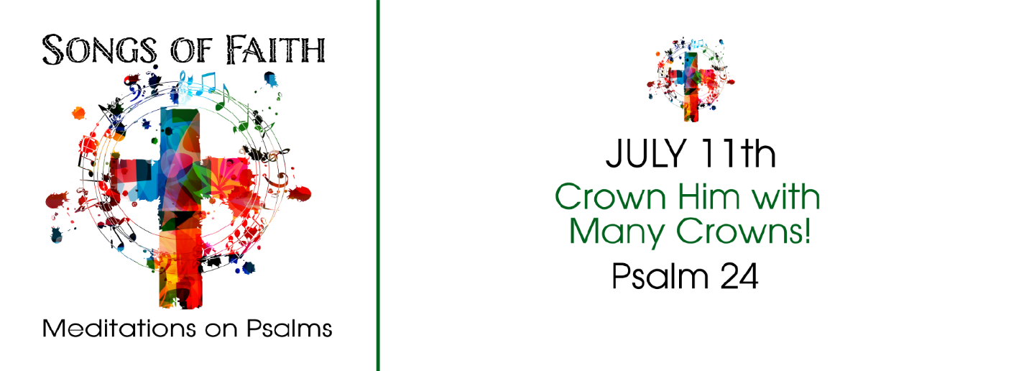
STUDY QUESTIONS FOR SONGS OF FAITH: CROWN HIM WITH MANY CROWNS!

Read Psalm 24

God’s Story
- Psalm 24:1-2 says the Earth belongs to God. According to this passage why is this so?
- A certain type of person is allowed to ascend the hill of the Lord or the sanctuary. According to Psalm 24:3-4, what characterizes this person?
- Psalm 24:5-6 says the person who enters the sanctuary of the Lord will receive something. What will they receive?
- Psalm 24:7-8 draws a picture of a fortress or temple with a gate. The Psalmist encourages those inside to lift the gates. Who is coming in and from where are they coming?
- Who is the King of glory, according to Psalm 24:10?

My Story
- Go outside and look at the world around you. Pick something that you see and ask: “In what ways does this speak of the creative work of the God of Psalm 24:1-2.”
- How does confession and forgiveness prepare us to worship? (Read Psalm 24:3-4 for help.)
- A primary outcome of worship is the effect it has on the worshiper. What outcomes do you experience from frequent worship attendance?
- Speaking spiritually, what might it mean for you to lift your gates to allow the King of Glory to enter in?
- What does the name for God “King of Glory” say about the Lord of hosts to you?

