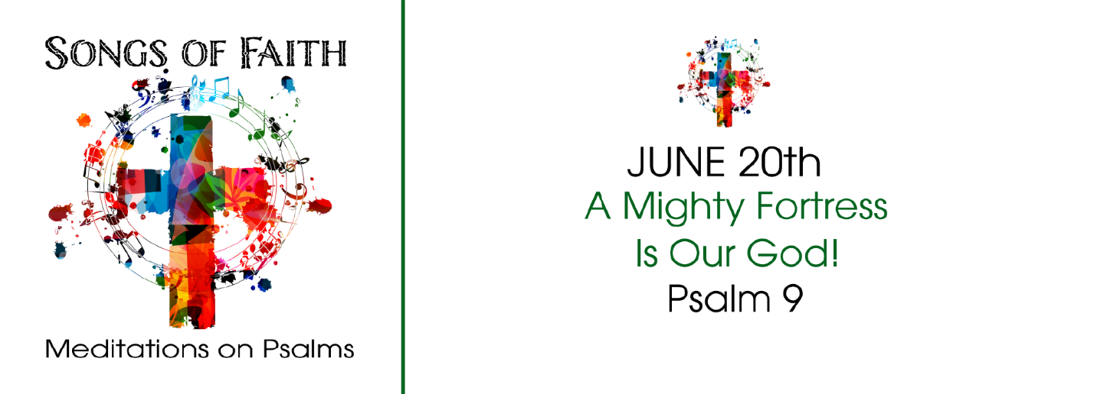
Study Questions for Songs of Faith: A Mighty Fortress is Our God

Read Psalm 9

God’s story
- In Psalm 9:9, we are told that the Lord is a stronghold. For whom is he a stronghold, according to this verse?
- Psalm 9:10 says people who know God’s name do something. What do they do?
- Psalm 9:11 encourages us to tell other people about something for which we sing praise to the Lord. About what are we to tell others?
- Psalm 9:12 says God looks out for someone and does not forget them. Who does God not forget?
- Psalm 9:13-18 is an appeal to God to do something. What is the Psalmist asking God to do and why?
- Psalm 9:19-20 is the capstone of this Psalm. What surprising thing is the Psalmist asking God to do?

My Story
- In times of trouble who do you turn to for support and help? In what circumstances do you ask for God’s help?
- In what areas of your life do you trust God’s intervention? In what areas of your life do you not trust God’s intervention? What’s the difference between these two areas of life?
- What are the major events in your life that shaped who you are today? In what ways can you trace the hand of God in these events, both good and bad?
- Think of a time when you felt afflicted. In what ways were you aware of God’s presence during this affliction? In what ways were you aware of God’s apparent absence during this affliction? What do you think determines your ability to discern God’s presence or absence in a situation of your life?
- In what ways are you aware of God’s grace in your life? Describe an incident where you were assured God is a God of grace?
- In what areas of your life do you need God to rise and act? How have you shared these concerns with God in prayer?

