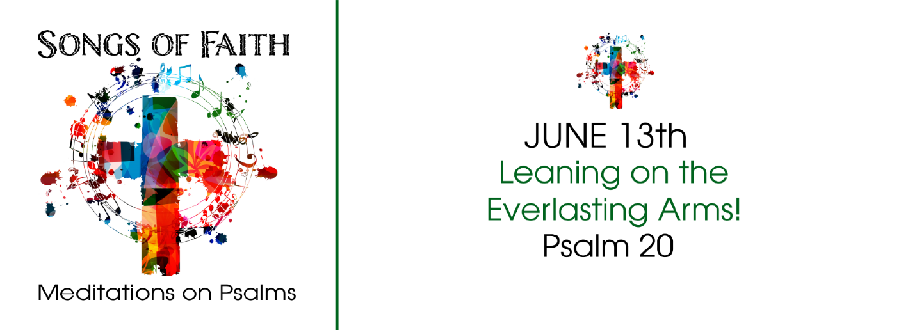
Study Questions for SONGS OF FAITH: Leaning on the Everlasting Arms!

Read Psalm 20

God’s Story
- The Psalmist begins with a wish for readers in Psalm 20:1. What’s the first wish the Psalmist extends to us?
- According to Psalm 20:2, from where does our help come?
- Worship offering is mentioned in Psalm 20:3. For what does the Psalmist hope for our offerings?
- The Psalmist mentions our hearts in Psalm 20:4. What does the Psalmist wish for our hearts?
- The focus on the text changes in Psalm 20:5-9. What does the Psalmist hope for everyone around us in this moment?

My Story
- What is wishful thinking? What best wishes do you send your friends and family?
- In times of trouble who do you turn to for assistance? In what ways do you turn to God?
- Offering and giving is a part of true discipleship. In what ways do you think God remembers and regards your offering?
- What is your heart’s deepest desire? In what ways does God play a part in the fulfillment of that desire?
- When other experience good fortune, in what ways do you celebrate with them? How might you like them to celebrate with you when you experience good fortune?

