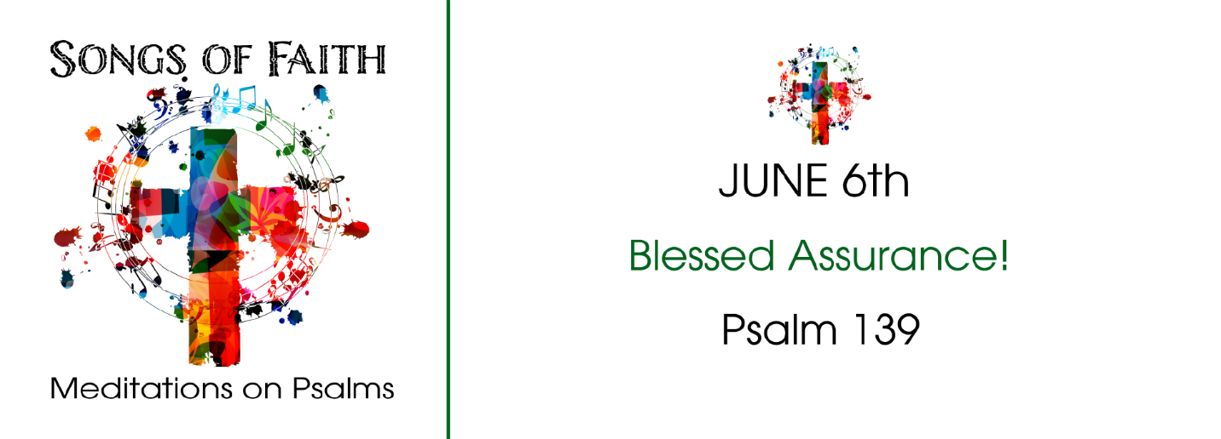
Study Questions for Songs of Faith: Blessed Assurance

Read Psalm 138

God’s Story
- David begins the Psalm in verse 1 asking us to give thanks with a part of ourselves. What part of ourselves are we supposed to use to give thanks according to the passage?
- Also in verse one, David says he is going to do something before other gods. What is he going to do?
- In verse two, David says he’s going to the holy temple. What is he going to do there?
- Also in verse two, David says he’s going to give thanks to God again. For what is he giving thanks?
- Verses three through eight tell us the reason why David is worshiping God. What are the reasons?

My Story
- What does it mean to do something whole heartedly?
- When you are happy, do you sing? What makes you sing? What do you sing?
- Think about a recent experience at Sunday worship. Did you feel a sense of God’s presence? Did you experience a sense of reverence? Did you bow down to God’s reverence?
- If you were going to write a song about something for which you are thankful, what would the song be about?
- List five things for which you are thankful to God?

