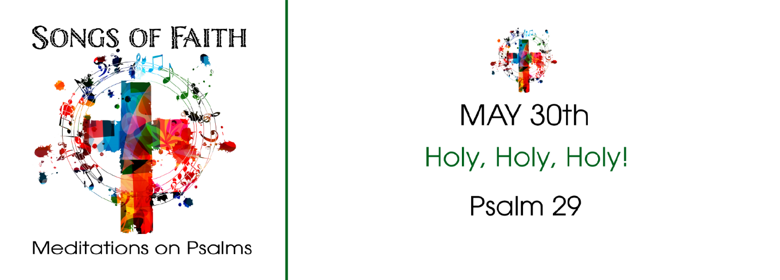
STUDY QUESTIONS FOR SONGS OF FAITH: Holy, Holy, Holy

Read Psalm 29

God’s Story
- Psalm 29:1-2 says to ascribe something to God. What does the writer wish the reader to ascribe?
- Psalm 29:3-9 is a multiverse reference to the voice of the Lord. What does the voice of the Lord do according to the passage?
- Stepping back from Psalm 29:3-9, what does the scene described seem to suggest? Hint: thunder, falling trees, flashes of fire, shaking wilderness, and whirling oaks.
- Psalm 29:10 paints a picture of the Lord in relation to a flood. What does it seem to imply about God? What does it imply about the flood?
- The clincher of Psalm 29 is verse 11. What does it say God gives his people?

My Story
- Worship and liturgy reflect the response of the people to God’s actions. What actions are implied for worshipers in Psalm 29:1-2? How is that the very definition of worship?
- What does it mean for someone to have a voice? How do the references in Psalm 29:3-9 about God’s voice align with what you understand about having a voice?
- Have you ever experienced a natural disaster? What did you see, hear, smell, and feel during the event? What was the impact of the disaster on your life? Where was God during the disaster in your opinion?
- In what ways do you think God watches over you in times of trouble?
- How does your experience of God during a time of trouble help you appreciate the strength of God and the peace that you receive through your relationship with God?

