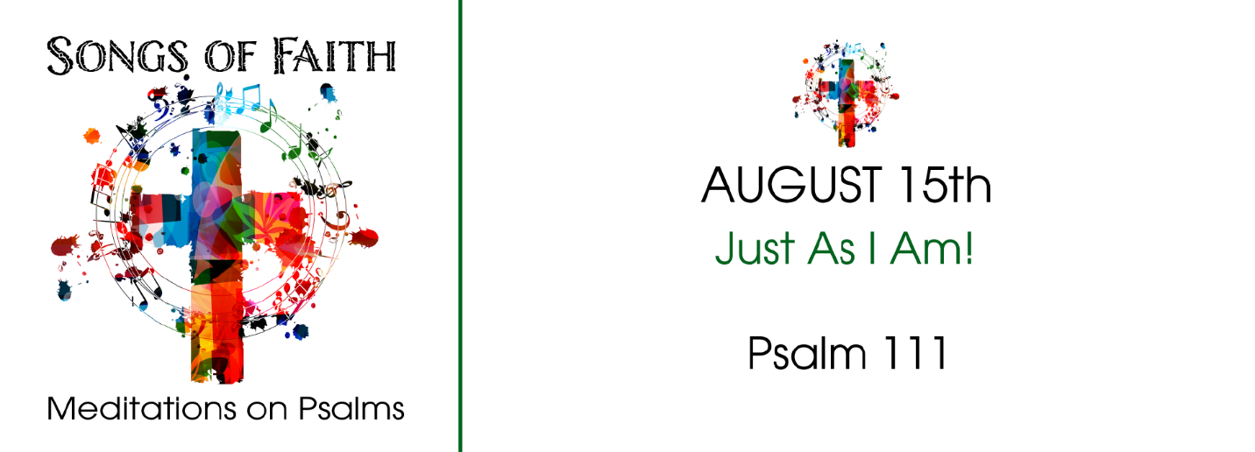
Study Questions for Songs of Faith: Just as I Am!

Read Psalm 111

God’s Story
- Psalm 111:1-2 begins with an exclamation of praise. About what is the Psalmist so happy?
- Psalm 111:3-4 says God has gained renown. What is God known for according to this passage?
- What has God done according to Psalm 111:5-6?
- The Psalmist says something about God’s precepts in Psalm 111:7-9. What does he say God’s precepts are?
- What is the beginning of wisdom according to Psalm 111:10?

My Story
- What does it mean to praise someone? How might this be appropriate in your relationship with God?
- What attributes of God are you most aware of in your life?
- In what ways do you think God provides for you?
- What does it mean to you that God is trustworthy?
- What do you think the Psalmist is encouraging in you in Psalm 111:10?

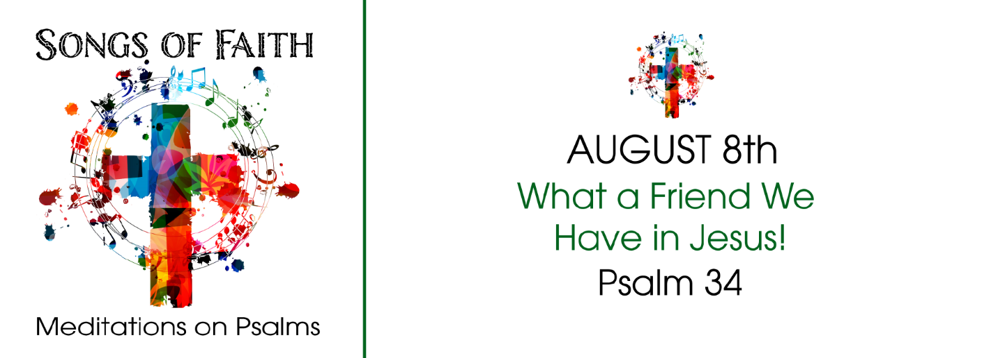
Answers to Last Week’s Study Questions – Songs of Faith: What a Friend We Have in Jesus
(Psalm 34)

- In Psalm 34:1 the Psalmist speaks of blessing the Lord. According to the passage, when can we bless the Lord? Answer: Always
- Psalm 34:2 says the Psalmist boasts. In what does the Psalmist boast? Answer: His soul
- Psalm 34:4-5 says God delivered the Psalmist from his fears. What is the psalmist’s response to God’s delivery from fear? Answer: Radiance and shamelessness
- Psalm 34:6-7 says someone encamps around those who fear the Lord. Who encamps around us? Answer: The angel of the Lord
- Taste and see, says Psalm 34:8. What are we invited to taste and see? Answer: The goodness of God

