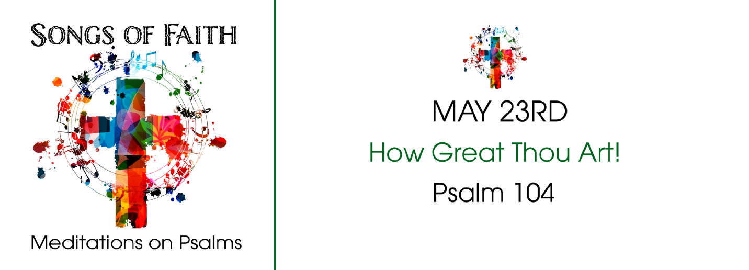
STUDY QUESTIONS FOR SONGS OF FAITH: HOW GREAT THOU ART!

Read Psalm 104:24-34, 35b

God’s Story
- Psalm 104:24 begins with an exclamation. About what does the psalmist seem to be excited?
- In Psalm 104:24, the psalmist begins his exclamation talking about things in the sea. What creature is mentioned in the description? What do you know about this creature? Look it up at Wikipedia.
- The psalmist makes a big claim in Psalm 104:27. What is that claim?
- In Psalm 104:28-30, God’s power is truly evident. What is God capable of doing, according to the passage?
- The mood of the Psalm changes in Psalm 104:31-34. What does the Psalmist wish for?

My Story
- When you think of God’s creation, what amazes you?
- Think about mythological creatures as mentioned in Psalm 104:24. What reality do such ideas and images connect you with that would be hard to explain if you tried to use empirical or everyday language? Why is myth significant for spiritual understanding?
- Look in your refrigerator and pantry. Do you believe God provided the items you find there? Why or why not?
- Do you believe God creates abundance and shortage as described in Psalm 104:28-30? Justify your position by explaining your answer.
- What is your general outlook on your life? Do you look at things in a hopeful way as the psalmist does or in a pessimistic way? Why do you think your outlook is the way it is?

