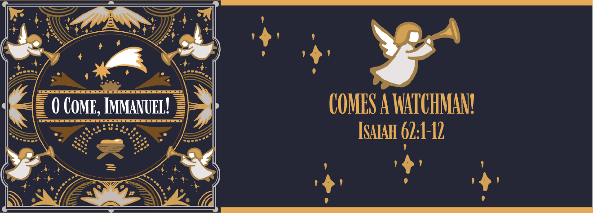

**Study Questions for O COME, IMMANUEL: COMES A WATCHMAN!**

Read Isaiah 62:1-12

God’s Story

1. Isaiah says that he will not keep silent in Isaiah 62:1. For whose sake must he speak?
2. Isaiah 62:2 says Zion will receive a new name. Who will see the renaming of Zion as God’s vindication?
3. Isaiah 62:3-4 list some of the names Zion was called by other nations. What were some of these names? What names did God give Zion to replace the names they were called?
4. Isaiah uses an analogy to speak of God’s relationship with Zion. To what is the relationship of Zion to God compared?
5. Isaiah 62:6-10 mentions watchmen posted on the walls of Jerusalem. For what are the watchmen looking? In the meantime, what are the people supposed to be doing, according to Isaiah 62:10.

My Story

1. Have you ever heard news that you knew you could not keep to yourself? What was the circumstance and what did you do with the news? Was it good news or bad news? Which do you prefer to share?
2. Naming something is a big deal in the Bible. It implies ownership. The one who names, owns and has power over that which is owned. Think about things that you have named. What do those names imply about your relationship with that which you named?
3. Have you ever been called a demeaning name? What was it? How did it make you feel? What name could you use for yourself that would flip the meaning of the demeaning name?
4. If you had to describe your relationship with God using an analogy (a description by comparison), what analogy might you use?
5. Have you ever stayed up all night watching over another person or a household? What was it like? What did you see during your vigil that you might have missed if you were sleeping as usual? Is being such a watchman easy? Why or why not?

