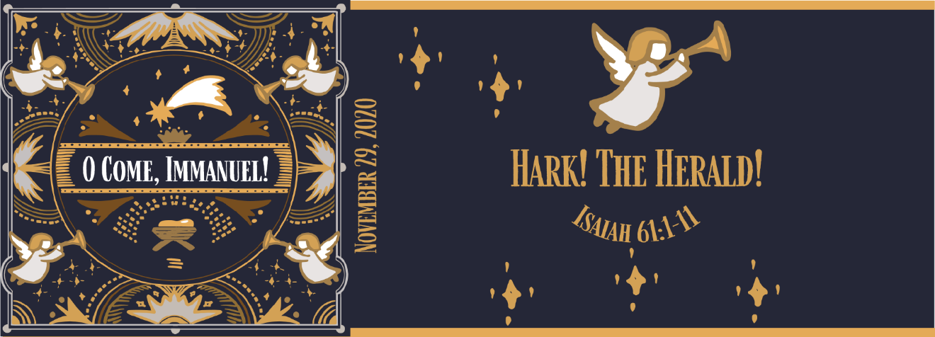

Study Questions for O Come, Immanuel: Hark! The Herald!

Read Isaiah 61:1-11

God’s Story
- In Isaiah 61:1-3, the prophet says that God’s Spirit is on him for a purpose. What is that purpose, according to the passage?
- Isaiah 61:4-6 speaks of activities of the people restored in verses 61:1-3. What will the restored people be doing?
- Isaiah 61:7 speaks to the reversal of fortune for those who God restores. What is the sign of this reversal of fortune according to the verse?
- Isaiah 61:8-9 presents a promise by God. What’s the promise?
- The prophet expresses strong emotions in 61:10-11. What emotions does he express?

My Story
- Jesus preaches his first sermon with a reference to Isaiah 61:1-3. Look up Luke 4:14-30. What’s the message Jesus presented with this text? How was it received?
- As Christians, we are restored people by grace. Reflecting on Isaiah 61:4-6, what do you think God desires of his restored people?
- Have you ever experienced a reversal of fortune? What were the circumstances? What was the outcome? How might God have played a role in the reversal of your fortune?
- What promises has God made to you? In what ways are these promises consistent with the promises God made to Israel as mentioned in Isaiah 61:8-9.
- When you think of the grace of God in your life, what strong emotions does it evoke. How do you express those emotions?

