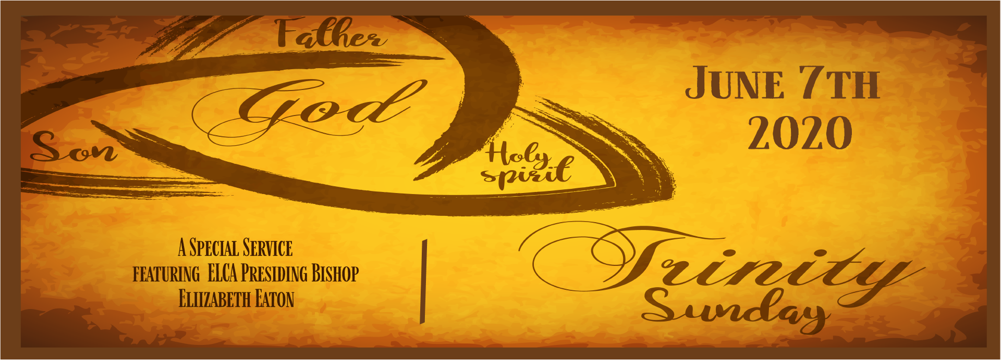STUDY QUESTIONS FOR TRINITY SUNDAY

Read Genesis 1:1-2:4a, 2 Corinthians 13:11-13, and Matthew 28:16-20

God’s Story
- According to the Genesis creation accounts, on which day were humans created?
- Compare Genesis 1:26-27 with Genesis 2:15-23, the two creation accounts as recorded in scripture. How are they the same? How are they different?
- Read 2 Corinthians 13:11-13. What does St. Paul encourage us to do to maintain quality human relationships?
- At the end of Matthew’s gospel, Jesus prepares the disciples for his departure. He directs them to do four things. What are four things does he tell them to do.
- The last words of Matthew’s gospel are perhaps the most comforting words in the entire book. What does Jesus say that assures our confidence and comfort no matter what is happening to us or the world?

My Story
- Think about the day you were born. What month and year was it? What day of the week was it? What was going on in the world the day you were born? In what way may you have been shaped by these details that give insight into the person you’ve become?
- The Genesis creation accounts have influenced our thinking on many things currently in modern discussion, including everything from animal rights to gender equality. How do these accounts clarify or confuse your perspective on these modern questions?
- If the idea of the Trinity indicates that God is a being in and for relationship, what does that imply for us, if we are created in God’s image?
- Christians are created with a purpose according to Matthew 28:16-20. We have a job to do. What gifts or talents has God given you to fulfill the purpose stated in Matthew 28?
- As people created for relationship, how does Jesus’ promise of eternal presence help you live a fulfilling life?

