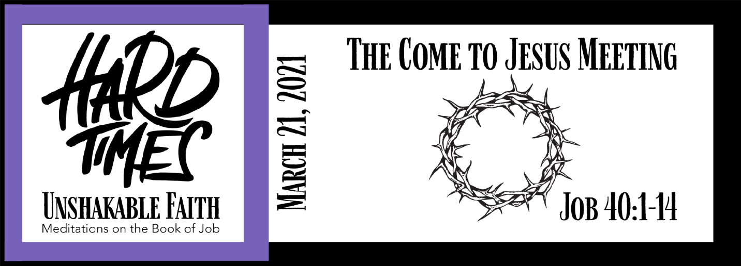
Study Questions for HARD TIMES, UNSHAKABLE FAITH: The Come to Jesus Meeting

Read Job 40:1-14

God’s Story
- In Job 40:1, God speaks to Job as a faultfinder. What does God say a faultfinder must do?
- Job responds to God’s demand in Job 40:3-5. How does he approach God and what does he say?
- In Job 40:6-8, God speaks to Job’s response with a harsh tone in order to correct something Job misunderstood about God. How did God correct Job?
- In Job 40:9-14, God reveals a new perspective from which Job must consider his situation, particularly as it relates to God. What is that new perspective?
- The whole text of Job 40:1-14 is like a courtroom showdown between God and Job. How does it demonstrate that God the unequal relationship we have with God? Does it confirm or deny that God is a God of justice?

My Story
- What is a faultfinder? In what ways have you experienced faultfinding in other people, other Christians, or even yourself? Why is this problematic when applied to our relationship with God?
- In Job 40:3-5, Job finds himself speechless when he finally has his day in court before God. When have you found yourself speechless when you had something on your mind that needed to be addressed, but you were too afraid to speak your truth?
- The life of faith sometimes involves moments where the faithful need correction. Think of a time in your faith journey where you needed to be corrected. How did you respond to the correction? What positive change came out of the situation?
- In the journey of faith, there are moments when we gain new perspective on problems that have plagued us for years. Think of a time when you received new perspective from reading a piece of scripture, listening to a sermon, or talking with another Christian friend.
- In Chapter 40 of Job, we finally come to Job’s big moment before God. How has your perception of your relationship with God been informed by the story of Job?

