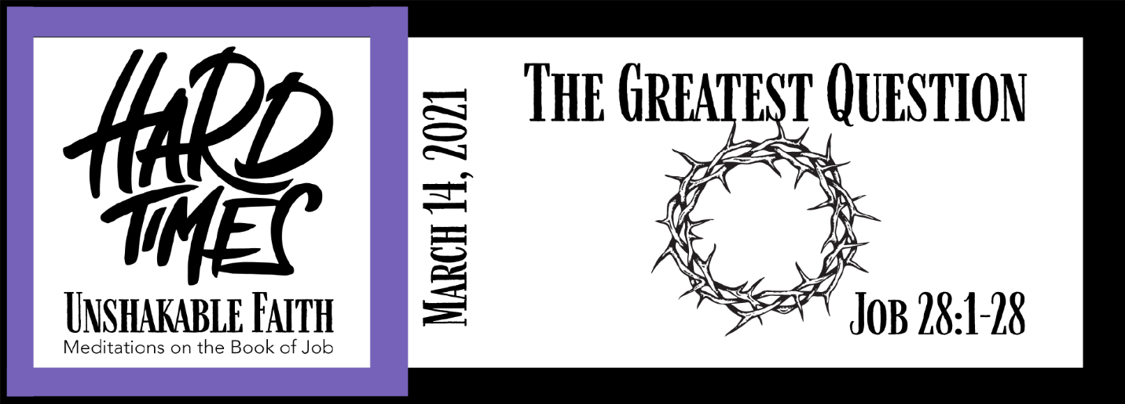
Study Questions for HARD TIMES, UNSHAKABLE FAITH: The Greatest Question

Read Job 28:1-28

God’s Story
- In Job 28:1-11 Job describes mines with precious metals and stones as places he might search for the source of wisdom. Does he find wisdom there?
- According to Job 28:13, Job says mortals don’t know something. What don’t mortals know?
- Job mentions Abaddon and Death in Job 28:22. What does he say about Abaddon, the angel of destruction and death?
- According to Job 28:23, who knows the way to wisdom?
- Job 28:28 is a quotable passage that answers the question of what wisdom is. What is wisdom, according to the passage?

My Story
- Think of things in creation that suggest the value of God’s wisdom. List those things. How do these things help you appreciate the value of godly wisdom?
- Why is a life centered on the things of the world an unwise life?
- Why is a life centered with God the source of a wise life?
- If God knows the way to wisdom, how might you avail yourself to wisdom?
- What does the “fear of the Lord” mean to you?

