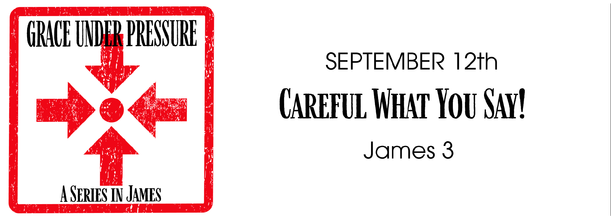
Study Questions for Grace Under Pressure: Careful What You Say!

James 3:1-12

God’s Story
- James 3:1 says many people are not equipped to do something. What are some people not advised to do?
- James 3:2-3 mentions a bridle on our speech. What does a bridle do to the whole body according to the passage?
- James 3:5 mentions a small member of the body that boasts great exploits. What body part is mentioned here?
- James 3:5-10 says something is a restless evil. What is the evidence of this restless evil according to this passage?
- James 3:11-12 asks two questions with the same answer. What point is James driving at by asking these two questions?

My Story
- Why do you think it might be difficult for someone to be a respected teacher of religion or spirituality? What expectations might you have for such teachers that you might not place on yourself?
- What are your thoughts on free speech? Should a person say whatever they want to always say? Why or why not?
- How does what you say and how you say it reflect the character of your soul?
- In what ways might what you say represent restless evil, even if you think what you say is right?
- In James 3:11-12 the writer asks us to consider the two-faced aspects of our words. How are your words sometimes two-faced? Why might this be problematic in your life?

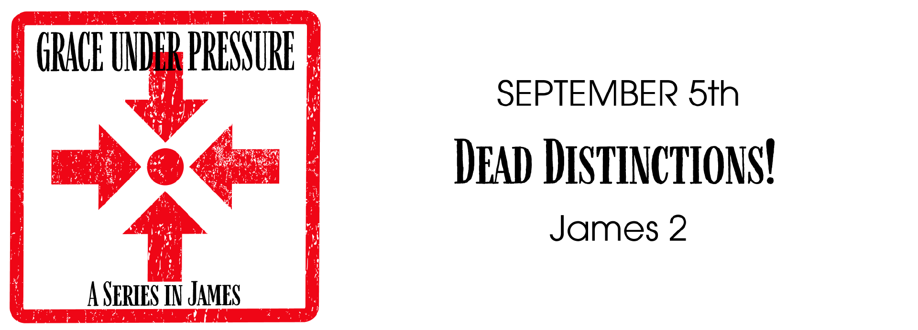
ANSWERS TO LAST WEEK’S STUDY QUESTIONS:
Grace Under Pressure: Dead Distinctions! (James 2:1-17)

1. In James 2:1-4, James points out a common practice that is against the way of Christ. What is this practice according to the passage? Answer: Showing favoritism
2. In James 2:5-7, James mentions a group of people that are often dishonored. Who are these people? Answer: The poor
3. James 1:8 quotes Jesus’ great commandment. What is that commandment? Answer: Love your neighbor as yourself
4. James 1: 9-11 calls something a sin. What is labeled a sin in this passage that we might not consider a sin? Answer: Showing partiality
5. James 1:12-3 mentions a law. What is law is mentioned here? Answer: The Royal Law – Love your neighbor as yourself
6. James 1:14-17 makes a controversial statement about faith and works. What does James say about faith and works? Answer: faith without works is dead

